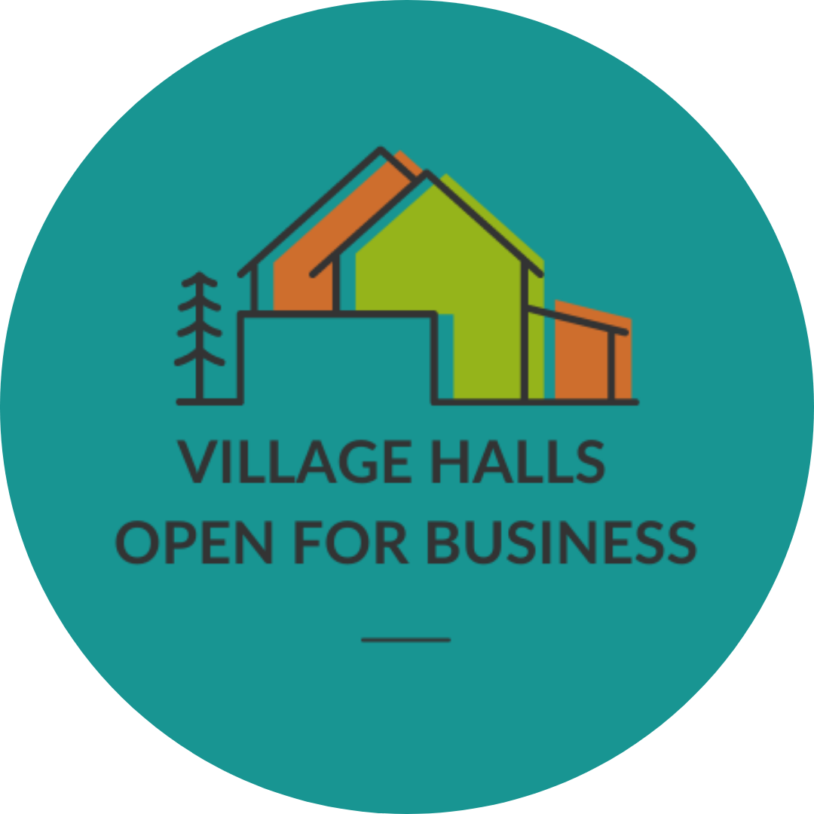
Named Village Hall
is open for business
To book this hall, call us on
Add number
Visit our website
Add website details

