Volunteer Reporting

To view your overall number of volunteers login into your dashboard, then click Reporting, then select Volunteer Report
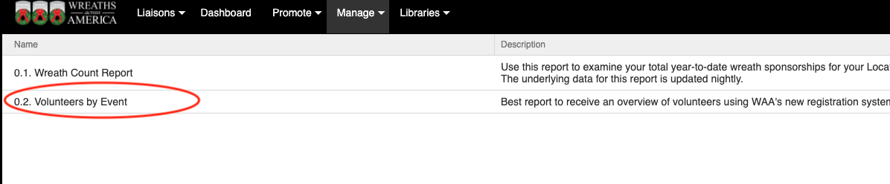
You will see an overall total for each event or get a breakdown of each individual event by selecting the event from the left hand menu.
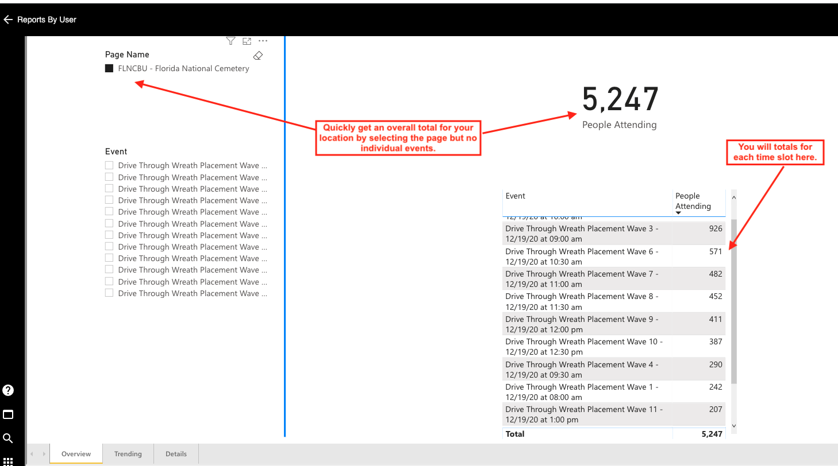
You can also view the details of the individual volunteers by clicking the detail tab. Reports can also be downloaded from this page by clicking on the 3 dots in the right hand corner and selecting export.
