Volunteer Management

These step-by-step instructions will help you learn how to view your volunteer list, send messages to volunteers, add volunteers, and delete volunteers.

To view your volunteer list, login into your dashboard, then click Manage, then Event Participants.

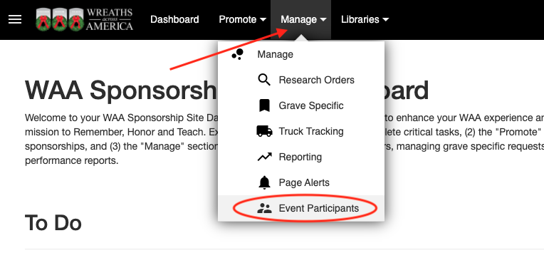

You will see a complete list of all the volunteers signed up for your event(s). 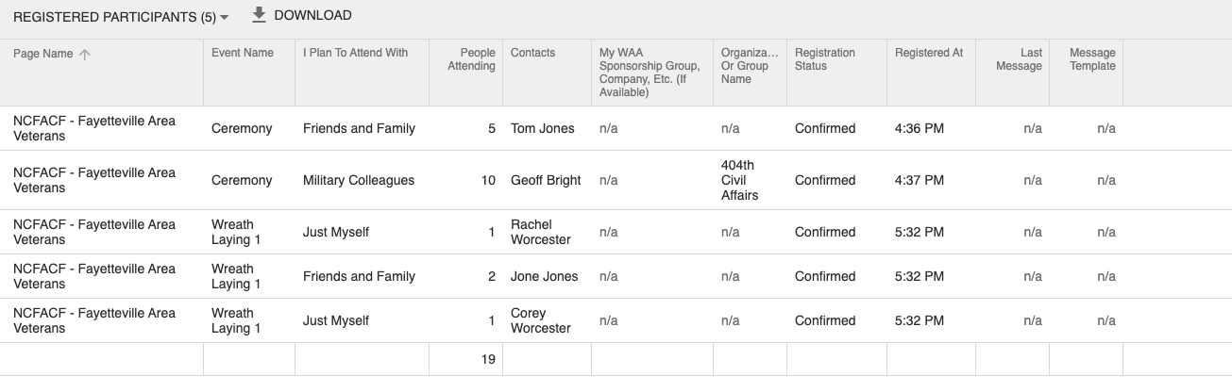

Each event that has been created for your location is listed under Event Name. If your location is staggering the wreath laying over a couple of days and/or times, you will see the Event Names vary slightly to make it easier for you to identify volunteers for a particular time slot. If your location simply has one event, that will be the only Event Name listed.

This report can be organized to your liking by clicking on any column and filtering the results. If you are looking for a specific volunteer name to edit their sign up or if you want to see how many volunteers are signed up for a specific event, this tool will be really helpful for you!

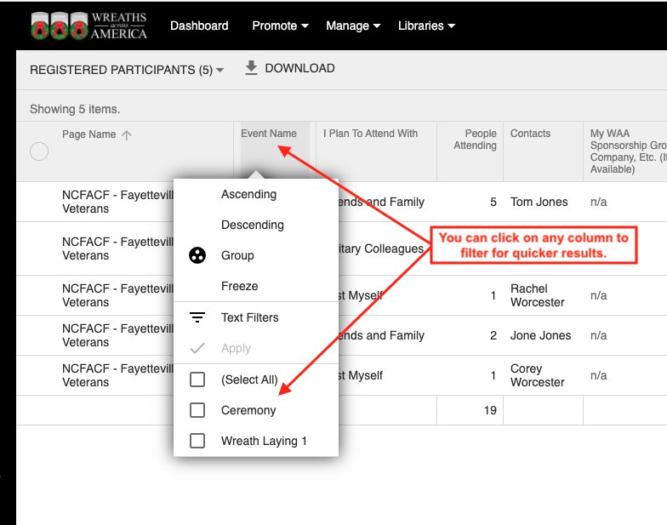

Clicking on the 3 dots next to any of the volunteers' names will bring up the menu where you can edit, delete, or message the volunteer.

**In order to completely delete a volunteer, you will need to do it at this level.
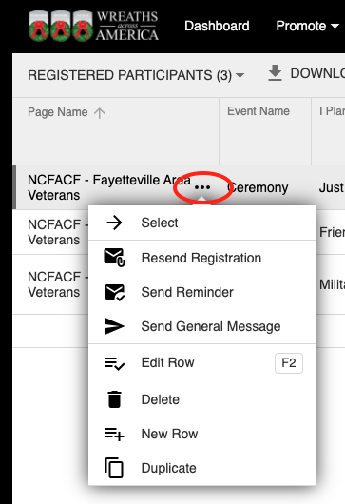
To send messages to your volunteers, there are a few options, all of which can be customized to your specific location.

Resend Registration = This is perfect to use if someone says they never received their confirmation and your location requires the receipt as a ticket for entry to the event.
Send Reminder = We recommend sending this a week or two prior to the event to remind them of the process, especially if they need to bring their receipt as a ticket for entry to the event.
Send General Message = This is perfect to use if you need to change plans or send specifics about the event at your location. It’s also a great way to reach out to people as you get closer to remind them to sponsor a wreath if they haven’t, so there are enough wreaths for every volunteer.

**Event info wildcard will pull in date, time, address and any special instructions set up for your event.

Each message can be customized, then when you click Save, it will become your new customized template. You can save a different message for each of your events, which will be great if you have different groups coming to each event (e.g Grave Specifics, Family Only, Public, etc).

** I always recommend sending a test first to see if everything is formatted correctly.
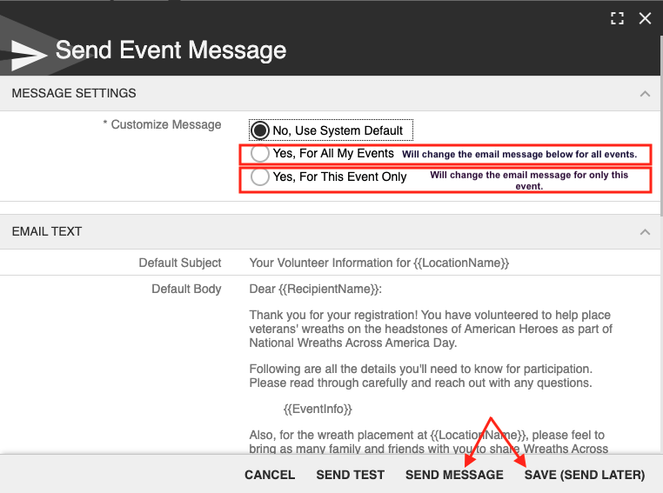

To Add A Volunteer to the list, best practice is to go to your public page and sign them up so that they receive the confirmation email and text, however, you can also manually add them by clicking on the black plus sign.

**This is helpful if someone verbally communicates with you that they are volunteering and you want to keep count of them.
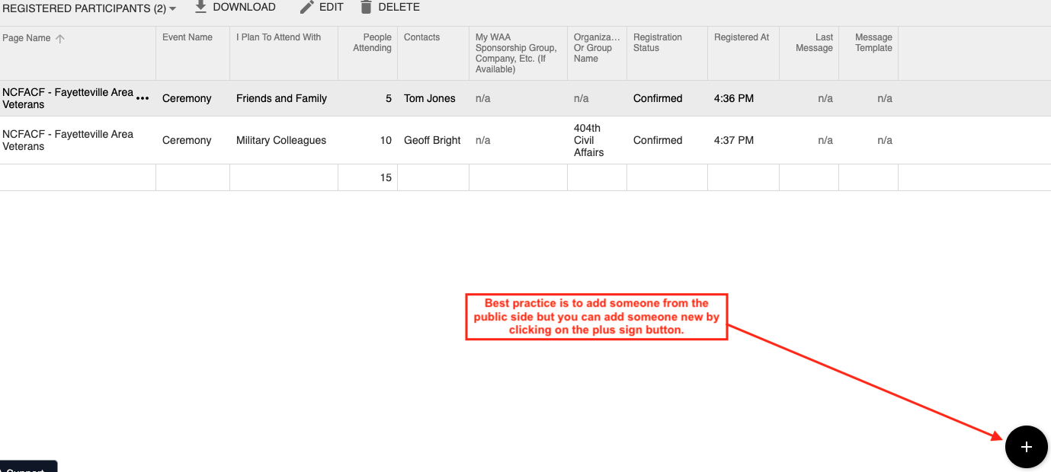
Next be sure to fill out each section and set the status as Confirmed, then click Save.
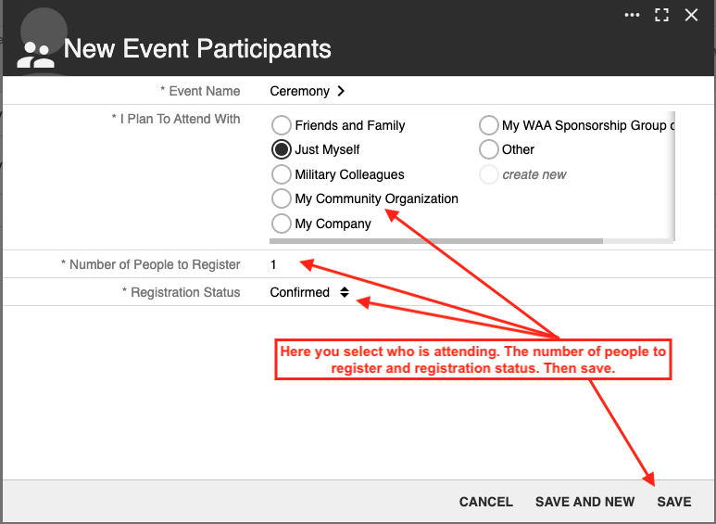

You can then either opt to just keep it as a number only or you can add their name and contact information. To add their contact info just click on + New and then fill out the requested information and click Save.

**Remember if you do not enter their contact information, they will not receive any messages.
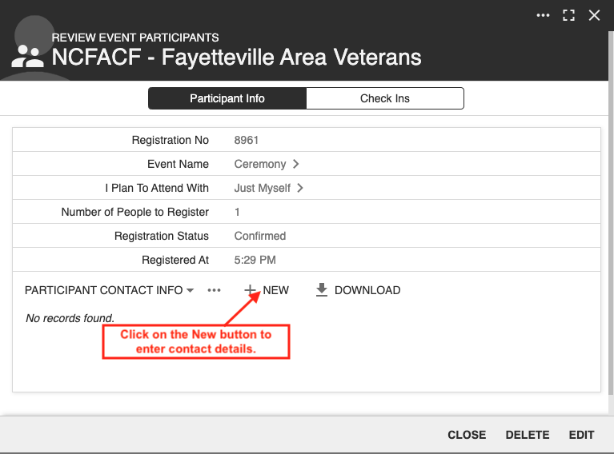

Editing the number in a party.

You will need to turn on Inline Editing to change the number. *We recommend turning it off when done as it is tricky to work with.
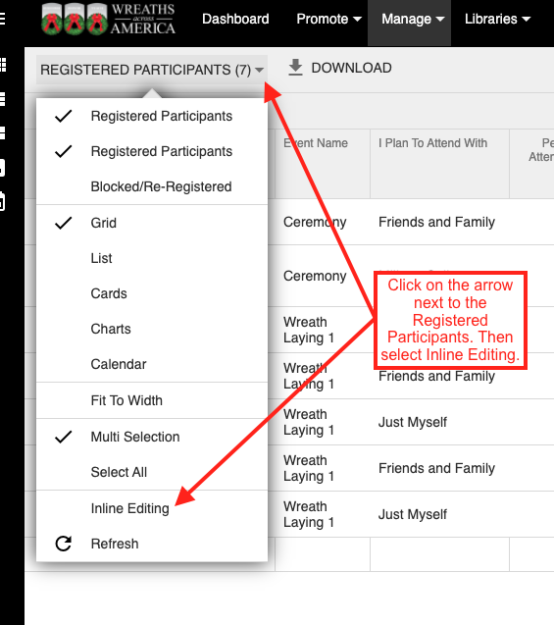

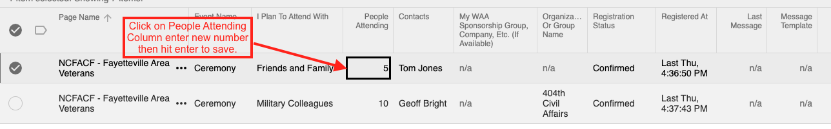
Remember if you need help just reach out to your liaison!

