Sending General Messages to Donors and Sponsorship Groups

Step 1: Click on Send Messages underneath Promote on your dashboard.
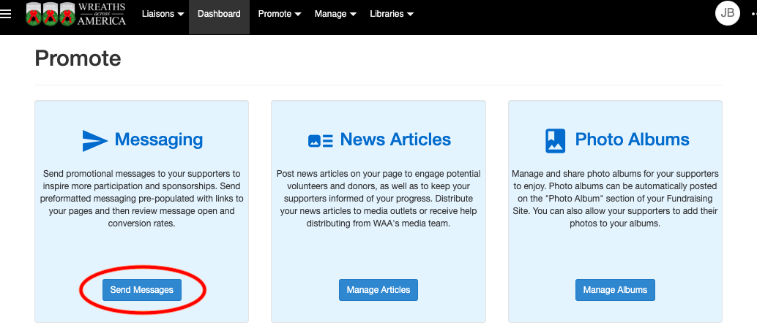

Step 2: Click on the paper airplane icon to Send a New Message.
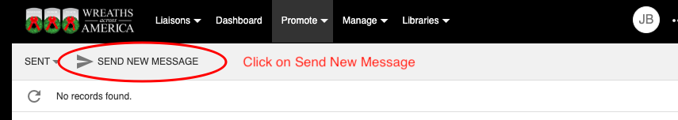

Step 3: Select which page your message is coming from.
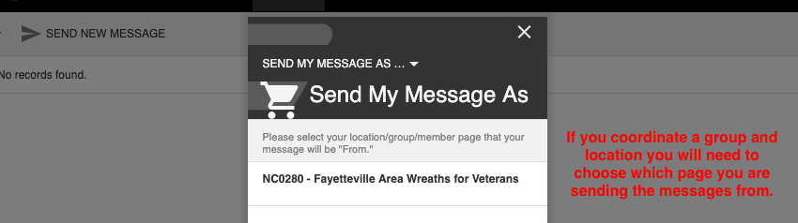

Step 4: Select the audience you want to send your message to.
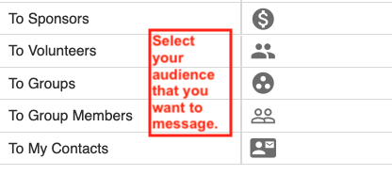

Step 5: Select the Message Template that you would like to use. Please note you can customize all of these messages, regardless of which template you select.
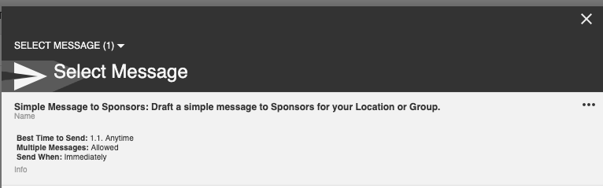

Step 6: Under the Preview tab, you will draft your message in the body section. You can access the font style changes by right clicking in the body section.
Note: Do NOT remove any words in {{double brackets}}. Those are “wildcards” that automatically pull information from the system into your message.
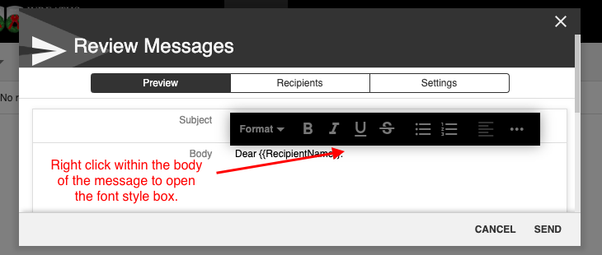

Step 7: Under the Recipients tab, you can choose to message previous or current year sponsors and registered sponsorship groups. To message volunteers, follow the directions in the next section below.
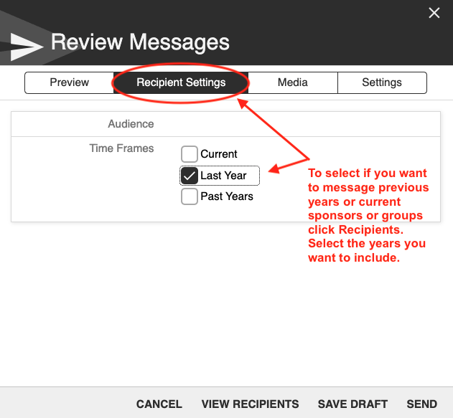

Step 8: Under the Settings tab, you can select to receive a copy of the message by toggling on Copy Sender.
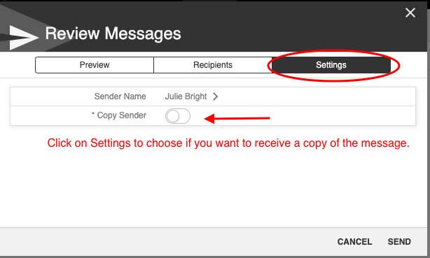
Step 9: Once you are finishing composing the message, click Send.
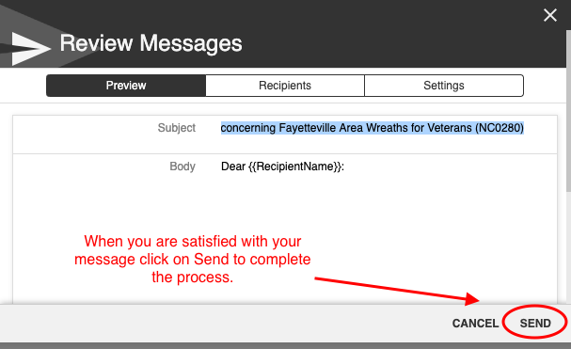

Sending Messages to Volunteers

To view a detailed report of all volunteers signed up for your event, go to Manage, then Event Participants. This report is only available for Location Coordinators because they are responsible for planning the logistics for the wreath laying ceremony.

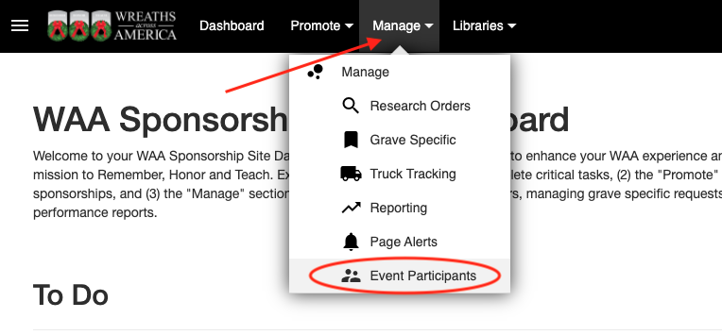

A complete list of all the volunteers signed up for your event(s) will be displayed. 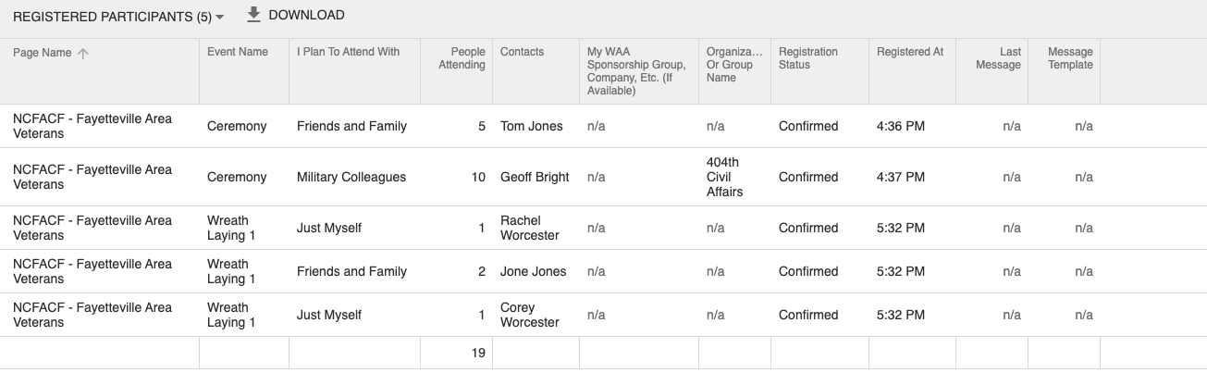

Each event that has been created for your location is listed under Event Name. If your location is staggering the wreath laying over a couple of days and/or times, you will see the Event Names vary slightly to make it easier for you to identify volunteers for a particular time slot. If your location simply has one event, that will be the only Event Name listed.

This report can be organized to your liking by clicking on any column and filtering the results. If you are looking for a specific volunteer name or if you want to see how many volunteers are signed up for a specific event, this tool will be really helpful for you!

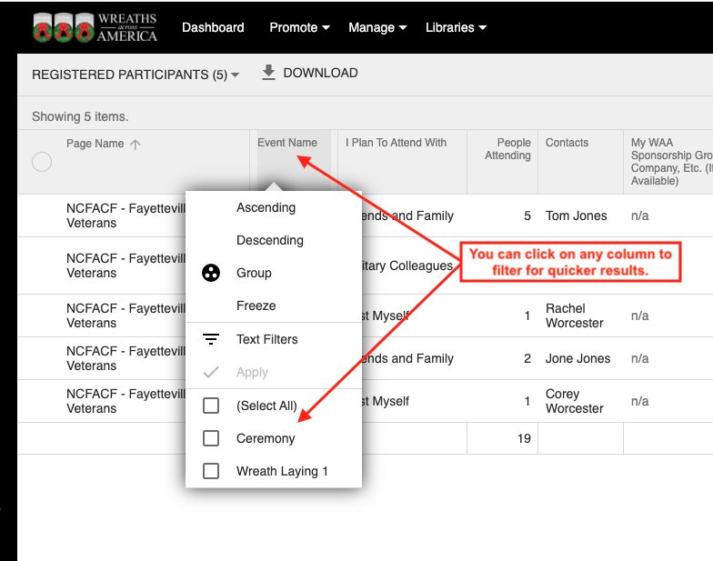

To edit a sign up or message a volunteer who has signed up for an event, click the 3 dots next to their name to bring up the menu where you can select your action.

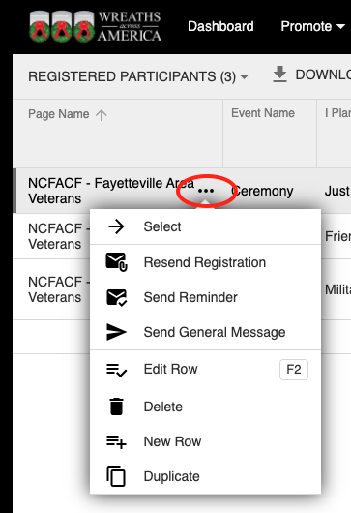

Messaging Event Participants

To send messages to your volunteers, select which template you would like to use:

- Resend Registration: This is perfect to use if someone says they never received their confirmation and your location requires the receipt as a ticket for entry to the event.

- Send Reminder: Send this a week or two prior to the event to remind volunteers of the process, especially if they need to bring their receipt as a ticket for entry to the event.

- Send General Message: Send this if you need to change plans or provide details about the event at your location. You may also consider using this as a way to reach out to volunteers, as you get closer to the Cutoff Date, to remind them to sponsor a wreath if they haven’t already, so there are enough wreaths for every volunteer.

Each message can be customized, then when you click Save, it will become your new customized template. You can save a different message for each of your events, which will be helpful if you have different groups attending each event (e.g Grave Specifics, Family Only, Sponsorship Groups, General Public, etc).

Note: Do NOT remove any words in {{double brackets}}. Those are “wildcards” that automatically pull information from the system into your message and autofill the date, time, address, and any special instructions already set up for your event.
** We recommend sending a test first to confirm that everything is formatted correctly. **
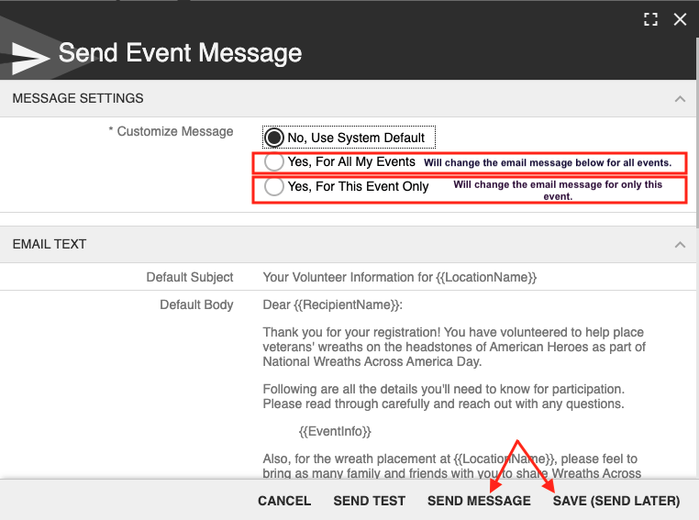

How to View Your Sent and Draft Folders

The Messaging portal is set up just like your standard email inbox. You have a Draft folder as well as a Sent folder. To view the messages in those folders, click the down arrow to the left of the paper airplane icon.

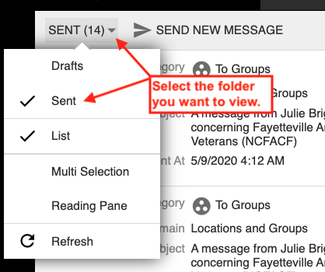

After a message has been sent, you can view its details by selecting it from your Sent folder. That’s where you will find the breakdown of the number of recipients, how many were delivered, the number that were opened, as well as any delivery errors. You can also view everyone who received the message by clicking on View Recipients.

