Join Us in Our Mission

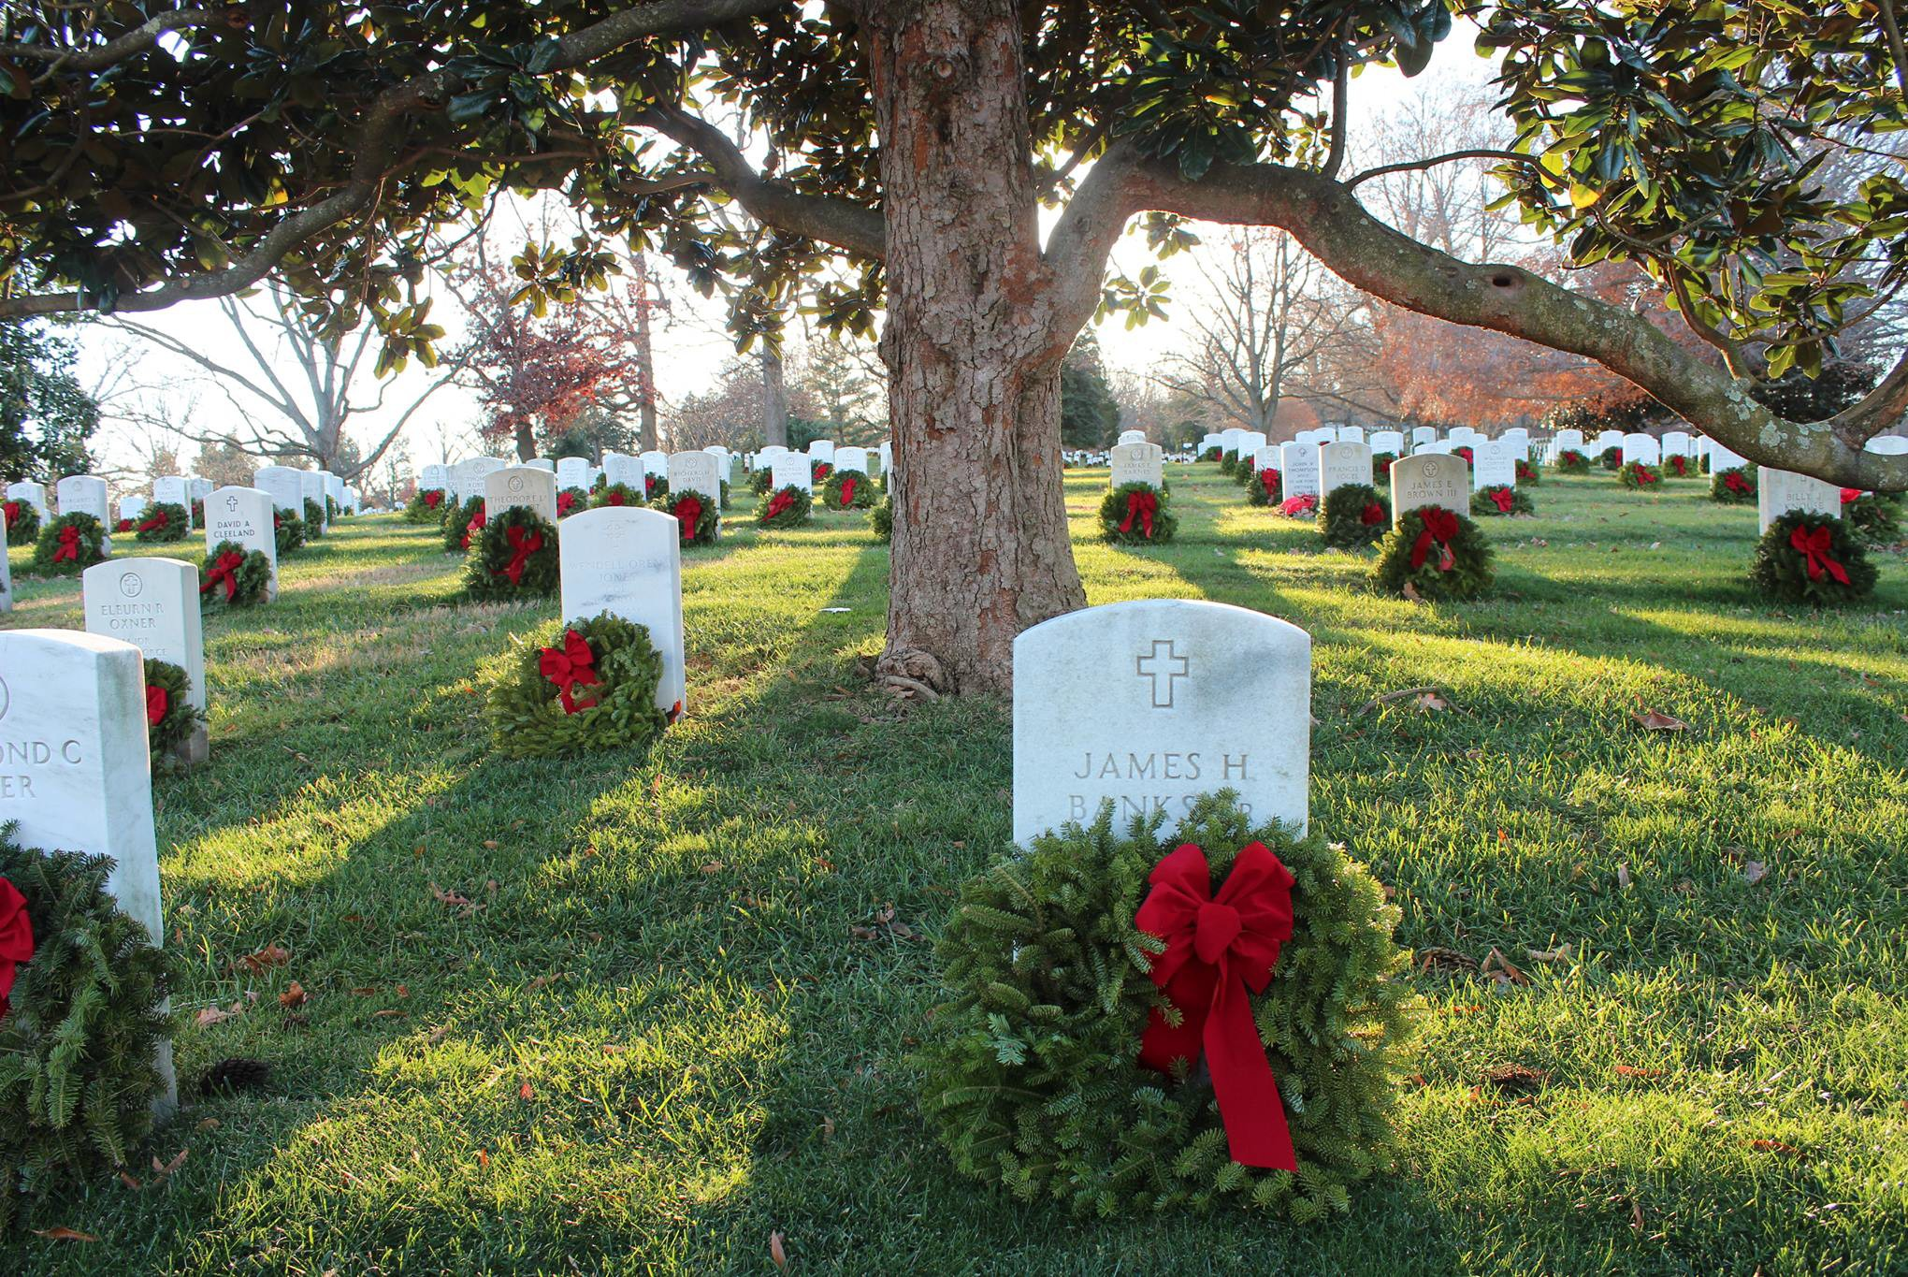

#FindAWay2022

Remember Honor Teach

**December 17, 2022**

National Wreaths Across America Day

Help the (Insert your group name here) honor local heroes!

Sponsor a wreath today to be placed on a veteran's grave this December at the (Insert your location name here).

Just scan the QR code to your right with your smart phone camera to make a donation online.

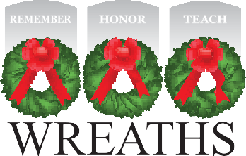

[www.wreathsacrossamerica.org](http://www.wreathsacrossamerica.org/)

