Let your clients know how you can support them with their
15 January provisional tax payment

Social Media / Newsletter – OPTION 1:
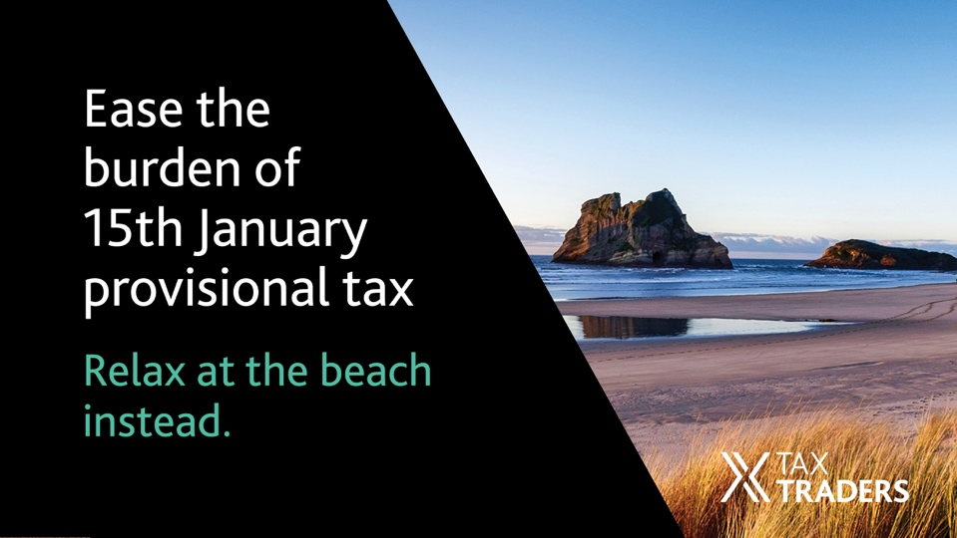
Tight cash flow in January? Provisional tax doesn’t have to be part of the problem.
Through our partnership with Tax Traders you can defer your 15 January 2022 provisional tax payment to as late as June 2023. It’s low-cost with rates typically under 4%, fully IRD-approved and no security or disclosures are required. It’s a great way to get some breathing space and keep cash on hand to support your business over the holiday period. We can get this underway for you in a matter of minutes. Talk to us to find out how easy it is.
[insert your firm’s contact info]
Social Media / Newsletter – OPTION 2:
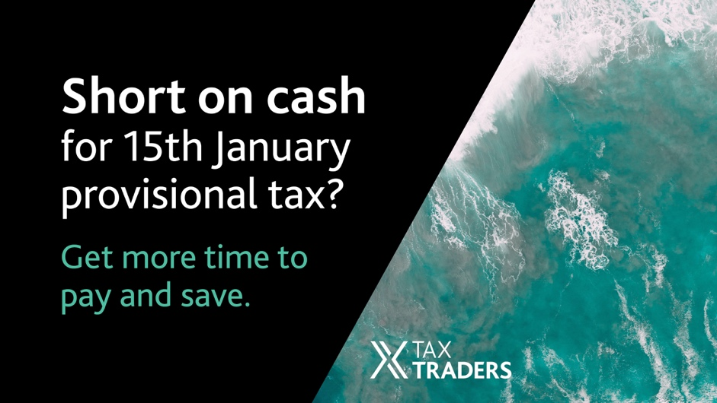
Take the pressure off your 15 January 2022 provisional tax payment, by delaying your payment by up to 15 months. With a financing arrangement through Tax Traders, you’ll eliminate IRD late payment penalties and save on use of money interest. It’s low-cost with rates typically under 4%, fully IRD-approved and no security or disclosures are required. We can set this up for you in minutes, so you can relax over the holiday period. Talk to us to find out how easy it is.
[insert your firm’s contact info]
EDM/Newsletter article:
Take the pressure off 15 January provisional tax
January can be a tight cash flow month for many businesses but provisional tax doesn’t need to be part of the problem. You can delay your provisional tax payment by up to 15 months and retain cash in your business for other priorities.
With a financing arrangement, you’ll eliminate IRD late payment penalties and save on use of money interest. It’s low-cost with rates typically under 4%, fully IRD-approved and no security or disclosures are required.
If you no longer need all the tax at the maturity date, there is no break fee and you only have to pay for what you need. If you want to repay early or pay by instalment, you can do that too.
We use Tax Traders – New Zealand’s most progressive tax pool – as the facilitator. They are an IRD-approved tax pooling intermediary and partner with us to help you access the greatest value.
We can set this up for you in minutes, so you can relax over the holiday period. Talk to us to find out how easy it is.
[insert your firm’s contact info]

Letter [on your firm’s letterhead]:
Dear [personalised name]
January can be a tough cash flow month, but provisional tax doesn’t have to be part of the problem.
Through our partnership with Tax Traders, you can defer your 15 January 2022 tax payment to as late as June 2023. It’s low-cost with rates typically under 4%, fully Inland Revenue-approved and no security or disclosures are required.
How does it work? Simply pay the interest up front and then pay your provisional tax at a maturity date of your choice up to 15 months later. The provisional tax is held for you in a Public Trust account at Inland Revenue and is transferred to your Inland Revenue account at maturity, once your provisional tax is paid.
If you no longer need all the tax at the maturity date, there’s no break fee, and you only have to pay for what you need. If you want to repay early or pay by instalment, you can do that too.
This is a great way to get some breathing space and keep cash on hand to support your business over the holiday period.
We can get this underway for you in a matter of minutes. Talk to us to find out how easy it is.
Kind regards,
[Partner name]

