Hey Neighbor!
I have an important message for you regarding New York’s Fastest Fiber-Optic Internet Provider, Greenlight Networks. Greenlight Networks is company founded in Rochester, NY that is building a fiber-optic network right to the home. Fiber-optic internet is faster and more affordable!
Building Greenlight's fiber network involves significant design, planning and construction work to lay hundreds of miles of new fiber-optic cable, which supports much higher data transmission speeds than traditional networks. Where they build and when is based on a number of factors including customer demand, cost and complexity of building the district, the number of easements and permits required, among other factors. If you’re interested in learning more about the construction of a fiber-optic network, read their "5 Steps to Fiber" blog today!
The best way to stay in the loop with the status of your district is by signing up on greenlightnetworks.com! The Greenlight team will communicate changes in your district as they progress with their construction. Make sure you are not left behind! For more ways to help spread the word and educate about Greenlight, click here!
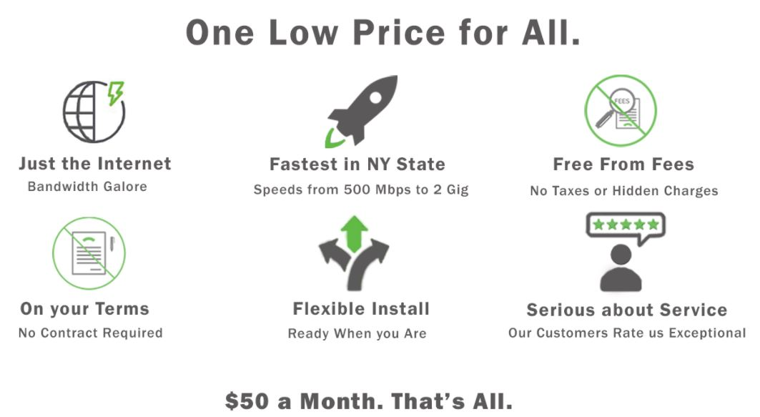

Sincerely,
(insert your name here)

