Hey Neighbor!
I have an important message for you regarding New York’s Fastest Fiber-Optic Internet Provider, Greenlight Networks. Founded in Rochester, NY Greenlight Networks is building a fiber-optic network right to the home in parts of Binghamton.
Building Greenlight's fiber network involves significant design, planning and construction work to lay hundreds of miles of new fiber-optic cable, which supports much higher data transmission speeds than traditional networks. Where they build and when is based on several factors including customer demand, cost, and complexity of building the district, the number of easements and permits required, among other factors. If you’re interested in learning more about the construction of a fiber-optic network, read their "5 Steps to Fiber" blog. Fiber-optic internet is faster and more affordable!
The best way to stay in the loop with the status of your neighborhood is by signing up on greenlightnetworks.com! The Greenlight team will communicate changes in your district as they progress with their construction. Make sure you are not left behind! For more ways to help spread the word and educate about Greenlight, click here!
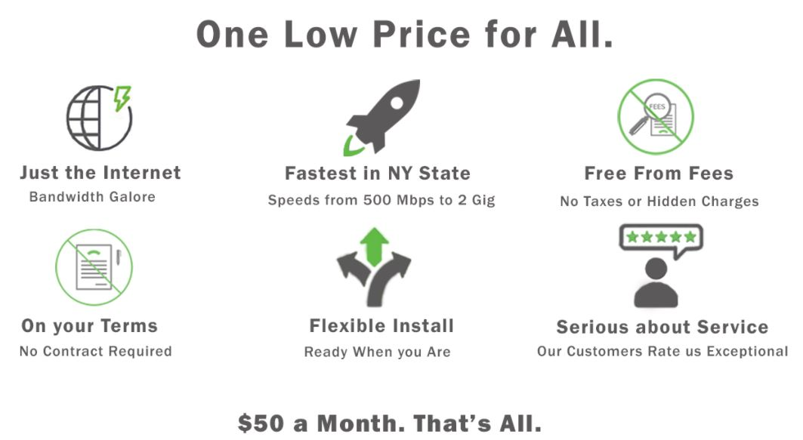

Sincerely,
(insert your name here)

