Sample survey questions to assess onboarding progress
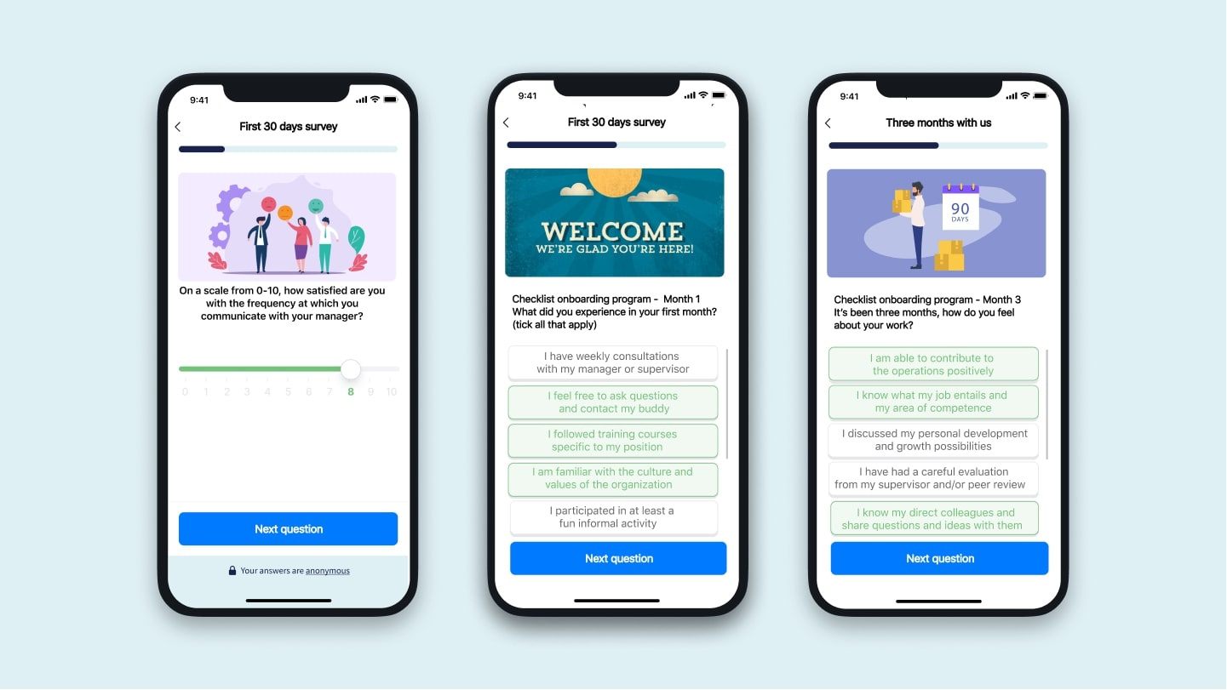

Checklist onboarding program - 1 month
What did you experience in your first month? (tick all that apply)
- I have weekly consultations with my manager or supervisor
- I feel free to ask questions and contact my buddy
- I followed training courses specific to my position
- I am familiar with the culture and values of the organization
- I understand how my role fits within the organization’s operation
- I participated in at least a fun informal activity
- Other: ………...

Checklist onboarding program - 3 months
It’s been three months, how do you feel about your work?
- I am able to contribute to the operations positively
- I know what my job entails and my area of competence
- I know my direct colleagues and share questions and ideas with them
- I have had a careful evaluation of the first three months from my supervisor and/or peer review
- I know all the basics, and I’m still learning to master my role
- I discussed my personal development plan and growth possibilities with the management
- I have participated in several informal activities
- Other: ………...

Checklist onboarding program - 1 year
- I can perform all tasks of my role in full autonomy
- I am familiar with the culture and core values of the organization
- I have strongly benefited from the contact with my buddy
- I can now be a buddy and mentor for a new colleague
- I can make an effective contribution to the organization
- I feel involved and engaged within the organization
- I am aware of the opportunities for growth within the organization and discussed my plan with the management
- Other: ….

