PERALTA COMMUNITY COLLEGE DISTRICT
District Academic Senate
District Academic Senate Meeting DRAFT MINUTES
February 15, 2022 – 2:30PM to 4:30PM
Zoom Link: https://cccconfer.zoom.us/j/9781680578

Present: VOTING – List full name below, identify which constituency group each individual represents (place X in box adjacent to name when present)

X | Donald Moore, DAS President, Laney | X | Matthew Goldstein, DAS Vice President, COA Senate President | X | Andrew Park, DAS Treasurer, COA Treasurer
X | Jennifer Fowler, DAS Recording Secretary, COA Senate Vice President | X | Matthew Freeman, BCC Senate President | X | Joseph Bielanski, BCC DAS Representative
X | Jeff Sanceri, COA DAS Representative | X | Eleni Gastis, Laney Senate President | X | Leslie Blackie, Laney Senate Vice President
X | Kimberly King, Laney DAS Representative | X | Thomas Renbarger, Merritt Senate President | X | Mary Ciddio, Merritt Senate Vice President
X | Lowell Bennett, Merritt DAS Representative

Guests: List full name below, identify which constituency group each individual represents (place X in box adjacent to name when present)

X | Inger Stark | X | Albert Maniaol | X | Becky Opsata
X | Stephanie Droker | X | Jennifer Shanoski | X | “Laney Library”
X | Nancy Cayton | X | Heather Sisneros

AGENDA ITEM | DISCUSSION | FOLLOW UP ACTION
- Call to order: Agenda review – (5 minutes) | Amendment to include College of Alameda Resolution on class caps as a discussion item. | Motion to approve the agenda as amended.  Moved by: Bielanski  Seconded by: Freeman  Motion Passed Unanimously
- Approval of minutes from previous meeting(s) – (5 minutes) |  | Motion to approve minutes from 2/1/22.  Moved by: Joseph  Seconded by: Leslie  Motion Passed Unanimously
- Public Comment – (3 minutes) | None
- Standing Items – (15 Minutes)

- Staff Development Officer Report, Inger Stark | Spring Flex well attended.  Dr. Stark would like 20 minutes on a future agenda to talk get feedback on tracking and reporting of professional development hours. We have an hourly professional development obligation that we currently do not track.  District wide mental health training was held last week.  Sabbaticals granted: 2 from Laney College, 1 from Berkeley City College, 1 from Merritt College, and 1 from College of Alameda.  Currently processing requests for column advancement.
- Treasurer’s Report, Andrew Park | ASCCC Spring Plenary April 7-9. Fill out Andrew’s interest form if you would like to attend online or in person. He will loop back with those that fill out the form and assist in filling out the District travel forms.
- CE Liaison Report, Leslie Blackie | The District CTE Committee is working on revising the committee makeup. Current draft below:  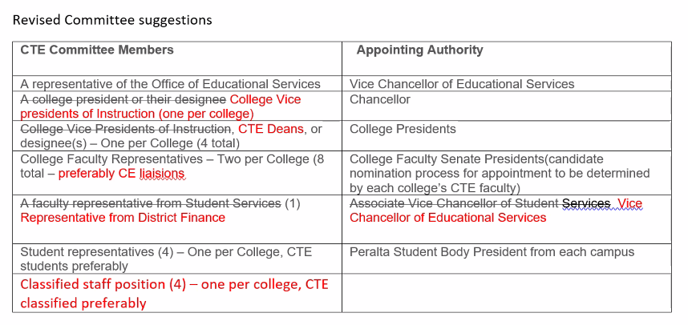  The committee also discussed ongoing confusion among faculty on allocations. There are concerns some CTE classes are being counting as grant funded classes from HERF funds last year. There is also confusion from the District Office trying to identify SAM coding and how those are funded and accounted for.
- DE Liaison Report, Director Maniaol | Honorlock discontinued last fall due to student privacy concerns. Respondus lockdown browser available this Spring on a trial basis.  Faculty expressed concerns about Repondus being implemented so late after the semester already started.
- CIPD | CIPD form updated. Discussed timeline for getting the changes through governance.
- For Discussion and/or Information – (40 minutes)
- Deputy Chancellor Stephanie Droker | No formal report but looks forward to engaging in conversation about the pending discussion items below.
- Estimating FTES for Fall 2022, determines allocation to colleges | President Moore: There is a lack of clarity around determination of FTEF allocations to colleges. Colleges are hearing there will be continued FTEF cuts next academic year.  Dr. Droker: There are different perspectives on how this is done. The Chancellor directed College Presidents to send information on FTEF cuts to the VPIs and to disseminate across the college.  Questions were raised about where the decision around class cuts came from. Faculty expressed concerns about the radical downsizing without an enrollment management plan. It is not clear how the class cuts lead to strategic enrollment.  There is ongoing criticism about relying heavily on productivity. The District projects next year’s FTES target based on previous years we never met the target. You can’t set a productivity target and expect it to be met without having a negative impact on the number of classes offered to students.  There were calls to not look at cutting to save costs, but the impact of the cuts in terms of revenues in terms of apportionment and tuition dollars. Our apportionment has been stable. We are cutting classes and saving on FTEF, but we are spending that money elsewhere.  There is also discussion that the Governor will continue to extend hold harmless, and that the “fiscal cliff” the district continues to tout will be the new fiscal floor. If we will be getting more revenue, it does not make sense to cut at all. We cannot cut our way out of a downward spiral—at what point do we stop cutting faculty?
- Frozen Faculty Positions | Chancellor and Cabinet make decisions about what positions would be hired and frozen. Make sure this issue about FTEF does not go away.
- COA Resolution on Class Caps | Main point of the resolution: Reiterate class sizes are a pedagogical issue. At Peralta class sizes are largely decided by fire code. Faculty should have more say in what class caps are best for their courses. Proposed DAS Action Item on March 1. | Motion: Send a formal email to the Board President and Chancellor Jackson on the most recent FCMAT corrective matrix.  Moved by: Gastis  Seconded by: Bennett  Motion passed unanimously.
- Return to Campus | There are still some concerns about the lack of presence of people at check points. When administration was consulted, they felt attempts by management to reach out to students were adequate.
- New Business/ Announcements | Let Andrew if you want to go to plenary. Apply for the scholarship.
- Next Meeting | March 1, 2022
- Adjournment | Meeting adjourned at 4:35pm.

Abbreviations:
- DAS – District Academic Senate
- PCCD – Peralta Community College District
- BOT – Board of Trustees
- DAC – District Administrative Center
- AP – Administrative Procedure
- BP – Board Policy

Title 5 §53200 DEFINITIONS [Source: http://www.asccc.org/communities/local-senates/handbook/partI. Retrieved 10/28/11.]
Academic Senate means an organization whose primary function is to make recommendations with respect to academic and professional matters.
Academic and Professional matters means the following policy development matters:
1. Curriculum, including establishing prerequisites.
2. Degree and certificate requirements.
3. Grading policies.
4. Educational program development.
5. Standards or policies regarding student preparation and success.
6. College governance structures, as related to faculty roles.
7. Faculty roles and involvement in accreditation processes.
8. Policies for faculty professional development activities.
9. Processes for program review.
10. Processes for institutional planning and budget development.
11. Other academic and professional matters as mutually agreed upon.
Consult collegially means that the district governing board shall develop policies on academic and professional matters through either or both of the following:
1. Rely primarily upon the advice and judgment of the academic senate, OR
2. The governing board, or its designees, and the academic senate shall reach mutual agreement by written resolution, regulation, or policy of the governing board effectuating such recommendations.
§ (SECTION) 53203 POWERS
A) The governing board shall adopt policies for the appropriate delegation of authority and responsibility to its college academic senate.
B) In adopting the policies described in section (a), the governing board or designees, shall consult collegially with the academic senate.
C) While consulting collegially, the academic senate shall retain the right to meet with or appear before the governing board with respect to its views and recommendations. In addition, after consultation with the administration, the academic senate may present its recommendations to the governing board.
D) The governing board shall adopt procedures for responding to recommendations of the academic senate that incorporate the following:
1. When the board elects to rely primarily upon the advice and judgment of the academic senate, the recommendation of the senate will normally be accepted, and only in exceptional circumstances and for compelling reasons will the recommendations not be accepted.

