The Insides TM Tube Insertion – Work Instruction
Before using this document, thoroughly read The InsidesTM System Setup Guide and The Insides™ System Instructions and Technical Description.
This work instruction is to act as a visual prompt and reminder of the key tasks, but does not contain all the necessary information.
- Prepare the workstation.

- Gloves
- Lubricant
- Scissors
- Ostomy appliance

- The InsidesTM Tube
- The InsidesTM Pump

Prepare the InsidesTM Tube.

Pull the retention sleeve towards the base of the tube, over the lubricant. Then pull it forwards towards back over the lubricant towards the bulbous end. Repeat until the retention sleeve moves freely.
Lubricate the tube on both sides of the retention sleeve using 10-20 mL of water-based lubricant.

Lubricate the bulbous section of the Tube.

Ensure the guidewire sits in the tip of the bulbous feature.

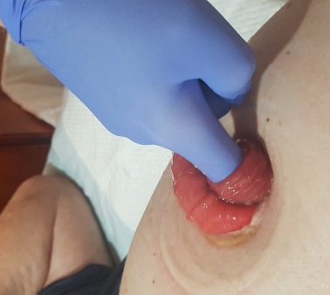

- Digitally palpate the distal intestine to determine if the tube is suitable, and the direction and distance to the fascia.

- Prepare the Tube for insertion.
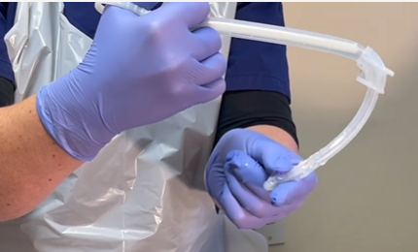
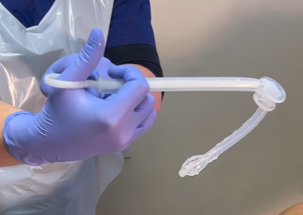

Pinch the bulbous feature and roll it between your fingers to further collapse the tube. ENSURE THAT THE GUIDEWIRE REMAINS WITHIN THE TIP.
Collapse the bulbous feature of the tube by inserting the guidewire until the base of the tube touches the stop of the guidewire. Pinch the guidewire through the tube to maintain the position.

- Insert the tube and apply gentle pressure until the bulbous features is 10-20mm past the abdominal fascia.

- Hold the retention sleeve to keep the tube in place and remove the guidewire.

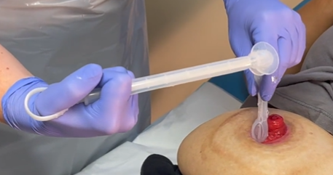
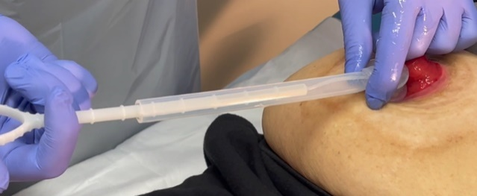

- Allow the tube to settle in its natural position then move the retention sleeve so it sits 1-2 mm away from the stoma.

- If using a 2-piece ostomy appliance, thread the baseplate over the tube and secure it in place.

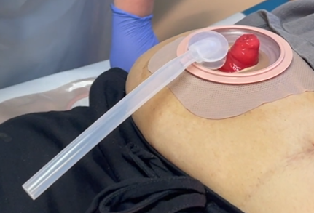
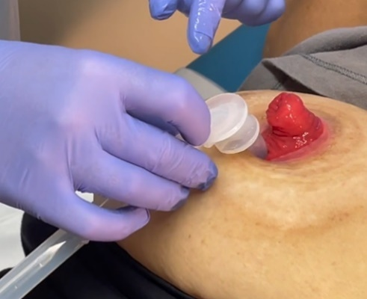

- Hold the Ostomy appliance against the tube and pump to determine the appropriate length of tube.

- Trim the tube to the desired length.

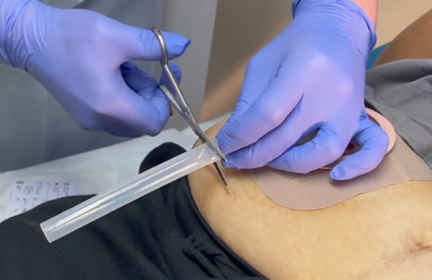
- Connect the Pump to the Tube. The Pump should be pressed up to the third ring of the pump.

- Remeasure the ostomy appliance against the Tube and Pump to ensure there is 10-20 mm clearance from the bottom of the pump to the bag.

- Carefully place the Tube and Pump into the ostomy appliance and secure it in place.

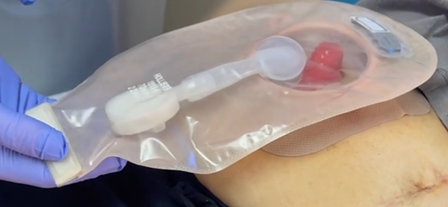
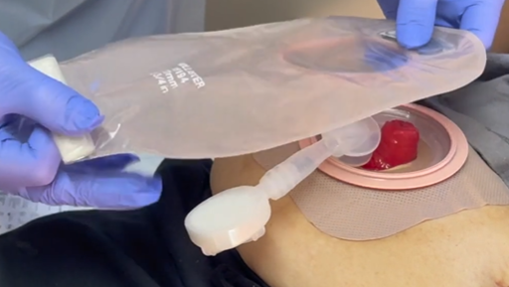
10-20 mm

