**Student Email Template**

Hello [**INSERT STUDENT FIRST NAME HERE**],

Awesome news - CircleIn is officially LIVE for [**TERM/SEMESTER**]!

[CircleIn](http://circleinapp.com) is a virtual student community we have just for you and your peers. CircleIn helps you connect with your classmates and stay on top of your academic goals while giving you the chance to earn rewards by helping your peers!

[**Hear what students have to say about CircleIn**](https://vimeo.com/542142466)

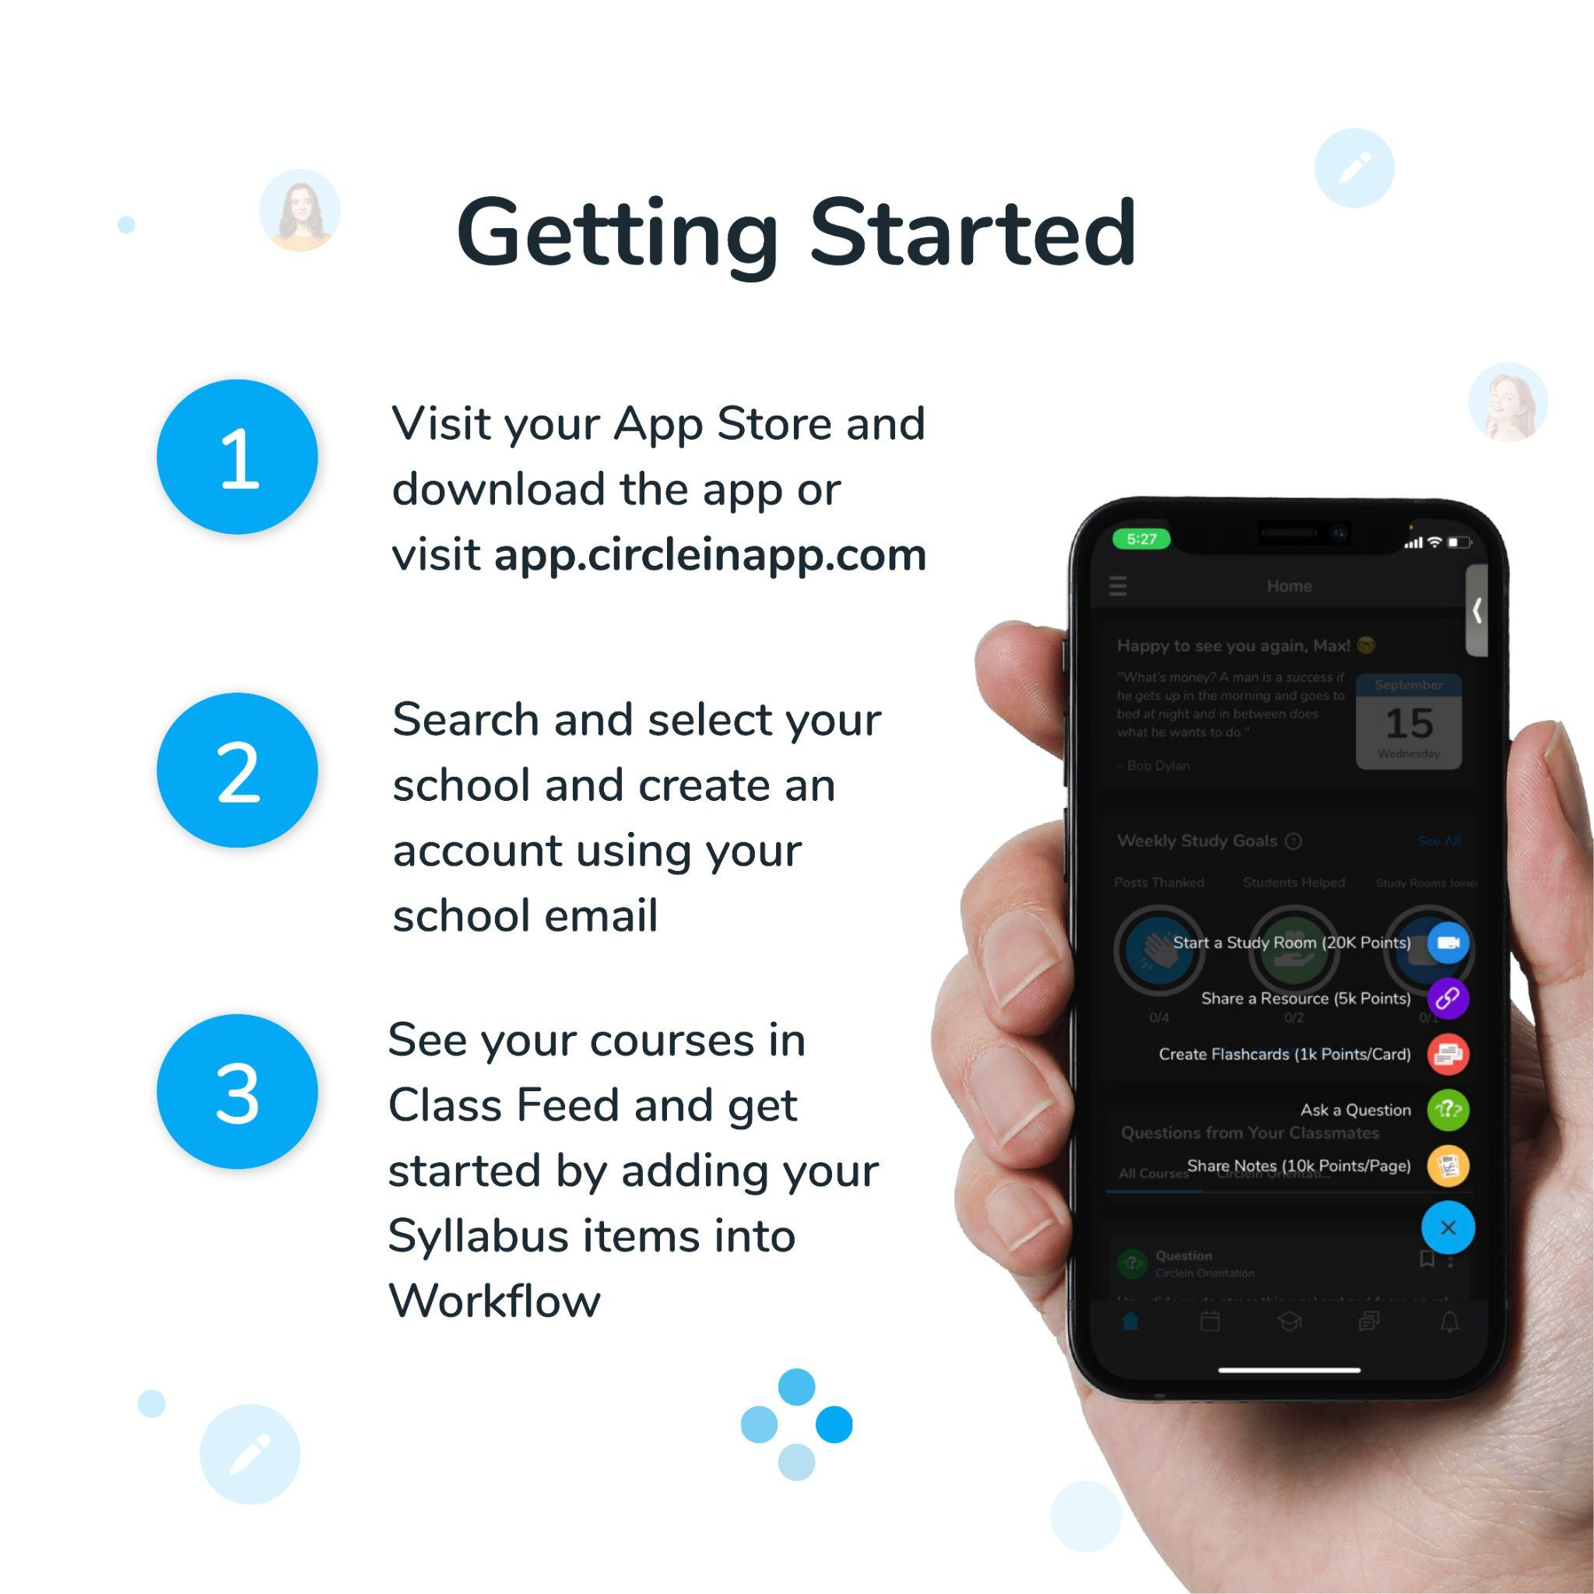

Once you’ve logged in, you’ll be instantly connected with all of your classmates and will have access to multiple studying features, all in one place, that will help you stay productive and succeed.

Make sure to let your classmates know about this new and exciting opportunity!

Want to learn more? Click [here](http://circleinapp.com) to visit the CircleIn Website.