

**CRISIS MANAGEMENT MANUAL**

**2022**



**Introduction**

Ohio Living is pleased to present this Crisis Management Manual. It has been designed to help our life plan communities, Ohio Living Home Health & Hospice and Ohio Living Foundation staff proactively deal with crisis situations when they occur. The crisis management manual and the corporate crisis support team are an addition to the procedures that you would ordinarily do in a crisis situation.

The corporate crisis support team has been formed to provide support in crisis management and communications with media, all staff, residents, patients, their families and other stakeholders to facilitate a timely, positive outcome and to ensure seamless continuity in day-to-day operations.

It is important to remember that the degree to which our organization effectively responds to a crisis affects our relationships. With this in mind, it is clear that an effective crisis management plan is critical to this organization. It is also important to note that a crisis management plan is not an emergency preparedness communications plan, but rather, a plan that should be used in conjunction, should the need arise, with an emergency preparedness communications plan.

However, since not every crisis is a disaster, the plan should function on its own, as well.

# **Anticipating a Crisis**

No organization can prepare for every contingency, but a crisis management plan that includes basic procedures will help us should a crisis occur. Strong organizational values, clear policies, a set of known procedures, and a readiness to act quickly will make the difference in how effectively our organization handles the situation and how our organization is perceived thereafter.

The following item should be addressed before a crisis ever happens. Careful attention to this detail will help us respond effectively to a crisis  keep an updated list of pertinent staff phone numbers, including home numbers, cell phone and pager numbers both at the office and at home.

# **Identifying a Crisis**

A crisis can be anything that generates negative perceptions about our organization/industry. Perception is reality. How our organization is perceived is the reality of our organization's image. Any event that is not dealt with effectively in a timely manner is a potential crisis and more damaging in the future.

**A crisis can be local and specific to our organization**.

Some examples include:

* Physical/emotional abuse of a resident or patient
* Significant injury, dismemberment and/or death
* Financial stability and integrity of our organization
* Misrepresentation of facts
* Emergency facility or physical plant problems
* Fire & evacuation emergencies
* Alleged food borne illnesses

**A crisis can be either an emergency or a controversial issue**.

Emergencies include:

* Threats to the physical wellness of the organization including natural disasters, fires, bomb threats, lack of heat or air-conditioning etc.
* Other emergencies include resident/patient abuse, criminal acts, suspicious death, outbreak of infectious disease, etc.

**Also recognize that emergencies can result from workplace violence, workplace safety and other situations that can adversely affect an organizations reputation.**

**A crisis can be a national issue or an issue specific to older adults.**

Negative and misleading media reports on issues affecting the elderly have become commonplace. In recent years, several television exposes have been released documenting abuse of the elderly in long-term care facilities, financial mismanagement, etc. These issues, although not targeting our organization specifically, paint a negative image of our organization and should be treated as a crisis. Having a plan to deal with this negative publicity is essential. Examples include: nursing home quality, Medicare and Medicaid issues, abuse and neglect, Medicare D drug benefits for seniors, and hypothermia/heat-related problems with the elderly.

**Ohio Living**

**Crisis Management Manual**

**Table of Contents**

**Section 1…………………………..…………………….……….Notification and Emergency Call List**

**Section 2 ………………………………………………………………….. First Response Action Steps**

**Section 3 …………………………………………….…………………………. Incident Report Forms**

**Section 4 ……………………………………………………...…………Corporate Crisis Support Team**

**Section 5………………………………………Local, State and Federal Required Reporting Forms**

**Section 6……………………………….………… State of Ohio Emergency Management Agencies**

**Section 7…………………...…………………………………….………………Post-Incident Analyses**

**Section 8………………...…………….…………………………….……………………..…Appendices**

**Appendix i ……….……………………………….……… Crisis Communications Resources**

**Appendix ii ………………….…………………………………Crisis Communications Forms**

**Appendix iii ………….……………………………………….…………Spokesperson Training**

**Appendix iv ………………………………………….…Environmental Emergency Response**

**Appendix v ………………………………………………..……..…………….Lessons Learned**

**Section 1**

**Notification**

**and**

**Emergency Call List**

**Local Crisis Notification** **Staff List**

1st Shift (Insert names):

1.____________________________________________________Executive Director

2._______________________________________________________Administrator

3.___________________________________________________Director of Nursing

4.__________________________________________Environmental Services Director

2nd and 3rd Shift (Insert names):

1. ______________________________________________Supervisor/Charge Nurse
2. ________________________________________________Security/Maintenance
3. ____________________________________________________On-Call Manager

##### 

##### **On Call Managers** **for All Emergencies**

|  |  |  |
| --- | --- | --- |
| Name | Home Phone | Cell Phone |
|  |  |  |
|  |  |  |
|  |  |  |
|  |  |  |
|  |  |  |
|  |  |  |
|  |  |  |
|  |  |  |

|  |  |  |  |
| --- | --- | --- | --- |
| **Cell and Home Phone Numbers** | | |  |
| **Executive Team, Corporate Office Team, Ohio Living Communities Executive Directors, Ohio Living Home Health, Hospice, & Palliative Medicine Executive Directors, and Ohio Living Physician Services Executive Director** | | | |
|  | |  | |
| **Name** | **Cell Number** | **Home Number** | |
| **Executive Team** | | | |
| Larry Gumina, Ohio Living CEO | 614.230.7171 | 614.230.7171 | |
| Dan Ginis, CDO Foundation | 614.205.8803 | 614.864.5638 | |
| Leslie Belfance, Division Executive South | 330.414.7904 | 330.250.9914 | |
| Dean Palombaro, Division Executive North | 330.550.9986 | 330.550.9986 | |
| Wendy Price-Kiser, Division Executive HHH | 419.367.9784 | 419.878.8393 | |
| Mica Rees, Chief Brand & Growth Officer | 740.508.7253 | 740.508.7253 | |
| Bob Stillman, CFO | 614.266.7870 | 614.266.7870 | |
| Dana Ullom-Vucelich, CHRO | 614.579.4604 | 614.431.2557 | |

|  |  |  |
| --- | --- | --- |
| **Corporate Office Team** | | |
| John Andrews, Div. Dir., Culinary & Nutritional Services | 614.205.8806 | 614.717.0732 |
| Matt Cheuvront, Corporate Executive, Information Technology | 614.581.1835 | 614.581.1835 |
| Lauren Mathis, Executive Asst. (CEO Office) | 740.816.7224 | 740.816.7224 |
| Darla Gore, Division Manager, Project Coordination | 614.975.0410 | 614.475.2711 |
| Michael Grimes, Div. Dir., Clinical Operations (South) | 740.461.4462 | 740.461.4462 |
| Jennifer Howell, Corp. Exec. Talent Management | 614.581.8851 | 614.581.8851 |
| Belinda Jones Sr. Clinical Systems Analyst | 614.284.6239 | 614.284.6239 |
| Alisa Miller, Corporate Executive of Creative Services | 214.542.9011 | 214.542.9011 |
| Cindy Ohms, Division Director, HH & H | 419.310.1256 | 419.310.1256 |
| Tammy Raybuck-Gavin, Div. Dir. Clinical Operations (North) | 440.477.4874 | 440.477.4874 |
| Bill Renner , Corporate Executive, Operational Planning & Analysis | 740.438.5280 | 614.833.6853 |
| Mark Roberts, Corporate Executive, Project Development | 614.205.8811 | 614.899.9512 |

|  |  |  |
| --- | --- | --- |
| **Ohio Living Communities Executive Directors** | | |
| Aric Arnett (OLSM) | 614.402.4847 | 614.402.4847 |
| Tricia Atwood (OLDL) | 937.538.0384 | 937.538.0384 |
| Julie Bauman (OLBV) | 440.645.7957 | 440.645.7957 |
| Kara Hanzie (OLRN) | 330.714.3079 | 330.899.1979 |
| Stan Kappers (OLMP) | 513.460.1839 | 513.477.7822 |
| Brian Kolenich (OLLV) | 330.881.8693 | 330.881.8693 |
| Sydney McBride (OLWT) | 513.285.2152 | 513.285.2152 |
| Tim Phillips (OLSC) | 937.538.0188 | 937.552.7631 |
| Brad Reynolds (OLCM) | 614.361.4602 | 614.361.4602 |
| Ann Roller (OLLT) | 937.538.0188 | 937.538.0188 |
| Paul Shaw (OLVC) | 419.341.1146 | 419.707.3394 |
| Sarah Thompson (OLQH) | 937.260.0234 | 937.260.0234 |

|  |  |  |
| --- | --- | --- |
| **Ohio Living Home Health, Hospice, & Palliative Medicine Executive Directors** | | |
| Rebecca Dasse (Greater Columbus) | 614.205.2403 | 614.205.2403 |
| Ben Fishback (Village) | 937.416.1958 | 937.416.1958 |
| Becky Grunden (Palliative Medicine) | 419.345.3978 | 419.345.3978 |
| Sarah Hadley (Greater Youngstown, Greater Cleveland) | 330.980.2396 | 330.980.2396 |
| Larry McCoy (Greater Toledo) | 419.276.1088 | 419.276.1088 |
| Kalee Scheer (Greater Cincinnati/Dayton) | 937.726.9864 | 937.726.9864 |
| Danelle Villers (Greater Akron) | 330.858.7982 | 330.858.7982 |

|  |  |  |
| --- | --- | --- |
| **Ohio Living Physician Services Executive Director** | | |
| Michelle Olson | 419.654.0269 | 419.654.0269 |

**Section 2**

**First Response**

**Action Steps**

First Responders to Scene

1. Follow appropriate incident and/or emergency preparedness communications plan, policy and procedure
2. Call 911 when emergency situation warrants
3. Secure area
   1. Don’t let anyone into the secured area
   2. Tape off area or lock door
   3. Station a guard for the area to prevent unauthorized access
4. If the danger is ongoing, and further actions are needed to make the conditions safe or secure:
   1. Decide if the area needs to be evacuated
   2. Decide if personal protective equipment is required, e.g., goggles, masks, gloves, and respirators
5. Speak directly with the most senior manager from the on call emergency staff list (section 1 of this manual) for directions regarding further communications needed, i.e. police, ambulance. It is preferable to OVER COMMUNICATE with internal management – don’t worry about bothering anyone!
6. Obtain from police and other emergency responders ASAP:
   1. Business cards or names of responders
   2. Where the injured party(s) were taken
   3. A copy of their reports (may take several days-keep requesting)
7. Start Incident Protocols (Manuals are located at the front desk, at the nurse’s station or on the intranet under Emergencies.)
   1. Note time incident reported or observed and each action step taken on an incident report and/or complete the “Person of Interest” form (forms are in Section 3 of this manual)
   2. Ask each witness to complete a written statement.
   3. Give the completed forms to the crisis support team when they arrive

Activate The Internal Communication System

1. The senior manager will contact:
2. The Ohio Living Communities and Ohio Living Home Health & Hospice COO within ***60 minutes*** of the notification of the crisis
3. The next person on the emergency call list to initiate the call tree
4. Additional staff members and/or other stakeholders as necessary

**Actions Prior to the Corporate Team Arrival**

1. Set up a command center in advance of the arrival of the corporate team
2. All verbal and written communication will go through the command center
3. The room should be large enough for 5 to 10 people, accommodate phone service and have an Ohio Living network connection.
4. The command center should have close access to a copier with scanning capability. All copying will be controlled from this area
   * 1. One person will be responsible for all copies requested by outside agencies
     2. Three copies will be needed
        1. One for our records
        2. One copy to legal
        3. One copy to requesting party after communication team approves release
5. Continue to collect information for incident protocols packet or pick up incident packet from first responders
6. Secure additional witnesses statements
7. Collect additional information as needed
8. Assign staff to take photos as needed to support documentation
9. Secure the site
10. In an event that will require security of a location or site: Station staff at the entrance of the location or building directing non-essential staff, residents, clients, visitors or media to a pre-determined area
11. Provide the “Sample Notice to Receptionists Form” found in Appendix ii to all receptionists and staff who might receive an external phone call
12. As necessary, provide a barrier to restrict access using caution tape or other means
13. The security staff should use the following statements during an emergency:

“Due to an unexpected emergency, we are requesting that you proceed to _________ where you will be briefed on the situation as more information is available.”

1. Set up an area for media to use
2. Ideally the chapel, however a room closest to an entrance (not the main entrance) should be set up for the media. This will be the room that will be used for interviews so appearance will be important to portray the community or location in the best light.

Sample Notice to Receptionists

As most of you probably already know –

Local media is sometimes interested in finding out more information to create stories after an unfortunate incident as happened here yesterday.

For example – often the person calling will lead you into confirming a situation by saying, “I understand that your resident/client, (name), (states what he or she thinks happened). At that point the caller is looking to create a story based upon your responses. To avoid being put in that uncomfortable and problematic position, please refer to the guide below.

**Response to Media Inquiries Regarding Crisis Situations**

Please follow the response steps below:

1. **“Our Executive Director __________________ may be able to help you, let me try and connect you”. At that point, immediately pass on the call to ______. If ______ is not immediately accessible, please refer the call to ______.**
2. **If neither ______ or ______ are available, respond to the caller by saying, “I’d be happy to take your name and number and ask ______to call you back. What is your deadline for information? I will give him that information. Thank you for calling”. End the call.**
3. **Record information about the call on the form we have provided.**

Should a camera crew or reporter arrive unexpectedly at your desk, insist that they wait until you notify **______** or **______**. Should you need assistance in keeping them in place call **______**for help. The media is *not* free to interview residents, clients or employees within the confines of your community since it is a private residence.

**Section 3**

**Incident Report**

**Forms**

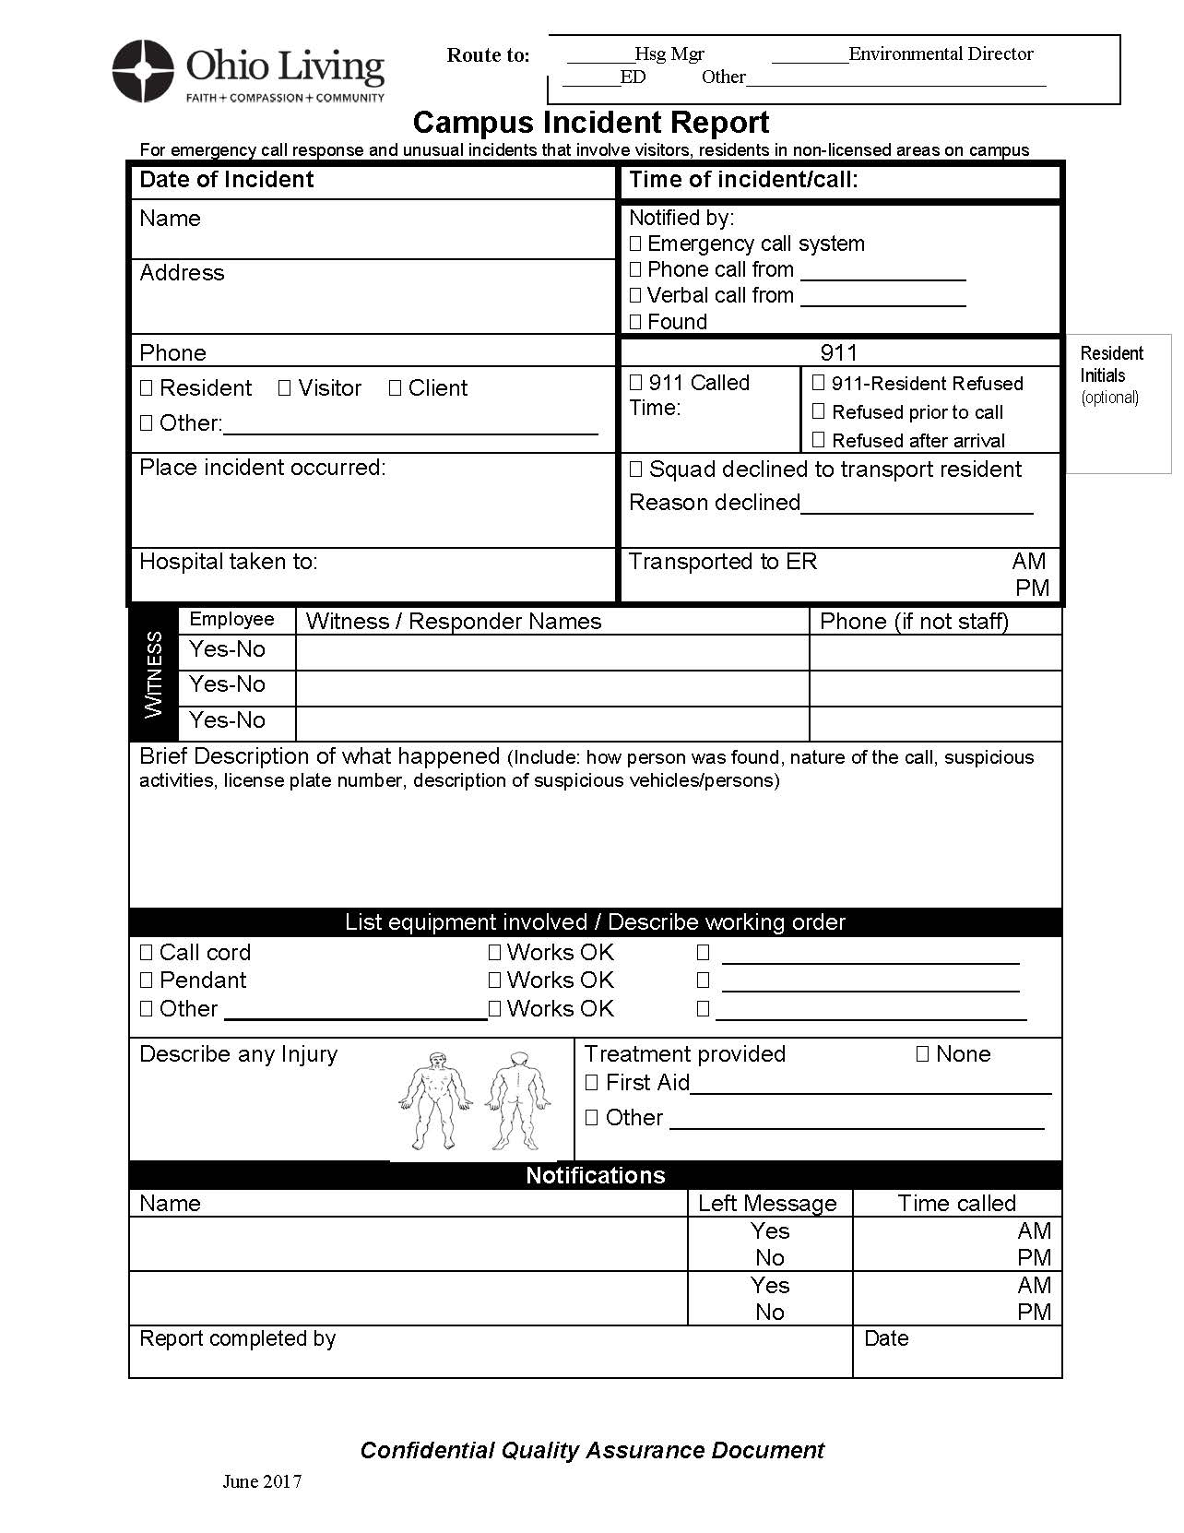

**Section 4**

**Corporate**

**Crisis Support Team**

**Corporate Crisis Support Communications Flow**



**Corporate Crisis Support Team Duties**

**Corporate Crisis Support Team members will assess needs regarding:**

1. Additional resources needed
   1. Staffing/Human Resources
   2. External team members from sister communities or HH & H locations
   3. Financial
   4. Ancillary support (vendors, contractors, etc.)
   5. Legal
2. Action steps
   1. Environmental and security area concerns
   2. Incident investigation, documentation and reporting
   3. Internal and external communications
   4. Stress management, counseling, spiritual, and emotional needs
   5. In-servicing, education, and training
   6. Implement, as necessary, changes or modifications throughout the organization

**Team roles are as follows:**

1. COO
   1. The COO and Crisis Strategist will appoint a local spokesperson
2. Crisis Strategist
   1. Remains aware of “big picture”
   2. Assigns team duties and reallocates resources as needed
3. Team Logistic Coordinator
   1. Coordinates food, accommodations, ancillary items etc.
   2. Gathers and prepares documents for press kit
   3. Works with IT to assure computers, phones, cabling, etc. are in place
4. Public Relations/Communication Support
   1. Initiates media monitoring (TV, radio, internet, newspapers, social media)
   2. Develops communication plan for release of information to outside entities such as board, family members, residents, clients and employees
   3. Scripting receptionist for incoming phone calls and visitor information
   4. Oversees interactions with media
5. Environmental Services Support
   1. Monitors safety and internal/external environmental concerns
   2. Develops and implements procedures to secure the location
6. Clinical Support
   1. Oversees investigations regarding regulatory, compliance and/or clinical issues
   2. Develops corrective measures

**When an end to the immediate crisis is declared, a post crisis evaluation is completed and ongoing action steps are established**. **Thecrisis readiness plan will be evaluated annually. The crisis team will meet once a year to review the plan and their preparedness.**

|  |  |  |  |  |  |  |
| --- | --- | --- | --- | --- | --- | --- |
| ***Crisis Team Actions Considerations List*** | ***Actions Completed*** | | | | | |
| **Injury / Loss of Life / Exposure** | Yes | No | N/A | Date | Time | By Whom |
| Ambulance services required and called |  |  |  |  |  |  |
| Police notification |  |  |  |  |  |  |
| Area secured for police investigation |  |  |  |  |  |  |
| Treatment provided to victims |  |  |  |  |  |  |
| Families notified |  |  |  |  |  |  |
| Counseling required for victims |  |  |  |  |  |  |
| Counseling required for families of victims |  |  |  |  |  |  |
| Co-workers informed of event and status of victims |  |  |  |  |  |  |
| Counseling required for co-workers |  |  |  |  |  |  |
| All employees informed of event and status of victims |  |  |  |  |  |  |
| Personal belongings of victims collected for family |  |  |  |  |  |  |
| Insurance coverage review conducted / activated |  |  |  |  |  |  |
| Insurance companies notified for immediate response |  |  |  |  |  |  |
| City health services notified |  |  |  |  |  |  |
| News media announcement on event, status and actions being taken on behalf of injured |  |  |  |  |  |  |
| Position statement for general distribution (other company locations, all management) |  |  |  |  |  |  |
| Legal counsel notification (if victim is a visitor to the facility) |  |  |  |  |  |  |
| Management informed of event, status and actions being taken |  |  |  |  |  |  |
| Direct management informed to make contingency arrangements  Privileged and Confidential Quality Assurance Use Only |  |  |  |  |  |  |

|  |  |  |  |  |  |  |
| --- | --- | --- | --- | --- | --- | --- |
| ***Crisis Team* *Actions Considerations List*** | ***Actions Completed*** | | | | | |
| **Facility/Community Security** | Yes | No | N/A | Date | Time | By Whom |
| Building access restrictions implemented |  |  |  |  |  |  |
| Floor / area security enforced |  |  |  |  |  |  |
| Additional security services obtained |  |  |  |  |  |  |
| Police complement obtained |  |  |  |  |  |  |
| Search procedures implemented |  |  |  |  |  |  |
| Visitor access restricted |  |  |  |  |  |  |
| Employees notified of security procedures |  |  |  |  |  |  |
| News media announcement issued |  |  |  |  |  |  |
| Building search conducted |  |  |  |  |  |  |
| Management notified |  |  |  |  |  |  |
| Security personnel trained in interim emergency procedures |  |  |  |  |  |  |
| Facility evacuation |  |  |  |  |  |  |
| **Notification to Stakeholders** |  |  |  |  |  |  |
| Executive management/board notification |  |  |  |  |  |  |
| Regulatory notifications |  |  |  |  |  |  |
| Employee communications |  |  |  |  |  |  |
| Resident/client/family notification |  |  |  |  |  |  |
| Supplier/vendor notification |  |  |  |  |  |  |
| Other Ohio Living locations notified |  |  |  |  |  |  |

Privileged and Confidential Quality Assurance Use Only

|  |  |  |  |  |  |  |  |  |  |
| --- | --- | --- | --- | --- | --- | --- | --- | --- | --- |
| ***Crisis Team Actions Considerations List*** | | ***Actions Completed*** | | | | | | | |
| **Forms Completed** | | Yes | No | | N/A | | Date | Time | By Whom |
| Person of interest form |  | | |  |  |  | |  |  |
| Incident report |  | | |  |  |  | |  |  |
| Witness statement(s) |  | | |  |  |  | |  |  |
| Medication error |  | | |  |  |  | |  |  |
| **News Media Management** | | Yes | No | | N/A | | Date | Time | By Whom |
| Sample notice and log distributed to receptionists | |  |  | |  | |  |  |  |
| Spokesperson identified | |  |  | |  | |  |  |  |
| Standby statement and talking points prepared | |  |  | |  | |  |  |  |
| Media interview location identified/practice interviews | |  |  | |  | |  |  |  |
| Begin Social Media monitoring/proactive posting | |  |  | |  | |  |  |  |
| Media conference conducted | |  |  | |  | |  |  |  |
| Media update schedule issued | |  |  | |  | |  |  |  |
| Internal stakeholders informed of point of contact | |  |  | |  | |  |  |  |
| Authorities issued all press releases | |  |  | |  | |  |  |  |
| Regulatory bodies issued all press releases | |  |  | |  | |  |  |  |

Privileged and Confidential Quality Assurance Use Only

Crisis Communication Fact Sheet

For use in EXTREME EMERGENCY (e.g., death, injury, physical plant damage)

1. Number of injuries and/or deaths:
2. How the injuries or deaths occurred:
3. Current condition of those injured:
4. Names of injured or dead (has appropriate notification of family occurred?):
5. Effect on continuing operations of facility:
6. Extent and location of significant damage to facility:

Privileged and Confidential Quality Assurance Use Only

General Crisis Communication Fact Sheet (Page 1 of 2)

1. Location (Community, Corporate, Home Health & Hospice or Foundation location):
2. Nature of the controversy, crisis or emergency:
3. How the crisis began:
4. Approximate time and location of crisis (timeline):
5. How the crisis occurred:

Privileged and Confidential Quality Assurance Use Only

G Fact Sheet (Page 2 of 2)

1. Current condition of the crisis:

General Crisis Communication Fact Sheet (Page 2 of 2)

1. Current condition of the crisis:
2. Who was involved (name/title):
3. Procedures for resolving the crisis:
4. When will the crisis be resolved:
5. Relevant regulatory and or legal issues:
6. When will additional facts be available:
7. Name of Crisis Strategist/home & cell #s:
8. Name of spokesperson/ home & cell #s

____________________________________________________________

*****General Fact Sheet***** (Utilize “We believe”)

****Pay attention to any positive highlights that can be used to redirect the negative situation (eg. Acts of heroism, etc.)

Privileged and Confidential Quality Assurance Use Only

**OHIO LIVING CRISIS MEDIA INTERVIEW GUIDE**

**\* TIP: Photocopy these pages for your notes and retain the originals.**

|  |  |
| --- | --- |
| **ACTION STEPS** | **NOTES** |
| * **Prepare for the interview.**   Find out as much as you can about the reporter and story angle. If possible, read the publication or watch the station prior to your interview.  **Note:** Please use the reference material in our Ohio Living Crisis Manual and coordinate your response with Corporate. |  |
| * **Choose the right location** **for the interview.**   The location of your interview can have as much impact as what you say. Consider whether the setting helps convey your message--your office (business-like/efficient), recreation area (fun/active community), Chapel (prayerful/concerned)--and choose appropriately. |  |
| * **Have an objective for the interview.**   What is the overall understanding you want the reporter to have when the interview is over? The one thing you want the reporter to remember? Your main message and key messages should support this objective. |  |
| * **Develop 1-3 key messages into sound bites.**   They are meant to stick with the reporter. You’ll be increasing the likelihood that your messages will get used in the story. |  |
| **OHIO LIVING CRISIS MESSAGES**  Through your words, actions and body language communicate these messages as they apply to your issue:   * Safety & Security is #1 Priority * Be extremely empathetic * Express openness and be transparent * Stress our strong reputation * Keep it local: speak about your facility * Emphasize that we take the issue seriously * Working closely with authorities * Reviewing, investigating internally * Will continue to communicate |  |
| * **Use the techniques of bridging, flagging and repeating** to keep on track with your messages. Bridging is the smooth transition statement, flagging is identifying what is important, and repeating, of course, is delivering your messages as many times as possible in compelling ways. |  |
| * **Create a list of potential questions.** Write down the questions you anticipate from the reporter using the 5W’s and an H. (Who, what, where, when, why and how) Include the question that you really don’t want to answer. |  |
| * **Practice your interview.** Have someone ask you these questions in an interview and practice delivering your key messages. |  |
| * **Remember to focus on people** during your interview. Speak from the audience’s point of view, not Ohio Living ’s point of view. What will the reader or viewer really care about? |  |
| * **Never do these:** Lie or mislead, speculate (just say “I don’t know”), go off the record, use jargon, repeat the negative or say “no comment” (this makes you seem guilty--instead use something like “we are still reviewing the situation and will get back to you”) |  |
| * **Stay calm.** A reporter’s job is to ask tough questions. Don’t take these personally. Just remember your role as spokesperson is to calmly return to your messages again and again. |  |
| * **Remember to exercise your rights** in the interview, including exercising control, answering questions without interruption and bringing up points not specifically raised by the reporter’s questions. |  |
| * **Stay positive and energetic.** As an advocate for your organization or issue, if you to press your points in an upbeat, respectful manner you will find success in getting your message through the media to your most important audiences. |  |

|  |  |  |
| --- | --- | --- |
| **Ohio Living Sample Message Form** | | |
| **Main Message:**  We are deeply concerned about this situation and are doing a complete review of our systems, while working with authorities to resolve this. | | |
| **Key Message (SAFETY)**  The safety and security of our residents, staff and volunteers is our number one priority. | **Key Message (CONCERN)**  We take this matter very seriously and we are deeply concerned. | **Key Message (ACTION)**  We are working closely with authorities and taking the appropriate actions. We will continue to communicate openly. |
| **Support**  We take (this issue) very seriously. List specific examples of the ways that illustrate how we ensure safety and security. If appropriate, explain that this is an extremely rare occurrence. | **Support**  Explain that we are a family and care for deeply one another. We are also a faith-based community and believe in the power of prayer. | **Support**  Explain what actions we are taking to resolve or correct the issue, including working with authorities, reviewing our processes, etc., and express openness and transparency with the media and others. |
| **NOTES:** Write any notes here. Particularly, try to think of the question you are most concerned about getting. Write the question and your best answer in this space. | | |

|  |  |  |
| --- | --- | --- |
| **Ohio Living**  **Media Interview**  **Message Form** | | |
| **Main Message:** (The one thing reporter should remember) | | |
| **Key Message** | **Key Message** | **Key Message** |
| **Support** | **Support** | **Support** |
| **NOTES:** Write any notes here. Particularly, try to think of the question you are most concerned about getting. Write the question and your best answer in this space. | | |

**Potential Scenarios**

**Employees**

Theft at client’s home

Gift planner is left in resident’s will

Fired employee violence

Walkout by nursing staff

Embezzlement by finance employee

Former IT employee steals database with donor social security numbers

Resident dies, family accuses foundation employees coercing millions

Theft of drugs by nurse

Bus accident, driver was high

**Residents**

Resident is missing

Resident dies in home fire

Resident wanders off

Resident hurt in construction

Grandchild deals drugs from ranch house

Nanny-cam shows lack of care

Residents are killed in drive-by shooting

**Nature**

Tornado devastates community

Fire destroys community

**Ohio Living Statement Guide**

NOTE: This guide is meant to help you quickly draft a simple statement for use in dealing with a crisis communications situation.

**1. Consider all relevant audiences:**

Residents

Staff

Families

Board

Donors

Potential Residents

Regulators

Media

Legislators

Others

**2. Develop your messages**

Consider the Ohio Living Key Messages below as the foundation for your messages. Then use the attached Ohio Living Message Form to create your messages. For your reference also review the attached Sample Message Form.

**Ohio Living Crisis Messages**

Through your words, actions and body language communicate these messages as they apply to your issue:

* Safety & Security is #1 Priority
* Be extremely empathetic
* Express openness and be transparent
* Stress our strong reputation
* Keep it local: speak about your facility
* Emphasize that we take the issue seriously
* Working closely with authorities
* Reviewing, investigating internally
* Will continue to communicate

**3. Create Your Statement**

* State the Facts, simply and clearly.
* As a prompt, think about the 5 W’s and H: Who, What, Where, Why, When and How.
* Realize that your statement might well be seen by thousands of people on social media and elsewhere and draft it appropriately.

**4. Distribute Your Statement**

* Work with Corporate to help determine the distribution of your statement.
* It may be distributed to the media and with minor modifications used to inform residents, staff, volunteers and other key audiences.

**Sample Statement Structure:**

(DATE)

STATEMENT (NAME OF EXECUTIVE DIRECTOR OR OTHER SPOKESPERSON)

(NAME OF FACILITY)

We learned today that (SIMPLE STATEMENT OF FACTS).

Our thoughts and prayers (OR OTHER EMPATHETIC RESPONSE AS APPROPRIATE)

At (NAME OF YOUR FACILITY) the safety and security of our residents, staff and volunteers is our top priority. We take this seriously and are working closely with (AUTHORITIES, SUCH AS POLICE).

In addition, we are (INVESTIGATING OR REVIEWING) to make sure we uncover all the facts.

We will continue to communicate as we learn more.

_________________________*ONLY AN EXAMPLE*: THEFT_________________________

January 1, 2013

Statement

Stephen Smith, Executive Director

Caring Hearts Retirement

We learned today that the home of a Caring Hearts resident is missing a number of personal items.

The safety and security of our residents is our top priority and we are working closely with Greenville Police on their investigation. We have no other details.

We take this very seriously and we are also reviewing our security to ensure the safety of our facility.

We will continue to communicate as we learn more.

_____________________*ONLY AN EXAMPLE:*  MISSING RESIDENT_____________________

January 1, 2013

Statement

Stephen Smith, Executive Director

Caring Hearts Retirement

We reported to Greenville Police today that Mary Smith is missing from her home in our community.

We are a family here at Caring Hearts and we are praying for Mary’s safe return.

Our top priority is the safety and security of our residents, staff and volunteers. We are in close touch with Mary’s family and with Greenville Police on their investigation.

We take this very seriously and we are also reviewing our security to ensure the safety of our facility.

We will continue to communicate as we learn more.

**Social Media Crisis Response**

1. Crisis Strategist (CS) communicates incident to Online Content Manager (OCM). The OCM performs the following:
2. Is there a need for immediate action/incident response on the websites?
   1. Sidebar callout
   2. Emergency homepage post
   3. Blog: A blog will be indexed on Google and will exist in some form for the foreseeable future.
   4. WCS: Homepage takeover
3. Is there a need for immediate action/incident response on social media?
   1. Twitter
   2. Facebook
   3. YouTube
   4. Google+
   5. LinkedIn

1. If yes, CS may provide scripted language to OCM or ask you to draft a message. When drafting, consider the Three A's:
   1. **Acknowledgement:** Basics of who, what, when, where, why, how did it happen, is it widespread, what/who does it affect, how Ohio Living found out.
   2. **Affirm:** Our residents and clients and their loved ones and our partners and stakeholders may be worried/be inconvenienced/want reassurances. Show you feel their pain/worry and are trying to alleviate it. *Saying you are listening and looking for answers can buy time and can quell confusion, worry and resentment.*
   3. **Action:** Share what steps Ohio Living proposes to take/has taken to determine what happened, prevent reoccurrence and maintain trust.
2. Prepare responses for various types of posts and submit to CS for approval.
3. Add relevant incident keyword searches to Google Alerts, including names of victim(s), involved staffers and residents, victim's family, on-scene officials/departments, first-responders; city/area; incident type (illness, shooting, etc.).
4. Sign up for any relevant alerts that may help you stay up-to-date (police, EMA, news agencies)
5. Check the social media of all the involved people and family, officials, municipalities, departments.
6. Use incident keywords to search Twitter for related information. Search Twitter several times per day.
7. Monitor local and national news and blog sites for all related stories, videos, interactives. Bookmark URLs for easy tracking. Do Google searches using incident keywords to catch the latest entries and seeing if it's trending currently.
8. Monitor comments on all news stories.
9. Report anything of significance to CS and/or other identified crisis team members.
10. All social responses/posts from OCM to users (positive or negative) must be approved by the CS, unless otherwise stated during crisis management. *Construct all messages within the framework of Ohio Living ' mission and beliefs.*
11. Identify news clips that will illustrate (positively if possible) the incident and submit for social posting approval. Bookmark these URLs and later request news reels for training purposes, to be approved by CS.
12. Check and recheck the decks:
    1. **Amplify**: Keep the websites, social networks updated. When something is approved for dissemination, discuss amplifying the message with the CS. Which tools should be used? Should a hashtag be created? Should a positive post be pinned at the top of the FB page?
    2. **Adhere:** Don't surrender Ohio Living ' values. You cannot solve every problem for everyone. Think of ways to pacify part of your discontent audience when solutions may not be found quickly.
    3. **Analyze:** Monitor real-time content on various media, networks to prepare Ohio Living ' website content and social content/responses.
    4. **Answer:** Allow comments on social -- otherwise there will be negative effects on your brand such as suspicion and distrust. Not every comment requires a reply, though. Know when to disengage. If a hostile commenter emerges, consider taking the conversation off social and engage them directly, asking them to email the OCM or CS. Try to bury the comment/post with more positive posts such as an approved quote from the CEO about the incident. *(Look to the approved comment and response approach.)*

***Keep monitoring. Don't delete your tools until the incident is completely resolved – this could be several months to several years.***

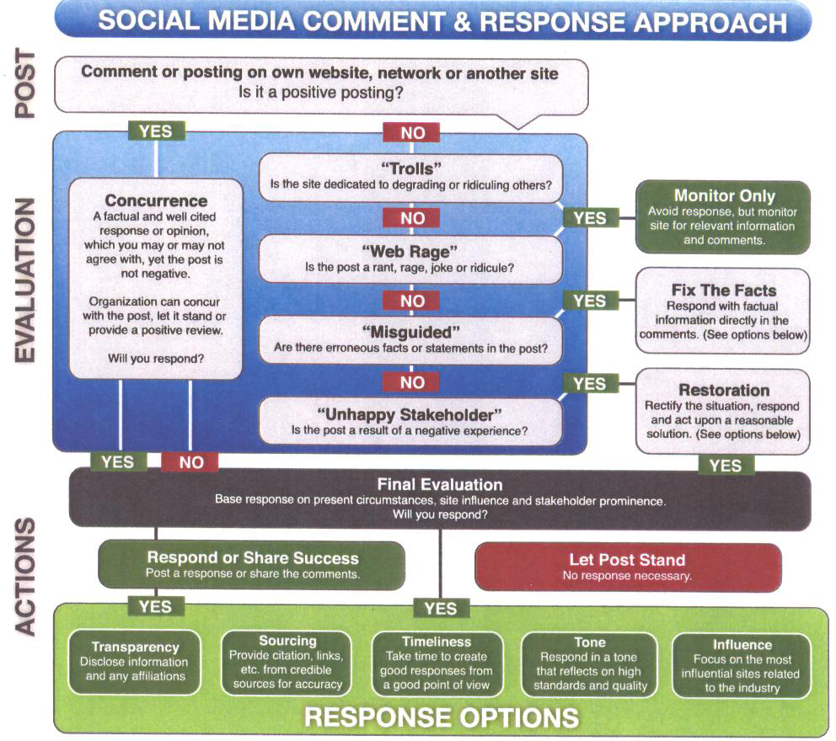

**Section 5**

**Local, State and Federal**

**Required Reporting Forms**

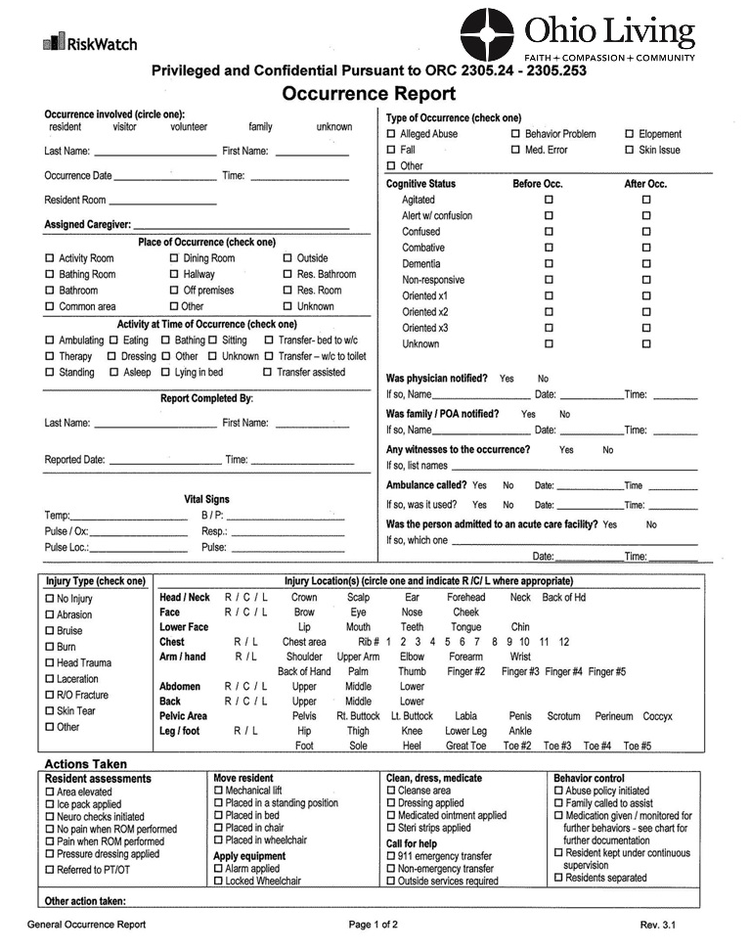

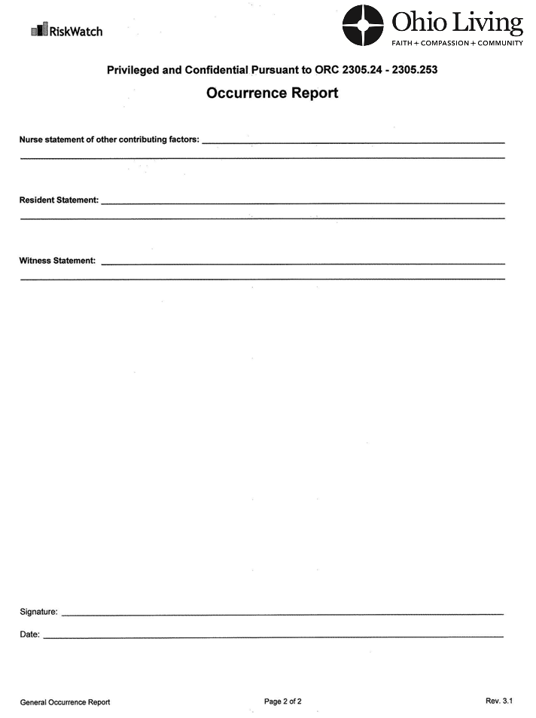

**Section 6**

**State of Ohio**

**Emergency Management Agencies**

**Emergency Management Agencies**

Depending on the scope and nature of the crisis, County Emergency Management Agencies are vital first points of contact. These contacts can assist you with managing a crisis that involves general security to the county and state. In an extreme situation, the National Homeland Security Office can provide additional support in the case of a national emergency. A list of county EMA directors and their contact information is provided below and can be accessed through the Agency’s Website at <http://www.state.oh.us/odps/division/ema/County.htm>.

State Homeland Security Office provides a response guide for businesses. Information on preparation and statewide updates regarding Ohio’s homeland security efforts is available through the State of Ohio Office of Homeland Security at <http://www.state.oh.us/odps/sos/ohshome.htm>

The National Homeland Security Office can offer resources and updates regarding response at the federal level. Information on national homeland security efforts can be accessed at http://www.dhs.gov/dhspublic/ or through the Federal Emergency Management Agency web site at <http://www.fema.gov/>

|  |  |
| --- | --- |
| **Ohio County Emergency Management Directory** | |
| **Adams Co Emergency Mgmt.** | |
| **Director: Howelett, Karen** 31 Logans Lane  West Union, OH 45693 937 544-6123 | email: [adamsema1@yahoo.com](mailto:adamsema1@yahoo.com) website: [No Website](http://webeoc.dps.ohio.gov/ohiocountyEMADirectorList/No%20Website) |
|  | |
| **Allen Co Office of Homeland Security & Emerg Mgmt** | |
| **Director: Berger, Thomas** 333 N. Main St. POBox1243 Lima, OH 45801 419 993-1404 | email: [tberger@allencountyohio.com](mailto:tberger@allencountyohio.com) website: [http://allen-ema.com](http://allen-ema.com/) |
|  | |
| **Ashland Co Office Homeland Security & Emerg Mgmt** | |
| **Director: Rafeld, Mark** 1763 State Route 60  Ashland, Oh 44805 419 282-4272 | email: [mrafeld@ashlandcounty.org](mailto:mrafeld@ashlandcounty.org) website: <http://www.ashlandcounty.org/ema> |
|  | |
| **Ashtabula Co Emergency Mgmt.** | |
| **Director: Fitchet, Mike** 25 West Jefferson St.  Jefferson, OH 44047 440 576-9148 | email: [ema@co.ashtabula.oh.us](mailto:ema@co.ashtabula.oh.us) website: <http://www.co.ashtabula.oh.us/web/framesets/EmergSvcs.html> |
|  | |
| **Athens Co Emergency Mgmt.** | |
| **Director: Pfeiffer, Dan**  13 West Washington St.  Athens, OH 45701 740 594-2261 | email: [dpfeiffer@athensoh.org](mailto:dpfeiffer@athensoh.org) website: <http://www.athenscountygovernment.com/acema> |
|  | |
| **Auglaize Co Emergency Mgmt.** | |
| **Director: Anderson, Troy** 209 S Blackhoof St. Rm206  Wapakoneta, OH 45895 419 739-6725 | email: [tanderson@auglaizecounty.org](mailto:tanderson@auglaizecounty.org) website: <http://www.auglaizecounty.org/EMA/index.html> |
|  | |
| **Belmont Co Emergency Mgmt.** | |
| **Director: Ivan, Dave** 68329 Bannock Rd. SR 331  St. Clairsville, Oh 43950 740 695-5984 | email: [emergency.management@co.belmont.oh.us](mailto:emergency.management@co.belmont.oh.us) website: [NoWebsite.asp](http://webeoc.dps.ohio.gov/ohiocountyEMADirectorList/NoWebsite.asp) |
|  | |
| **Brown County Department of Public Safety Services** | |
| **Director: Davis, Barb** 755 Mt. Orab Pike  Georgetown, Oh 45121 513 748-7788 | email: [bdavis@browncountyohio.gov](mailto:bdavis@browncountyohio.gov) website: <http://www.browncountyohio.gov/index.php?option=com_content&view=article&id=34&Itemid=71> |
|  | |
| **Butler Co Emergency Mgmt.** | |
| **Director: Haverkos, Matthew** 315 High St., Ste 670  Hamilton, Oh 45011 513 785-5810 | email: [HaverkosMr@butlercountyohio.org](mailto:HaverkosMr@butlercountyohio.org) website: <http://butlercountyohio.org/ema/> |
|  | |

|  |  |
| --- | --- |
| **Ohio County Emergency Management Directory** | |
| **Carroll Co Disaster Svcs.** | |
| **Director: Cottis, Tom** 106 Kensington Road NE PO Box 628 Carrollton, Oh 44615 330 627-0003 | email: [ccemalepc@eohio.net](mailto:ccemalepc@eohio.net) website: <http://carrollcountyohio.net/emergencymanagement.html> |
|  | |
| **Champaign Co Emergency Mgmt. Office of Homeland Security** | |
| **Director: Freeman, James** 1512 State Route 68 Suite C103  Urbana, OH 43078 937 484-1642 | email: [ema@co.champaign.oh.us](mailto:ema@co.champaign.oh.us) website: [NoWebsite.asp](http://webeoc.dps.ohio.gov/ohiocountyEMADirectorList/NoWebsite.asp) |
|  | |
| **Clark Co Emergency Mgmt.** | |
| **Director: D`Allessandris, Lisa** 3130 East Main St. Suite 1E  Springfield, OH 45505 937 521-2175 | email: [ldallessandris@clarkcountyohio.gov](mailto:ldallessandris@clarkcountyohio.gov) website: <http://www.clarkcountyohio.gov/ema/index.htm> |
|  | |
| **Clermont County Emergency Management Agency** | |
| **Director: Haverkos, Pam** 2279 Clermont Center Drive  Batavia, Oh 45103 513 732-7661 | email: [phaverkos@clermontcountyohio.gov](mailto:phaverkos@clermontcountyohio.gov) website: <http://www.ema.clermontcountyohio.gov/> |
|  | |
| **Clinton Co Emergency Mgmt.** | |
| **Director: Jones, Mike** 1645 Davids Drive  Wilmington, Oh 45177 937 382-6673 | email: [ccema1@clintonsheriff.com](mailto:ccema1@clintonsheriff.com) website: <http://co.clinton.oh.us/emergency-management/emergency-management> |
|  | |
| **Columbiana Co Emergency Mgmt.** | |
| **Director: Clark, Peggy**  215 South Market St.  Lisbon, OH 44432 330 424-9725 | email: [peggy.clark@ccoema.org](mailto:peggy.clark@ccoema.org) website: <http://ccoema.org/> |
|  | |
| **Coshocton Co Office Of Homeland Security & Emerg Mgmt** | |
| **Director: McMasters, Rob** 724 South Seventh St.  Coshocton, Oh 43812 740 622-1984 | email: [robbiemcmasters@coshoctoncounty.net](mailto:robbiemcmasters@coshoctoncounty.net) website: <http://www.coshoctoncounty.net/agency/ema/> |
|  | |
| **Crawford Co Emergency Mgmt.** | |
| **Director: Flock, Tim** 112 E Mansfield St.  Bucyrus, Oh 44820 419 562-6009 | email: [ccema@crawford-co.org](mailto:ccema@crawford-co.org) website: <http://emacrawford-co.org/feedback/default.htm> |
|  | |
| **Cuyahoga Co Emergency Management Administration** | |
| **Director: Christie, Mark**  9300 Quincy Avenue  Cleveland, Oh 44106 216-443-5683 | email: [mchristie@cuyahogacounty.us](mailto:mchristie@cuyahogacounty.us) website: <http://ja.cuyahogacounty.us/en-US/emergency-management.aspx> |
|  | |
|  | |

|  |  |
| --- | --- |
| **Ohio County Emergency Management Directory** | |
| **Darke Co Office Of Homeland Security & Emerg Mgmt** | |
| **Director: Saylor, Mindy** 5183 County Home Rd.  Greenville, Oh 45331 937 548-1444 | email: [mindy@darkecountyema.org](mailto:mindy@darkecountyema.org) website: <http://www.darkecountyema.org/> |
|  | |
| **Defiance Co Emergency Mgmt.** | |
| **Director: Rittenhouse, Julie** 22491 Mill Street  Defiance, Oh 43512 419 782-1130 | email: [ema@defiance-county.com](mailto:ema@defiance-county.com) website: <http://www.defiance-county.com/publicsafety/index.php> |
|  | |
| **Delaware Co Emergency Mgmt.** | |
| **Director: Miller, Sean** 10 Court St.  Delaware, OH 43015 740 833-2180 | email: [delcoema@co.delaware.oh.us](mailto:delcoema@co.delaware.oh.us) website: <http://www.co.delaware.oh.us/dcems/dcema/index.htm> |
|  | |
| **Erie Co Office of Homeland Security & Emerg Mgmt** | |
| **Director: Jonovich, Tim** 2900 Columbus Ave  Sandusky, Oh 44870 419 627-7617 | email: [tjonovich@eriecounty.oh.gov](mailto:tjonovich@eriecounty.oh.gov) website: <http://www.eriecounty.oh.gov/departments-and-agencies/health-and-safety/emergency-management/> |
|  | |
| **Fairfield Co Emergency Mgmt.** | |
| **Director: Kochis, Jon** 241 W. Main Street Ste 100  Lancaster, OH 43130 740 654-4357 | email: [jkochis@co.fairfield.oh.us](mailto:jkochis@co.fairfield.oh.us) website: <http://www.co.fairfield.oh.us/emergencymang/> |
|  | |
| **Fayette Co Emergency Mgmt.** | |
| **Director: Havens, Melissa** 133 South Main Street. Suite L15  Washington CH, Oh 43160 740 335-8264 | email: [Melissa.Havens@fayette-co-oh.com](mailto:Melissa.Havens@fayette-co-oh.com) website: <http://fayette-co-oh.com/fcema/index.html> |
|  | |
| **Franklin Co Office of Homeland Security & Emerg Mgmt** | |
| **Director: Young, Jeffrey J.** 5300 Strawberry Farms Blvd.  Columbus, Oh 43230-1049 614 794-0213 | email: [jjyoung@franklincountyohio.gov](mailto:jjyoung@franklincountyohio.gov) website: <http://www.franklincountyohio.gov/emahs/> |
|  | |
| **Fulton Co Emergency Mgmt.** | |
| **Director: Freeman, Kelvin** 123 Courthouse Plaza, Suite 3  Wauseon, OH 43567 419 337-9207 | email: [ema@fultoncountyoh.com](mailto:ema@fultoncountyoh.com) website: <http://www.fultoncountyoh.com/ema.htm> |
|  | |
| **Gallia Co Emergency Mgmt.** | |
| **Director: Daines, Sherry**  1191 State Route 160  Gallipolis, Oh 45631 740 441-2036 | email: [gclepc@gallianet.net](mailto:gclepc@gallianet.net) website: <http://www.facebook.com/pages/Gallia-County-Emergency-Management-Agency/116420875060160> |
|  | |
|  | |

|  |  |
| --- | --- |
| **Ohio County Emergency Management Directory** | |
| **Geauga Co Emergency Mgmt.** | |
| **Director: Petersen, Roger** 12518 Merritt Rd.  Chardon, Oh 44024 440-279-2171 | email: [RPetersen@co.geauga.oh.us](mailto:RPetersen@co.geauga.oh.us) website: <http://www.co.geauga.oh.us/Departments/DES/Main.aspx> |
|  | |
| **Greene Co Disaster Svcs.** | |
| **Director: Anders, Roseanne** 45 N. Detroit Street  Xenia, Oh 45385 937 562-5994 | email: [randers@co.greene.oh.us](mailto:randers@co.greene.oh.us) website: <http://www.co.greene.oh.us/EMA/EMA_Links.htm> |
|  | |
| **Guernsey Co Emergency Mgmt.** | |
| **Director: Beckner, Gerry** 627 Wheeling Ave. Suite 302  Cambridge, Oh 43725 740 432-9292 | email: [ema@guernseycounty.org](mailto:ema@guernseycounty.org) website: [http://www.guernseycountyema.com](http://www.guernseycountyema.com/) |
|  | |
| **Hamilton Co Emergency Mgmt.** | |
| **Director: Crossley, Nick** 2000 Radcliff Drive  Cincinnati, Oh 45204 513 263-8200 | email: [nick.crossley@hamilton-co.org](mailto:nick.crossley@hamilton-co.org) website: <http://www.hamiltoncountyohioema.org/> |
|  | |
| **Hancock Co Emergency Mgmt.** | |
| **Director: Swisher, Lee** P O Box 964  Findlay, Oh 45839 419 424-7092 | email: [hcema@bright.net](mailto:hcema@bright.net) website: [NoWebsite.asp](http://webeoc.dps.ohio.gov/ohiocountyEMADirectorList/NoWebsite.asp) |
|  | |
| **Hardin Co Emergency Mgmt.** | |
| **Director: Trachsel, Max** 1025 South Main St, RM 111  Kenton, Oh 43326 419 674-2276 | email: [hardinema@hardinsheriff.com](mailto:hardinema@hardinsheriff.com) website: [NoWebsite.asp](http://webeoc.dps.ohio.gov/ohiocountyEMADirectorList/NoWebsite.asp) |
|  | |
| **Harrison Co Emergency Mgmt.** | |
| **Director: Wilson, Eric** 538 North Main St Ste F  Cadiz, Oh 43907 740 942-3922 | email: [hcema34@frontier.com](mailto:hcema34@frontier.com) website: [NoWebsite.asp](http://webeoc.dps.ohio.gov/ohiocountyEMADirectorList/NoWebsite.asp) |
|  | |
| **Henry Co Emergency Mgmt.** | |
| **Director: Busch, Tracy** 1847 Oakwood Avenue  Napoleon, Oh 43545 419 599-6432 | email: [ema@henrycountyohio.com](mailto:ema@henrycountyohio.com) website: <http://henrycountyohio.com/emergencymanagement.htm> |
|  | |
| **Highland Co Emergency Mgmt.** | |
| **Director: Lyle, James** 1487 North High Street STE 600  Hillsboro, Oh 45133 937 393-5880 | email: [jlyle@co.highland.oh.us](mailto:jlyle@co.highland.oh.us) website: <http://www.co.highland.oh.us/Department%20Home%20Pages/EMA.html> |
|  | |
|  | |

|  |  |
| --- | --- |
| **Ohio County Emergency Management Directory** | |
| **Hocking Co Emergency Mgmt.** | |
| **Director: Gustafson, Cesalie** 52 East Second Street  Logan, Oh 43138 740 385-6168 | email: [emadirector@co.hocking.oh.us](mailto:emadirector@co.hocking.oh.us) website: <http://www.co.hocking.oh.us/ema/> |
|  | |
| **Holmes Co Emergency Mgmt.** | |
| **Director: Mellor, Gary** 2 Court Street, Suite 11  Millersburg, Oh 44654 330 674-0989 | email: [gmellor@co.holmes.oh.us](mailto:gmellor@co.holmes.oh.us) website: <http://www.co.holmes.oh.us/emergency-management-overview> |
|  | |
| **Huron Co Emergency Mgmt.** | |
| **Director: Ommert, Bill (Interim)** 255-B Shady Lane Drive  Norwalk, Oh 44857 419 663-5772 | email: [director@huroncountyema.com](mailto:director@huroncountyema.com) website: <http://www.huroncountyema.com/> |
|  | |
| **Jackson Co Emergency Mgmt.** | |
| **Director: Czechlewski, Robert** 200 Main Street  Jackson, Oh 45640 740 286-5630 | email: [jacksoncoema@hotmail.com](mailto:jacksoncoema@hotmail.com) website: [http://www.jacksoncoema.webs.com](http://www.jacksoncoema.webs.com/) |
|  | |
| **Jefferson Co Emergency Mgmt.** | |
| **Director: Parker, John** 300 Airport Road P O Box 2039  Wintersville, OH 43953-2039 740 264-4646 | email: [jeffersoncounty88@yahoo.com](mailto:jeffersoncounty88@yahoo.com) website: [NoWebsite.asp](http://webeoc.dps.ohio.gov/ohiocountyEMADirectorList/NoWebsite.asp) |
|  | |
| **Knox Co Office of Homeland Security & Emerg Mgmt** | |
| **Director: Maxwell, Mark** 11540 Upper Gilchrist Road  Mt. Vernon, Oh 43050 740-393-6772 | email: [markmaxwell@co.knox.oh.us](mailto:markmaxwell@co.knox.oh.us) website: [No Website](http://webeoc.dps.ohio.gov/ohiocountyEMADirectorList/No%20Website) |
|  | |
| **Lake Co Emergency Mgmt.** | |
| **Director: Greene, Larry** 8505 Garfield Rd., PO Box 480  Mentor, Oh 44061-9998 440 350-5499 | email: [Larry.Greene@lakecountyohio.gov](mailto:Larry.Greene@lakecountyohio.gov) website: <http://www2.lakecountyohio.org/ema/> |
|  | |
| **Lawrence Co Emergency Mgmt.** | |
| **Director: Boster, Michael** 515 Park Avenue-Rear  Ironton, Oh 45638 740 533-4375/4376 | email: [LawCoOHEMA@gmail.com](mailto:LawCoOHEMA@gmail.com) website: <http://www.lawcohd.org/LEPC/tabid/97/Default.aspx> |
|  | |
| **Licking Co Office of Homeland Security & Emerg Mgmt** | |
| **Director: Grady, Sean** 155 East Main Street  Newark, Oh 43055 740 670-5577 | email: [sean.grady@lcounty.com](mailto:sean.grady@lcounty.com) website: <http://www.lcounty.com/ema/> |
|  | |
|  | |

|  |  |
| --- | --- |
| **Ohio County Emergency Management Directory** | |
| **Logan Co Emergency Mgmt.** | |
| **Director: Norris, Helen** 1855 State Route 47 West  Bellefontaine, Oh 43311 937 593-5743 | email: [ema@co.logan.oh.us](mailto:ema@co.logan.oh.us) website: <http://www.co.logan.oh.us/201/Emergency-Management-Agency> |
|  | |
| **Lorain Co Office of Homeland Security & Emerg Mgmt** | |
| **Director: Kelley, Thomas** 322 North Gateway Blvd.  Elyria, OH 44035 440 329-5117 | email: [tkelley@loraincounty.us](mailto:tkelley@loraincounty.us) website: <http://www.loraincounty.us/getdoc/5d52127e-4cfd-454f-8815-d20b614f36d7/Emergency-Management---Homeland-Security.aspx> |
|  | |
| **Lucas Co Emergency Mgmt.** | |
| **Director: Moomey, Patricia** 2144 Monroe Street  Toledo, Oh 43604 419 213-6506 | email: [pmoomey@co.lucas.oh.us](mailto:pmoomey@co.lucas.oh.us) website: <http://www.co.lucas.oh.us/index.aspx?nid=724> |
|  | |
| **Madison Co Emergency Mgmt.** | |
| **Director: Roberts, Roger** 271 Elm Street  London, Oh 43140 740 852-4200 | email: [rroberts@co.madison.oh.us](mailto:rroberts@co.madison.oh.us) website: <http://co.madison.oh.us/ema/> |
|  | |
| **Mahoning Co Emergency Mgmt.** | |
| **Director: O'Hara, Dennis**  700 Industrial Rd.  Youngstown, Oh 44509 330 740-2200 | email: [dohara@mahoningcountyoh.gov](mailto:dohara@mahoningcountyoh.gov) website: <http://www.mahoningcountyoh.gov/tabid/767/default.aspx> |
|  | |
| **Marion Co Emergency Mgmt.** | |
| **Director: McNamee, Sarah** 222 West Center Street  Marion, Oh 43302 740 223-4142 | email: [smcnamee@co.marion.oh.us](mailto:smcnamee@co.marion.oh.us) website: [NoWebsite.asp](http://webeoc.dps.ohio.gov/ohiocountyEMADirectorList/NoWebsite.asp) |
|  | |
| **Medina Co Emergency Mgmt.** | |
| **Director: Fozio, Christina** 555 Independence Drive  Medina, Oh 44256 330 722-9240 | email: [cfozio@medinaco.org](mailto:cfozio@medinaco.org) website: <http://www.ema.co.medina.oh.us/> |
|  | |
| **Meigs Co Emergency Mgmt.** | |
| **Director: Jones, Jamie** 41859 Pomeroy Pike  Pomeroy, OH 45769 740 992-4541 | email: [meigsema@hotmail.com](mailto:meigsema@hotmail.com)  website: [NoWebsite.asp](http://webeoc.dps.ohio.gov/ohiocountyEMADirectorList/NoWebsite.asp) |
|  | |
| **Mercer Co Emergency Mgmt.** | |
| **Director: Robbins, Mike** 321 Riley Street  Celina, Oh 45822 419 586-6468 | email: [EMA@mercercountyohio.org](mailto:EMA@mercercountyohio.org) website: <http://www.mercercountyohio.org/EMA/> |
|  | |
|  | |

|  |  |
| --- | --- |
| **Ohio County Emergency Management Directory** | |
| **Miami Co Emergency Mgmt.** | |
| **Director: Artz, Kenneth** 510 W. Water Street  Troy, Oh 45373 937 332-8560 | email: [kartz@miamicountyema.org](mailto:kartz@miamicountyema.org) website: [www.miamicountyohio.gov](http://webeoc.dps.ohio.gov/ohiocountyEMADirectorList/www.miamicountyohio.gov) |
|  | |
| **Monroe Co Emergency Mgmt.** | |
| **Director: Keevert, Phillip** 47069 State Rte 26  Woodsfield, Oh 43793 740 472-2144 | email: [philkeevert@gmail.com](mailto:philkeevert@gmail.com)  website: <http://www.monroecountyohio.net/monroecountyema.html> |
|  | |
| **Montgomery County Office of Emergency Management** | |
| **Director: Jordan, Jeffrey J.** 117 S. Main St. Ste. 721  Dayton, Oh 45422 937 224-8936 | email: [jordanj@mcohio.org](mailto:jordanj@mcohio.org) website: <http://www.mcohio.org/services/emergencymgt/> |
|  | |
| **Morgan Co Office of Homeland Security & Emerg Mgmt** | |
| **Director: Wilt, John** 60 South Fourth Street  McConnelsville, OH 43756 740 962-3900 | email: [EMA@morgancounty-oh.gov](mailto:EMA@morgancounty-oh.gov) website: [http://www.Morganema.com](http://www.morganema.com/) |
|  | |
| **Morrow Co Emergency Mgmt.** | |
| **Director: Harsch, John** 140 South Main Street  Mount Gilead, Oh 43338 419 947-4041 | email: [mcema@rrohio.com](mailto:mcema@rrohio.com) website: <http://www.morrowcounty.info/www/index.php/2013-01-11-19-24-05/emergency-mangement-agency> |
|  | |
| **Muskingum Co Emergency Mgmt.** | |
| **Director: Keck, Bo** 2215 Adamsville Rd.  Zanesville, Oh 43701 740 453-1655 | email: [muskingumema@muskingumcounty.org](mailto:muskingumema@muskingumcounty.org) website: <http://ema.muskingumcounty.org/> |
|  | |
| **Noble Co Emergency Mgmt.** | |
| **Director: Schmelzenbach, Chasity** 48535 Coldwater Creek Road  Caldwell, Oh 43724-9436 740 732-7387 | email: [nobleema@myfatlink.net](mailto:nobleema@myfatlink.net) website: [NoWebsite.asp](http://webeoc.dps.ohio.gov/ohiocountyEMADirectorList/NoWebsite.asp) |
|  | |
| **Ottawa Co Emergency Mgmt.** | |
| **Director: Petersen, Fred** 315 Madison St., Annx Basement  Port Clinton, Oh 43452 419 734-6900 | email: [fpetersen@co.ottawa.oh.us](mailto:fpetersen@co.ottawa.oh.us) website: <http://www.co.ottawa.oh.us/ottawacoema/index.html> |
|  | |
| **Paulding Co Emergency Mgmt.** | |
| **Director: Bohn, Edward** 503 Fairground Drive, Ste 2  Paulding, Oh 45879 419 399-3500 | email: [ema@pauldingcounty-oh.com](mailto:ema@pauldingcounty-oh.com) website: [NoWebsite.asp](http://webeoc.dps.ohio.gov/ohiocountyEMADirectorList/NoWebsite.asp) |
|  | |
|  | |

|  |  |
| --- | --- |
| **Ohio County Emergency Management Directory** | |
| **Perry Co Emergency Mgmt.** | |
| **Director: Spicer, Rita** 121 West Brown Street, Suite E  New Lexington, OH 43764 740 342-1141 | email: [ema@perrycountyohio.net](mailto:ema@perrycountyohio.net) website: [NoWebsite.asp](http://webeoc.dps.ohio.gov/ohiocountyEMADirectorList/NoWebsite.asp) |
|  | |
| **Pickaway Co Emergency Mgmt.** | |
| **Director: Conrad, David** 139 West Franklin Street  Circleville, Oh 43113 740 477-1165 | email: [ema@pickaway.org](mailto:ema@pickaway.org) website: <http://www.pickaway.org/ema.htm> |
|  | |
| **Pike Co Emergency Mgmt.** | |
| **Director: Dickerson, Tim** 2577 Alma Omega Rd.  Waverly, OH 45690 740 947-7346 | email: [ema@pikecounty.oh.gov](mailto:ema@pikecounty.oh.gov) website: [NoWebsite.asp](http://webeoc.dps.ohio.gov/ohiocountyEMADirectorList/NoWebsite.asp) |
|  | |
| **Portage Co Emergency Mgmt.** | |
| **Director: Shackelford, Ryan** 8240 Infirmary Road  Ravenna, Oh 44266 330 297-3607 | email: [rshackelford@portageco.com](mailto:rshackelford@portageco.com) website: <http://www.co.portage.oh.us/emergencymanagement.htm> |
|  | |
| **Preble Co Office of Homeland Security & Emerg Mgmt** | |
| **Director: Anderson, David** 6818 U.S. 127 North  Eaton, Oh 45320 937 456-5647 | email: [danderson@prebleema.org](mailto:danderson@prebleema.org) website: <http://prebleema.org/> |
|  | |
| **Putnam Co Emergency Mgmt.** | |
| **Director: Klear, Michael** POB 370, 117 Thatye Drive  Ottawa, Oh 45875-0370 419 538-7315 | email: [pcops@pcops.org](mailto:pcops@pcops.org) website: <http://www.pcops.org/index.php?option=com_content&view=section&id=9&Itemid=45> |
|  | |
| **Richland Co Emergency Mgmt.** | |
| **Director: Bailey, H. Michael**  597 Park Avenue East  Mansfield, Oh 44905 419 774-5686 | email: [mbailey@richlandcountyoh.us](mailto:mbailey@richlandcountyoh.us) website: <http://www.richlandcountyoh.us/emerg.htm> |
|  | |
| **Ross Co Emergency Mgmt.** | |
| **Director: Minney, Paul** PO Box 87; 475 Western Ave  Chillicothe, Oh 45601-0087 740 773-1700 | email: [RossEMA@rosscountyohio.gov](mailto:RossEMA@rosscountyohio.gov) website: [NoWebsite.asp](http://webeoc.dps.ohio.gov/ohiocountyEMADirectorList/NoWebsite.asp) |
|  | |
| **Sandusky Co Emergency Mgmt.** | |
| **Director: Kuelling, Lisa** 2323 Countryside Drive, Suite B  Fremont, Oh 43420 419 334-8933 | email: [lkuelling@co.sandusky.oh.us](mailto:lkuelling@co.sandusky.oh.us) website: <http://www.sandusky-county.org/County%20Services/Emergency%20Management/default.asp> |
|  | |
|  | |

|  |  |
| --- | --- |
| **Ohio County Emergency Management Directory** | |
| **Scioto Co Emergency Mgmt.** | |
| **Director: Carver, Kimberly** 729 Sixth Street, Lower Suite  Portsmouth, Oh 45662 740 355-8300 | email: [scema@sciotowireless.net](mailto:scema@sciotowireless.net) website: <http://www.sciotocountyohio.com/emergencymanagement.html> |
|  | |
| **Seneca Co Emergency Mgmt.** | |
| **Director: Stahl, Daniel** 126 Hopewell Avenue  Tiffin, Oh 44883-2636 419 447-0266 x10 | email: [dstahl@senecacountyohio.gov](mailto:dstahl@senecacountyohio.gov) website: [NoWebsite.asp](http://webeoc.dps.ohio.gov/ohiocountyEMADirectorList/NoWebsite.asp) |
|  | |
| **Shelby Co Emergency Mgmt.** | |
| **Director: Cheri Drinkwine** 800 Fair Road  Sidney, Oh 45365 (937) 492-5635 | email: [shelbycountyema@gmail.com](mailto:shelbycountyema@gmail.com) website: <http://shelby-ema.com/> |
|  | |
| **Stark Co Emergency Mgmt.** | |
| **Director: Warstler, Tim** 4500 Atlantic Blvd, NE;LL  Canton, Oh 44705-4374 330 451-3900 | email: [starkema@starkcountyohio.gov](mailto:starkema@starkcountyohio.gov) website: <http://www.starkcountyohio.gov/ema> |
|  | |
| **Summit Co Emergency Mgmt.** | |
| **Director: Smoot, Thomas (Interim)** 175 S Main St Ste 103  Akron, Oh 44308 330 643-2558 | email: [tsmoot@summitoh.net](mailto:tsmoot@summitoh.net) website: <https://co.summitoh.net/index.php/departments/law/public-safety/emergency-management> |
|  | |
| **Trumbull Co Emergency Mgmt.** | |
| **Director: Beil, Linda** 640 N. River Road, NW, Suite B  Warren, Oh 44483 330 675-2666 | email: [embeil@co.trumbull.oh.us](mailto:embeil@co.trumbull.oh.us) website: <http://www.homelandsecurity.co.trumbull.oh.us/> |
|  | |
| **Tuscarawas Co Homeland Security & Emerg Mgmt** | |
| **Director: McCarthy, Alex** 2295 Reiser Ave. SE  New Philadelphia, Oh 44663 330 308-6671 | email: [McCarthy@co.tuscarawas.oh.us](mailto:McCarthy@co.tuscarawas.oh.us) website: <http://www.co.tuscarawas.oh.us/ema/index.html> |
|  | |
| **Union Co Emergency Mgmt.** | |
| **Director: Gilbert, Brad** 233 West 6th Street  Marysville, OH 43040 937 645-3174 | email: [bgilbert@co.union.oh.us](mailto:bgilbert@co.union.oh.us) website: <http://www.co.union.oh.us/ema> |
|  | |
|  | |
| **Van Wert Co Emergency Mgmt.** | |
| **Director: McCoy, Rick** 1220 Lincoln Hwy, PO Box 602 Van Wert, OH 45891 419 238-1300 | email: [emamccoy@vanwertema.com](mailto:emamccoy@vanwertema.com) website: [http://www.vanwertema.com](http://www.vanwertema.com/) |
|  | |
|  | |

|  |  |
| --- | --- |
| **Ohio County Emergency Management Directory** | |
| **Vinton Co Emergency Mgmt.** | |
| **Director: Faught, William (Bill)** 106 South Market Street  McArthur, Oh 45651 740 596-3524 | email: [ema@vintonco.com](mailto:ema@vintonco.com) website: [NoWebsite.asp](http://webeoc.dps.ohio.gov/ohiocountyEMADirectorList/NoWebsite.asp) |
|  | |
| **Warren Co Emergency Services Agency** | |
| **Director: Bunner, Michael** 500 Justice Drive  Lebanon, Oh 45036 513 695-1315 | email: [michael.bunner@wcoh.net](mailto:michael.bunner@wcoh.net) website: <http://www.co.warren.oh.us/emergencyservices/> |
|  | |
| **Washington Co Emergency Mgmt.** | |
| **Director: Kelly, Glen** 204 Davis Ave, Suite C  Marietta, OH 45750 740 373-5613 | email: [ema@wcgov.org](mailto:ema@wcgov.org) website: <http://www.washingtongov.org/index.aspx?NID=126> |
|  | |
| **Wayne Co Emergency Mgmt.** | |
| **Director: Villegas, Joseph** 201 W. North St, Justice Ctr  Wooster, Oh 44691 330 262-9817 | email: [ema@wcjcohio.org](mailto:ema@wcjcohio.org) website: [NoWebsite.asp](http://webeoc.dps.ohio.gov/ohiocountyEMADirectorList/NoWebsite.asp) |
|  | |
| **Williams Co Emergency Mgmt.** | |
| **Director: Baldwin, Dawn** 1425 E. High Street, Suite A  Bryan, OH 43506 419 633-5001 | email: [dbaldwin@wmsco.org](mailto:dbaldwin@wmsco.org) website: <http://www.co.williams.oh.us/911/new_page_1.htm> |
|  | |
| **Wood Co Emergency Mgmt.** | |
| **Director: Gilbert, Bradley** #1 Courthouse Square  Bowling Green, Oh 43402 419 354-9269 | email: [woodcountyema@co.wood.oh.us](mailto:woodcountyema@co.wood.oh.us) website: [NoWebsite.asp](http://webeoc.dps.ohio.gov/ohiocountyEMADirectorList/NoWebsite.asp) |
|  | |
| **Wyandot Co Emergency Mgmt.** | |
| **Director: Risley, Dale**  10 Court Street  Upper Sandusky, OH 43351 419 294-6406 | email: [wycoema@co.wyandot.oh.us](mailto:wycoema@co.wyandot.oh.us) website: [NoWebsite.asp](http://webeoc.dps.ohio.gov/ohiocountyEMADirectorList/NoWebsite.asp) |
|  | |

Bottom of Form

**Section 7**

**Post-Incident Analysis**

|  |  |  |  |
| --- | --- | --- | --- |
| Crisis Team Post Incident Analysis | | | |
| Community Date | | | |
| Description of Incident |  | | |
| Review Effectiveness | Acceptable | Unacceptable | Actions |
| Communications |  |  |  |
| Training |  |  |  |
| Security |  |  |  |
| External support |  |  |  |
| Crisis Management Manual |  |  |  |

**Section 8**

**Appendices**

**Appendix i**

**Crisis Communication Resources**

Effective crisis management includes a proactive process to communicate with media, all staff, residents, clients, their families and other relevant stakeholders to facilitate a timely and positive outcome. This guide has been designed as a quick reference to be used during a crisis in your community or location.

**There are three sections included in this guide:**

1. Precepts, Personnel & Process
2. Interview Strategies
3. Sample Interview Questions

### **I. Precepts, Personnel & Process**

**Precepts**

A crisis is not the end of the world. No matter how devastating a problem may seem, people will measure us not on the fact that it occurred, but on how well we handled it. Crises do not happen at opportune times. Our first reaction may be to "lay low and maybe it will go away"; and perhaps it will. But if it doesn't, the situation may develop rapidly and we will have lost precious planning moments while hoping the situation would resolve itself.

**Honesty is the only policy.**

In a crisis, the first impulse is to hide the facts, the second is to rush out and make an announcement before we have the facts. *Our objective should be to get the whole story told -- all the facts that our stakeholders have a right and the need to know.* In other words, we need to be forthcoming quickly with all the information that the public has a right to know, and at the same time we have a responsibility to consider privacy and legal liability concerns. We must consider the privacy of our residents and clients, their families and our employees, as well as what is and what is not appropriate public information.

**“No Comment” is NEVER an appropriate response. Never.**

It is best to avoid saying "no comment". It gives the perception that we are hiding something. Even if we don't have the answer to a specific question, it is better to respond with "I don't have the answer to your question, but I will find out." When we say “no comment” we are giving the media permission to tell only one side of the story. We want to make sure we give the facts so an accurate story is told.

**Any written document should be considered public domain.**

Be careful with what we leave around for others to see. An internal memo can easily get into a reporters hand.

**The visibility we receive in a crisis situation will either reinforce a public perception of an organization with strong values that knows what it's doing, or of one that got caught by surprise and looked ineffective.**

**The timeliness and the manner in which we respond to our publics is critical and will have tremendous influence on how the crisis is perceived**. It is important however, that we are prepared before speaking to the media. We should know the facts that are available and practice for reporter’s questions.

Providing our publics with as much information as possible about the crisis, as quickly as possible, demonstrates that our organization is handling the situation candidly and forthrightly. By demonstrating this, we are maintaining our public’s confidence that this kind of incident will not happen again.

# **Contain the crisis -- Watch for misperception and misinformation**

As stated previously, our goal is to release information in as timely a manner as possible. Of course, if the situation is such that new information important to the public becomes known later, the facts will need to be updated. But the goal is still to give all the facts quickly and then to contain endless reporting by repeating only those facts, not feeding the frenzy for related stories and emotional reactions.

Letting people, especially the representatives from the press, pry details from us and others outside of the organization over several days ensures that the reporters will view each piece of information as a major story to be displayed on the front page of our local newspaper. Additionally, if a crisis results in the media arriving at our organization, make sure there is a designated place/room to direct the media. ***Media should be supervised at all times.***

By the second day, the press will have contacted other sources (i.e. police, witnesses, families, etc.). Be aware of false information and rumors and deal with them.

**Personnel**

Activate the Corporate Crisis Support Team. By activating the team, no one needs to wonder who to call when a crisis occurs. The decision has already been made at the best possible time, when every thing is running smoothly.

**Our corporate crisis management team utilizes staff with diverse responsibilities and experience resulting in the development of a multidisciplinary crisis communication plan**. Additional persons may be added to the crisis team from the list of potential members depending on the issues involved in the crisis.

Examples of potential team members include:

* Clinical Services
* Environmental Services
* Dining/Materials Management
* PR/Communications
* Marketing/HR
* Logistics/IS
* General Counsel
* Compliance Office

Team members are asked to name a replacement for themselves on the team if, for whatever reason, they are unavailable. The COO has a list of team members and potential team members that includes home addresses and telephone numbers. If team members do not have their cell phones, blackberries™ or pagers turned on, they have been asked to have an answering machine on their home telephones.

When the COO has been notified by the location, he or she will designate a crisis strategist and situational leadership will pass to this person as soon as the crisis begins so that others in this organization will respect and respond to that leadership. At the time of a crisis, the entire team will be notified.

**A spokesperson will be designated for the specific crisis.**

We have identified and trained a limited number of spokespersons for each location and corporate office so that we can speak with one voice. The fewer the number of spokespersons we have, the easier it is to communicate a coherent message and control the flow of information.

The entire staff will be notified who the designated spokesperson is and told to direct all questions to that person.

*Crises can usually be turned into opportunities. The essential factor is that from the first moment, our organization's leaders must look like they know what they're doing.*

### **Process**

**Gather the facts and assess the current condition of the crisis.**

It is critical that the facts of the situation be collected and it is crucial that this is done quickly before anyone speaks to the public. Complete the communications fact sheets found in Appendix iii that contains all the information related to the situation. The crisis strategist will coordinate this task.

**Develop a press kit for all controversies, crises and emergencies including:**

1. A factual statement including public messages and supporting points about the controversy, crisis or emergency (include names only in compliance with HIPAA regulations)*.* Refer to the fact sheet when preparing all messages and supporting points. See the messages and supporting points form in Appendix iii. It is important to gather the facts and assess the current condition of the crisis
2. Name of the designated spokesperson with office and cell phone numbers.
3. A general fact sheet about the locations and our organization.

**Pay careful attention to any positive stories that resulted from the crisis (acts of heroism, etc.) that can be used to redirect the negative situation**

**In case of extreme emergency (i.e. death, injury, physical plant damage) an additional communications fact sheet found in Appendix iii should be completed indicating the number of injuries and/or deaths, etc.**

**Develop a crisis communications plan**. Without an effective crisis communication plan, years of good public relations can go down the drain in weeks or even days. See the crisis communications plan form in Appendix iii.

**Make sure the team is aware of their responsibilities.**

The crisis team should meet often so they keep apprised of their responsibilities during a crisis.

**Identify all audiences and how best to communicate with them.**

It is critical to address "internal" stakeholders first ... our employees. It’s always better to tell our staff the news before they read it in the newspaper, read it on the internet or see it on television. Furthermore, it is crucial that our employees are armed with the facts and are trained to refer all questions to the spokesperson. Realize that all employees are potential spokespersons.

The next and almost simultaneous, communications targets should be those people effected by what happened (families of residents or clients, staff etc.).

Third, should be the news media. Be prepared to provide the press kit to the media.

**Determine the best way to communicate.**

For urgent or complicated issues, a press conference is in order. Keep in mind that the press will evaluate whether or not a press conference is worth their time, and would appreciate receiving the information in some other way if possible. Other ways to consider are by fax, e-mail, hand-delivery, overnight mail, etc.

# **Don't forget about the website and intranet!**

Use the website and intranet to post press releases and other information to be made immediately available. Update the site frequently and remove information that is no longer relevant.

**Re-establish relationships**.

Soon after the crisis ends, reassure our stakeholders, i.e. clients, families, staff and others in the community that the harmful effects have been minimized. Draft a press release and write to key audiences covering all aspects of the situation -- preparations against a recurrence, return to normal operations, a word of thanks to those who assisted during the crisis, etc. Be sure to write thank you notes to the media.

**Evaluate the crisis communication plan**.

After the crisis has passed, meet with the crisis team to evaluate the effectiveness of the plan. If changes are made, make sure all affected parties are notified and that the forms nd information in the Crisis Management Manual is updated. See the communications evaluation form in Appendix iii.

**Interview Strategies: Communicating With Confidence Will Make Your Audience Trust What We Say**

**Practice. Practice. Practice**

Rehearsing your message aloud is especially important for broadcast interviews. Use a tape or video recorder to critique your presentation style.

**Play devil’s advocate**

Anticipate tough questions and prepare straightforward answers. Look for a way to bridge from negative questions to the positive points you have prepared. Understand your answers and be prepared for follow-up questions.

**Master the short answer**

Answer questions in 30 seconds or less. Each reply should be a self-contained message, independent of any prior statement or of any later comment. This will make it easier for radio and television to use your response and decrease the chance that your statement will be edited.

**Speak with power**

Vary your pitch, rate and volume to add interest to your message. Move quickly through ideas the audience understands, then slow down for new, complex information. Tell stories in a quick, relaxed manner.

**Be enthusiastic**

Let your natural enthusiasm come through. If you behave as though your in-formation deserves attention, the audience will listen.

**Dress for the part**

Dress professionally. Avoid distracting stripes, plaids and large or sparkling jewelry. Wear glasses if you do normally.

**Make eye contact**

Unless directed otherwise, don't look directly into the camera. Look directly at the interviewer to project a sincere image.

**Position yourself effectively**

Sit comfortably in your chair, lean forward slightly to appear more assertive. Don't limit your gestures by leaning on your arm, locking your hands or putting them in your pockets. Let your gestures flow naturally, keeping them in front of you rather than to the side where they can disappear off camera.

**Think like a star**

Assume you are on camera at all times, not just when you are talking. Don't assume you are off the air until you are told that you are.

**Review your position**

Take time to frame your responses carefully.

**Find out what the interviewer wants**

What specifically about the situation interests the reporter? Who is the intended audience? How much background does the reporter have in long term care or senior housing issues? How has the reporter covered long term care or our organization in previous stories?

**Get the details for radio and television**

For a broadcast interview, ask if the show is live or taped and how long the interview will last on the air. Discover what arrangements are desired for visual treatments.

**Create your own agenda**

Use your messages and supporting statements that you developed from your fact sheet.

**Know your answers inside and out**

Practice your answers aloud instead of simply reviewing your notes. Prepare written documentation for the reporter to review later.

**Make your points early**

The beginning of an answer gets the most attention, so put your strongest point first. If you start with a long preamble, you may be interrupted before you reach your important message.

**Be concise**

Summarize the essence of your message with a few simple, hard-hitting points.

**Watch your language**

Avoid technicalities, professional buzzwords and abstractions and you will appear caring, not clinical.

**Be positive**

Do not repeat the negative language in a question. Instead, turn the question around to make a positive point.

**If asked about:**  **Respond with:**

Cheap treatment Affordable care

Danger Safety record

**Simplify statistics**

Make your numbers listener-friendly. Don’t say an injury occurs in “27 percent of the population,” say it occurs in “one out of four people.”

**Stay “on the record”**

There is no such thing as “off the record.” Don’t say anything to a reporter that you don’t want to see in a headline in tomorrow’s newspaper.

**Stick to your own story**

Do not be lead into presenting an opponent’s side of an issue. Simply say,

“I will let them speak for themselves. My view is…”

**Don’t guess**

If you don’t know the answer, say so. Then promise to get the information as soon as possible.

**Tell the truth**

You need not tell all you know about an issue, but never lie to the press. Stick to your fact sheet.

**Multiple questions**

Pick out the one or two questions for which you have the best responses, and calmly present your answers. Then ask, “What were your other questions?” and let the reporter ask the unanswered questions again.

## **Interruptions**

Pause until the interviewer is finished with the interruption. Then say, “I’ll be happy to address that in a moment. As I was saying…” and (quickly) finish your point.

## **Paraphrasing**

Clearly say, “That’s not what I said. What I said was…” and repeat your statement.

## **Negative introduction**

Don’t let the negative impression stand at the top of the show; the audience will assume you agree with it. When you are given your first opportunity to speak, calmly state, “There’s something I’d like to correct,” and politely correct the initial statement.

## **Inaccurate data**

Graciously correct it, and move on to the positive point. If you do not recognize a fact stated by a reporter, do not assume it’s accurate. Simply explain that you are unfamiliar with the data, and if the reporter will share it with you, you will be happy to review it and comment.

## **Skepticism**

Stay focused and reaffirm the validity of your statement. Introduce another fact supporting your position or restate your original position.

## 

## **Long pauses**

Don’t rush to fill lulls in the conversation. You may say something you will later regret. Calmly wait out the reporter or say “I believe I’ve answered that question. What else do you wish to discuss?”

## **False charges**

Immediately correct the false assumption of guilt without restating the charge by saying, “That isn’t true.” Then describe your positive view of the situation.

# **77 Questions Commonly Asked by Journalists During a Crisis**

(Reprinted from: Covello, V.T., *Keeping Your Head In A Crisis: Responding* To *Communication Challenges Posed By Bio-terrorism And Emerging Infectious Diseases.* Association of State and Territorial Health Officers (ASTHO), 2003 in press)

Journalists are likely to ask six questions in a crisis (who, what, where, when, why, how) that relate to three broad topics:

1. What happened

2. What caused it to happen

3. What does it mean.

Specific questions include:

1. What is your name and title?

2. What are your job responsibilities?

3. What are your qualifications?

4. Can you tell us what happened?

5. When did it happen?

6. Where did it happen?

7. Who was harmed?

8. How many people were harmed?

9. Are those that were harmed getting help?

10. How certain are you about this information?

11. How are those who were harmed getting help?

12. Is the situation under control?

13. How certain are you that the situation is under control?

14. Is there any immediate danger?

15. What is being done in response to what happened?

16. Who is in charge?

17. What can we expect next?

18. What are you advising people to do?

19. How long will it be before the situation returns to normal?

20. What help has been requested or offered from others?

21. What responses have you received?

22. Can you be specific about the types of harm that occurred?

23. What are the names of those that were harmed?

24. Can we talk to them?

25. How much damage occurred?

26. What other damage may have occurred?

27. How certain are you?

28. How much damage do you expect?

29. What are you doing now?

30. Who else is involved in the response?

31. Why did this happen?

32. What was the cause?

33. Did you have any forewarning that this might happen?

34. Why wasn't this prevented from happening?

35. What else can go wrong?

36. If you are not sure of the cause, what is your best guess?

37. Who caused this to happen?

38. Who is to blame?

39. Could this have been avoided?

40. Do you think those involved handled the situation well enough?

41. When did your response to this begin?

42. When were you notified that something had happened?

43. Who is conducting the investigation?

44. What are you going to do after the investigation?

45. What have you found out so far?

46. Why was more not done to prevent this from happening?

47. What is your personal opinion?

48. What are you telling your own family?

49. Are all those involved in agreement?

50. Are people over reacting?

51. Which laws are applicable?

52. Has anyone broken the law?

53. How certain are you?

54. Has anyone made mistakes?

55. How certain are you?

56. Have you told us everything you know?

57. What are you not telling us?

58. What effects will this have on the people involved?

59. What precautionary measures were taken?

60. Do you accept responsibility for what happened?

61. Has this ever happened before?

62. Can this happen elsewhere?

63. What is the worst-case scenario?

64. What lessons were learned?

65. Were those lessons implemented?

66. What can be done to prevent this from happening again?

67. What would you like to say to those that have been harmed and to their families?

68. Is there any continuing the danger?

69. Are people out of danger? Are people safe?

70. Will there be inconvenience to employees or to the public?

71. How much will all this cost?

72. Are you able and willing to pay the costs?

73. Who else will pay the costs?

74. When will we find out more?

75. What steps need to be taken to avoid a similar event?

76. Have these steps already been taken? If not, why not?

77. What does this all mean?

**Appendix ii**

**Crisis Communications Forms**

**(for use by Corporate Crisis Support Team)**

|  |  |  |  |
| --- | --- | --- | --- |
| **Media Inquiries** |  |  |  |
| **For people who were interviewed** | |  |  |
| ***Please follow the response steps below:*** | | | |
|  |  |  |  |
| **Record information about the call below.** | | | |
|  |  |  |  |
| **Date/Time** | **Name of Reporter** | **Newspaper/TV/Radio Name** | **Reporter's Telephone #** |
| **Your name/position** | | | |
| **Questions they asked you & how you responded** | | | |

**Standby Statement**

With as much analysis as time allows, the Crisis Team should develop a company position on the situation. The Crisis Communications Team will then draft position statements that briefly describe where the organization stands on the issue (and why it has taken that stand) and outlines how the company will address the issue.

__________________________is currently investigating reports that a_____________has taken place at _____________________________.

(Name of organization) is in contact with__________________ and its representatives to establish the facts of the incident _____________________ has full contingency plans to deal with such situations, and these are now being activated.

______________________.'s primary concern is to help resolve the issue at minimum (disruption) to (the public/employees/customers) and we will publish a statement once the facts are known.

Quote: "We are investigating the situation right now, and let me assure you that we are doing everything possible to address it. The company is committed not only to protecting the health and safety of its employees, immediate neighbors, and community, but also to maintaining an open flow of communication to internal and external groups, to alleviate concerns about the situation."

Privileged and Confidential Quality Assurance Use Only

**Crisis Communications Plan**

|  |  |  |  |
| --- | --- | --- | --- |
| Activity | Person(s) Responsible | Notes and Details | Deadline |
| Crisis occurs begin notifications  Gather Crisis Team – Develop fact sheets  Get legal advice  Develop messages  Assign communications responsibilities:   * Board of Directors * Employees * Residents/clients * Family members * Government agencies * News media * Local Board Members * Sister Communities/SI locations * Officers * Huddles * Key Persons in the Greater Community |  |  |  |

Privileged and Confidential Quality Assurance Use Only

|  |  |  |  |
| --- | --- | --- | --- |
| Activity | Person(s) Responsible | Notes and Details | Deadline |
| Other: |  |  |  |
| Draft written communications - |  |  |  |
| Practice for media interviews and other face-to-face communication |  |  |  |
| Hold an all-employee meeting |  |  |  |
| Decide on proactive or reactive public communication |  |  |  |

Privileged and Confidential Quality Assurance Use Only

|  |  |  |  |
| --- | --- | --- | --- |
| **Activity** | **Person(s) Responsible** | **Notes and Details** | **Deadline** |
| Respond quickly |  |  |  |
| Respond to others outside the organization who have knowledge of the crisis |  |  |  |
| Debrief |  |  |  |
| Determine activities to rebuild image |  |  |  |

Privileged and Confidential Quality Assurance Use Only

**Message Box**

**Issue**

**Main Message**

*(Draft the wording of your major message here)*

*________________________________________________________________________________________________________________________________________________________________________________________________________________________________________*

Supporting points:

*________________________________________________________________________________________________________________________________________________________________________________________________________________________________________*

**Secondary Message**

*________________________________________________________________________________________________________________________________________________________________________________________________________________________________________*

Supporting points:

*________________________________________________________________________________________________________________________________________________________________________________________________________________________________________*

**Secondary Message**

*________________________________________________________________________________________________________________________________________________________________________________________________________________________________________*

Supporting points:

*________________________________________________________________________________________________________________________________________________________________________________________________________________________________________*

**Sample Organization Fact Sheet**

COMPANY NAME Background Information

COMPANY NAME, Inc.

**Locations:**

XXXX Wilber Road, Columbus, Ohio - Headquarters

XXXX Main St., Columbus, Ohio - East Side Location

XXXX Main St., Columbus, Ohio - Marketing Building

**Business:** Insert company information/overview. (1-3 paragraphs providing company overview, summary of current operations and description of various sites.) May also include hours/seasons of operations.

**Senior Management**

* + - 1. Name, Title –
      2. Name, Title

**Employment**

X,XXX Employees at XX locations (nationwide, statewide)

**History** Insert brief company history. (1-2 paragraphs.)

**Talking Points Guidelines**

Talking points are succinct statements that an organization wants to make to the public regarding a particular situation. In general, when speaking to any public, these are the positioning statements that put the organization in its best light. Crafting talking points will help any spokesperson remain focused during what might be an uncomfortable or nerve wracking situation.

You may want to consider writing crisis talking points that include the following:

1. The general facts of the situation

2. How the situation will impact/has impacted operations

3. General message of concern

4. The timeline for information dissemination

5. How other entities are involved

6. What the organization is doing to overcome/combat the situation

As you can tell, this is almost identical to the information found in the prepared statement and press materials. Talking points give you a chance to put a face and feeling into the information disseminated.

Sample Talking Points for External Contacts

* The residents (clients), staff and families of ______________ (location) are (some adjective about the event) of (date).
* (Residents/clients names) were (e.g. living in an independent house at address on the community name campus).
* Example of Description of What Happened: Emergency personnel and the sheriff arrived at the resident’s home at approximately (time) on (date). The residents were transported to (name of) Hospital and then taken by helicopter to (name of) Hospital in (city name). (Resident A) was pronounced dead at the hospital and (Resident B) is scheduled to move today from intensive care to a regular room at (name of) Hospital. According to hospital personnel his condition is serious but he is awake and talking.
* (Resident B) has admitted (insert statement). The sheriff has handed over the case to the grand jury for review.
* Funeral services for (Resident A) will be private and held on (date).
* We ask you to continue to keep the resident family in your prayers.
* Support for caregivers and people with Alzheimer’s is available through the Alzheimer’s Association, adult day services providers, local Area Agencies on Aging and online at icaregiver.org.
* To respect the privacy of our residents and their families we are not able to provide other information about these residents or their family. Nor are we able to disclose information about their health status or any services provided by (community name) to this couple.

**Public Statement Sample**

__________________Retirement Community or location Address_____________________________

Contact: _______________________ Executive Director Phone Number

Date

This is what we can confirm at this time:

At approximately________________________(time)this morning/afternoon/evening,

we experienced_________________________________________________

At this point we cannot provide you with the full details because members of our team are continuing to assess the situation.

Our primary goal(s) is/are to ensure (the safety of everyone) (the security of the facility)(restoration of services) and to provide the most accurate information possible.

Optional sections ­

We can confirm that damage has occurred to:_________________________

We have requested assistance from:_________________________________

We can confirm________________________________________________

person(s) have been injured.

At this time there is/are known fatality(ies)

We ask members of the media to stay in touch to confirm all facts as they become available.

In the meantime we will (respect the family's privacy as they deal with this loss) adhere to privacy guidelines as mandated by the State of Ohio.

**Preliminary Employee Statement**

_______________ has confirmed that an incident has taken place at___________

The known facts of the situation are (when, where and nature of the incident or the organization's involvement.)

(Location name) is currently working with (appropriate agencies) to resolve the matter as quickly as possible.

In situations such as this, the location’s first priority is the health and safety of its employees, residents/clients and our location. We will keep you fully informed as new information becomes available. This situation (describe how it relates to the employees, i.e. ‘poses no threat to your safety or operations,’ ‘will require changes to our operating schedule’ etc.) Please (describe action employees should undertake, i.e., ‘continue work as usual’ or ‘see your supervisor for your new work schedule,’ etc.)

As a reminder, employees should not discuss this situation with anyone outside the community. This includes family members, media, visitors, neighbors and friends. Please refer all inquiries to (insert name and title) at (numbers/e-mail addresses).

**Sample Press Release** - A **Crisis Has Occurred**

**Company letterhead**

FOR IMMEDIATE RELEASE

Media Contact: John Doe

Acme Toy Company

Phone: XXX-XXX-XXXX

Cell: XXX-XXX-XXXX

**(HEADLINE HERE)**

**Insert subhead here, if necessary**

COLUMBUS, OH (Month XX, 2003) –

A________________at_______________________________involving___________________occurred today at____________________. The incident is under investigation and more information will be forthcoming.

(For example):

An explosion at 1210 Market Street, the main plant for the Acme Toy Company occurred today at 3 p.m. Acme is working closely with the local authorities. The incident is under investigation and (company name) will provide more information as it becomes available.

*You could put down* a *definitive time for the next news conference or release of information if you know it but it is not necessary. This will not solve your problems, but may buy you enough time to prepare for the next news conference or release.*

*You could also add information if it is available such as the number and degree of injuries, what hospital the injured residents/clients/staff were taken to and any other pertinent information that is available.*

*Once again, this information should be definitive and not speculative, verify everything you say. This will help your credibility in the long run.*

*Sample Press Release - provided at the 2nd contact with the media (the 5:30 press conference at the Recreation Center)*

**HOLIDAYTOWN IMPACTED BY TORNADO**

*Holidaytown, OH* - *June* 5, *2003* - A tornado struck Holidaytown, at 3:30 p.m. Thursday afternoon, June 5, *2003.* The tornado was measured as an F4, and the National Weather Service estimated wind speeds exceeded 215 m.p.h.

Preliminary damage estimates total $50 million including $25 million in damage to the Wild Hare Roller Coaster and several food stands at Funtime Amusement Park. Additional damage was reported at the Riverside Marina, the roofs were blown off two 300-room hotel properties, a mini-golf park was hit and several restaurants were leveled. In addition, all land­line telephone communications were blocked for more than an hour until Holidaytown Utilities was able to repair the lines.

The Holidaytown police report no loss of life, however, the injuries to the public range from minor to critical. At present, 22 people, including 10 out-of-state visitors are being treated at nearby hospitals.

"We are working with state and county emergency management offices to assess the damage," reports Jim Dandy, director, Holidaytown Office of Emergency Management. "Our first goal is to ensure that all residents of the area are safe. At that point, we will begin making a formal damage assessment."

"While it is impossible to predict the weather, we have made careful preparations to act quickly in such a situation," said Kathy Credible, public relations director, Holidaytown Convention and Visitors Bureau. "Summer is a busy tourism season for the area and we will " work with area properties in their clean-up efforts to ensure the doors reopen quickly and the season runs smoothly for the entire community."

For additional information contact:

Holidaytown Office of Emergency Management Jim Dandy

123-555-5543

Holidaytown Convention and Visitors Bureau Kathy Credible

123-555-6654

-30-

**Back To Normal/Post Event Release**

**Company Letterhead**

FOR IMMEDIATE RELEASE:

**Media Contact:** John Doe Grapes of Wrath Winery

Phone: XXX-XXX-XXXX

Cell: XXX-XXX-XXXX

**(HEADLINE HERE)**

**Water Park Reopens After Water Main Break**

COLUMBUS, OH (Month XX, 2003) - Wet and Wild Water Park will reopen Monday following a water main break that forced the park to close Friday afternoon.

(Details): The park was closed Friday after a water main break. Employees worked throughout the weekend cleaning and sanitizing the slides and pool equipment. The city has repaired the water main and Department of Health inspectors have assessed the water quality and approved the park for re-opening.

(Quote): "We are very thankful to the members of our community and various city agencies who teamed up to help us quickly fix the problem," said park owner Bob Smith. "We are grateful that no one was injured in the incident, and are now ready to get back to business."

(Boilerplate/Company description): Wet and Wild Water Park, headquartered in Columbus, Ohio, is a family-owned business that has been serving the greater central Ohio area since 1968. The company operates three parks across the state and currently employs 24 individuals.

Be sure to include contact information for where individuals may call with any further questions.

-30-

*Back to Normal Release - provided at the 3rd , and in this case final, contact with the media regarding this situation*

**HOLIDAYTOWN CLEAN-UP BEGINS**

*Summer travel unlikely to be impacted*

*Holidaytown, OH* - *June* 4, *2003* - Clean-up efforts have begun in Holidaytown and throughout Vacation County following yesterday's F4 tornado. The twister touched down at 3:30 p.m. damaging several area properties. Damage estimates top $50 million.

The storm injured 22, however, all but two are out of the hospital. The two remaining in City Hospital are expected to be discharged within 24 hours.

According to John Smith, Holidaytown City Manager, the clean-up efforts are expected to take about two weeks. "Holidaytown is committed to rebuilding all structures impacted by the storm. Crews will work around the clock to ensure the community is in shape to welcome its more than one million summer visitors."

"This has been a devastating storm for the entire Holidaytown community," said the Honorable John Goodguy. "It has, however, been heartening to see the entire community assist in clean-up efforts. This is what makes Holidaytown such a remarkable place to live and visit. The intuitive sense of generosity shown both to neighbors and guests is the hallmark of Holidaytown hospitality."

"We have been fielding calls from visitors and those within the travel industry regarding the impact this will have on summer travel, which we believe will be minimal," said Jane Dow, president, Holidaytown Convention and Visitors Bureau. "We also set-up a toll-free phone number whereby visitors can contact their home or friends and family can contact visitors. In addition, we have posted information on the website, www.holidavtownusa.com and will continue to update that as appropriate."

Emergency crews will begin working today and will operate around-the clock to clean and repair all public places as well as public access to privately owned properties. Winter snow emergency routes along city streets will be in effect until the clean-up is completed.

-30-

**Template For Written Customer Alert**

Customer relations are paramount in a crisis --depending on the crisis, the level of communication can vary. However, if residents, clients or staff are directly impacted, timely information is imperative. An information help line, set up within the first couple of hours of a crisis will help ally immediate concerns. Depending on the flexibility of the organization's Website, this information can be relayed there as well.

It is important that within 24-48 hours all stakeholders (as appropriate) should have received notification.

This notification should:

* Reassure them that the situation is under control
* Demonstrate the same high quality of customer service and care that is shown in normal working conditions
* Give accurate advice on any change to service
* Indicate where to go for further help

Important stakeholders include: staff, residents, clients, families, referral sources, board members, etc. .

It is important to clearly communicate information without scaring anyone provided safety is not an issue. If the crisis is such, i.e. a flood, that prevents people from coming to the location for a specific time, it is best to notify them of that timeframe.

**Sample Customer Letter**

The following letter is designed to be the basis for a customer notification letter and will generally only be sent to those such as referral sources who might have questions

**Company letterhead**

Date

Dear xxx

You probably have heard reports in the media about (situation.) As a valued referral source for our (organization), you may be concerned about these reports. I am therefore writing to reassure you personally that (location) has the situation under control.

We have full contingency procedures to deal with such an occurrence and these have now been activated. (State if appropriate)

If, for any reason, further developments occur that mean we cannot fulfill our normal standards of service obligation to you, I will ensure that you are informed immediately.

In the meantime, if you have any other questions or concerns, we have also set-up a special information help line at (number).

Thank you for your continued support.

Yours sincerely,

Name Title

**Debrief: The Crisis in Review**

1. What did we do well?

2. Did we meet our objectives?

* Project concern for the physical and emotional well being of residents/clients and employees
* Present an accurate and up-front account of the situation
* Portray an image of professionalism and compassion
* Reaffirm and support the organization's mission

3. What went poorly?

4. What surprises were there?

5. What would we do differently the next time?

6. What adjustments should we make in the Crisis Communications Plan?

7. What immediate actions should we take to help rebuild our image?

8. Risk analysis

**Appendix iii**

**Crisis Spokesperson**

**Training**

  
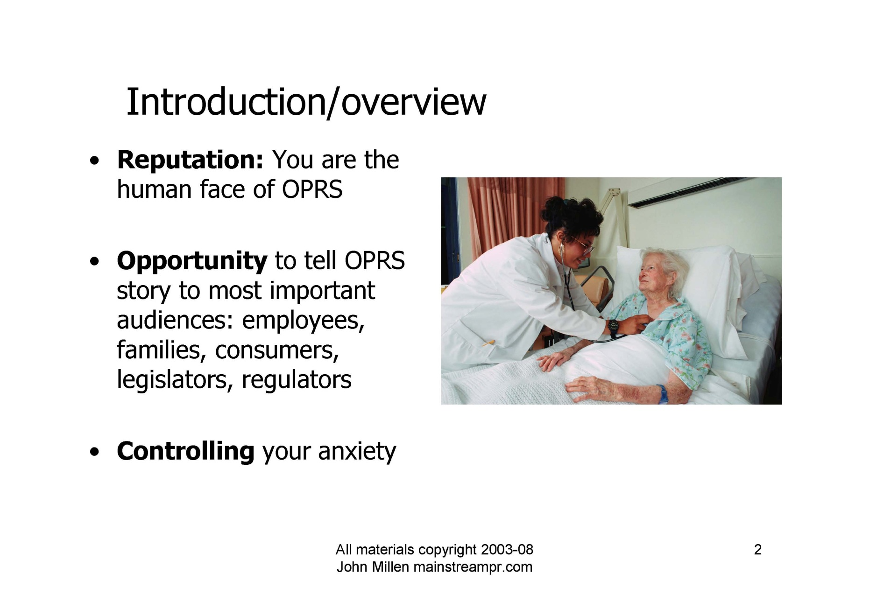

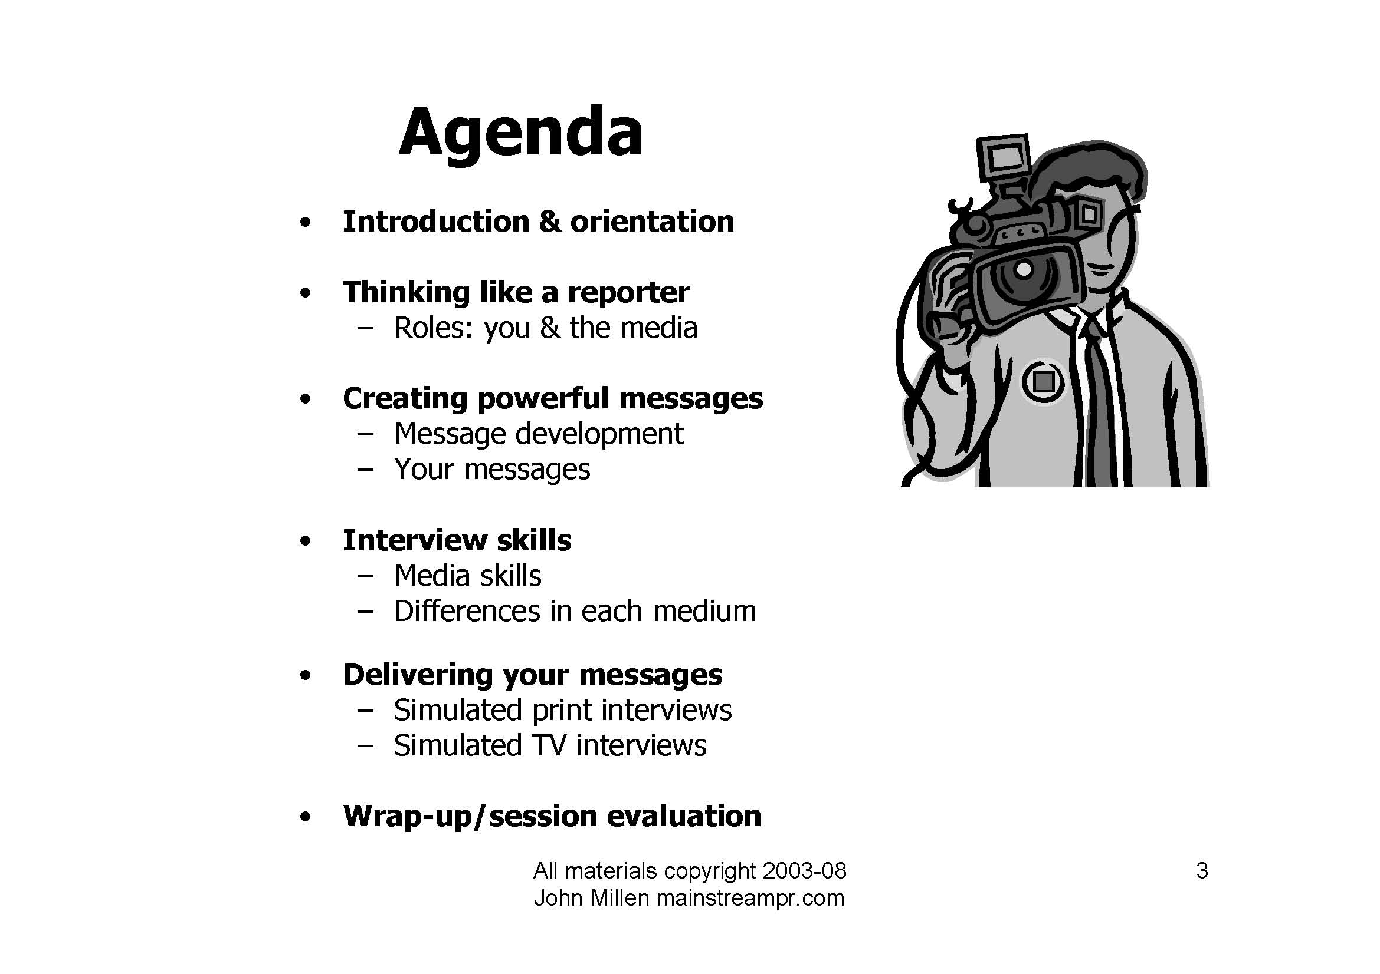

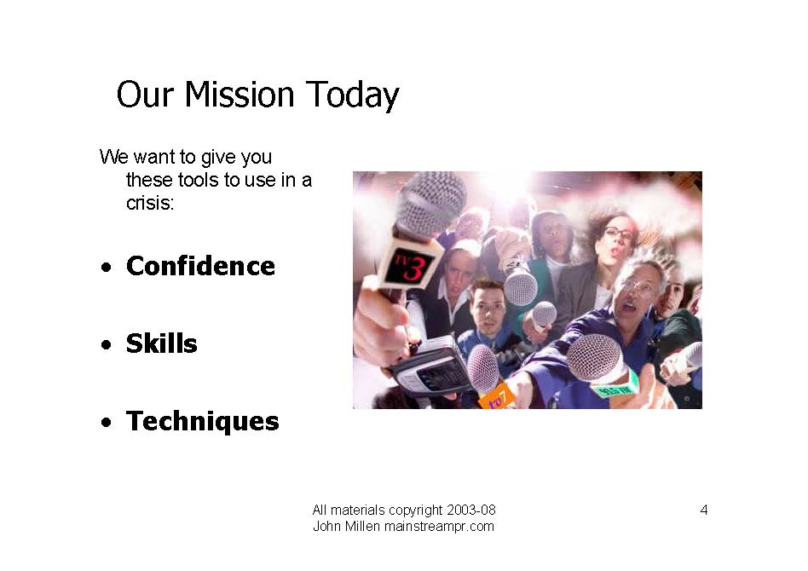

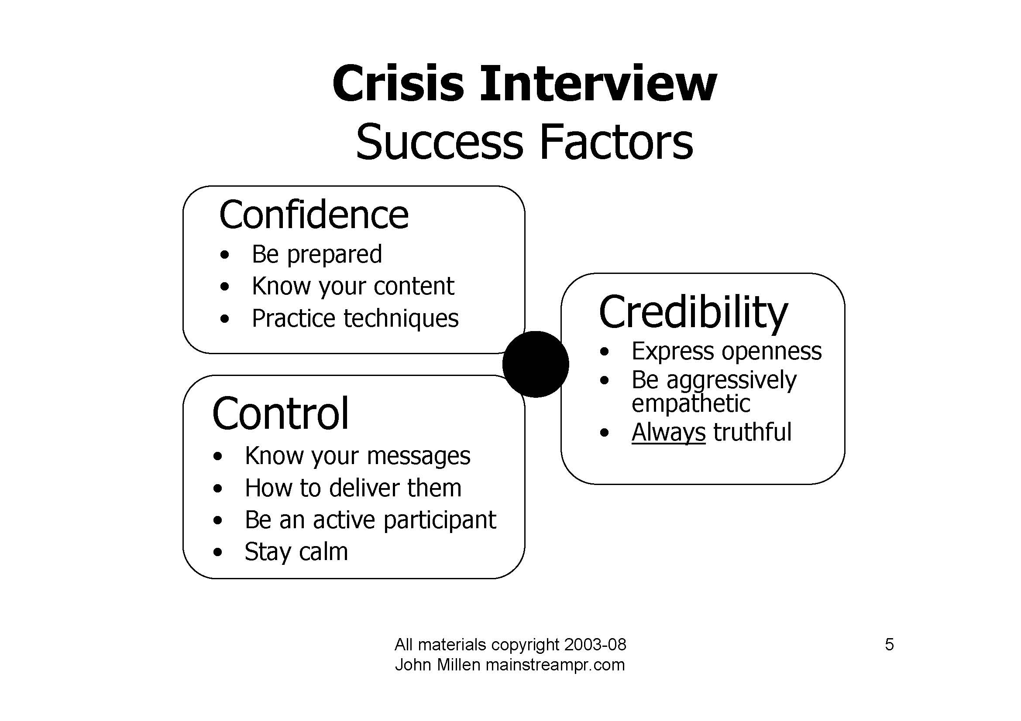

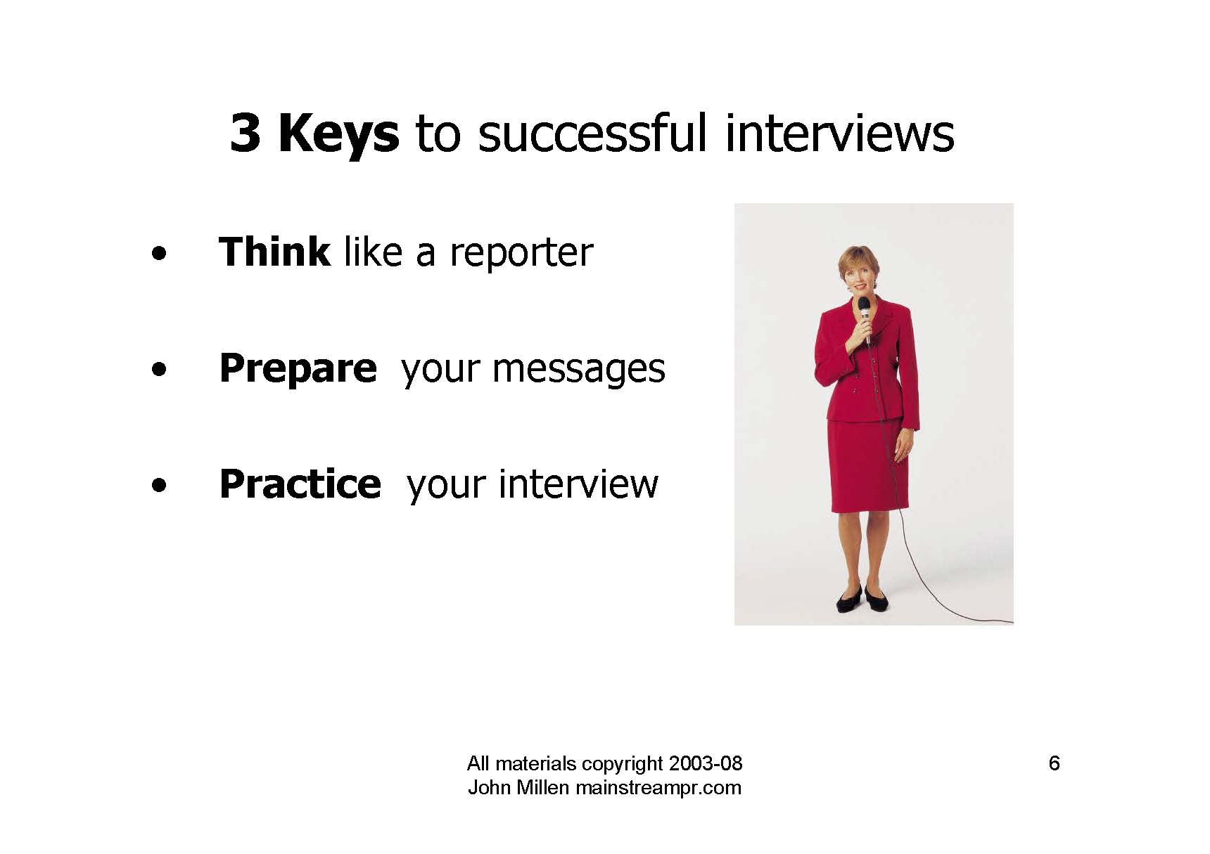

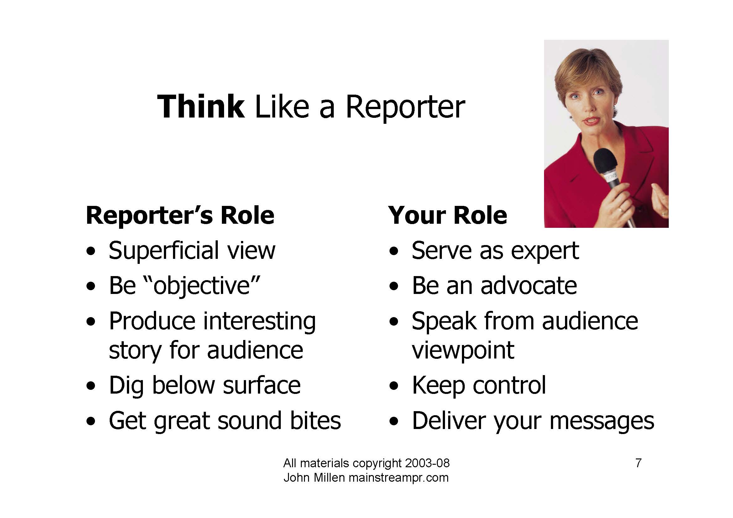

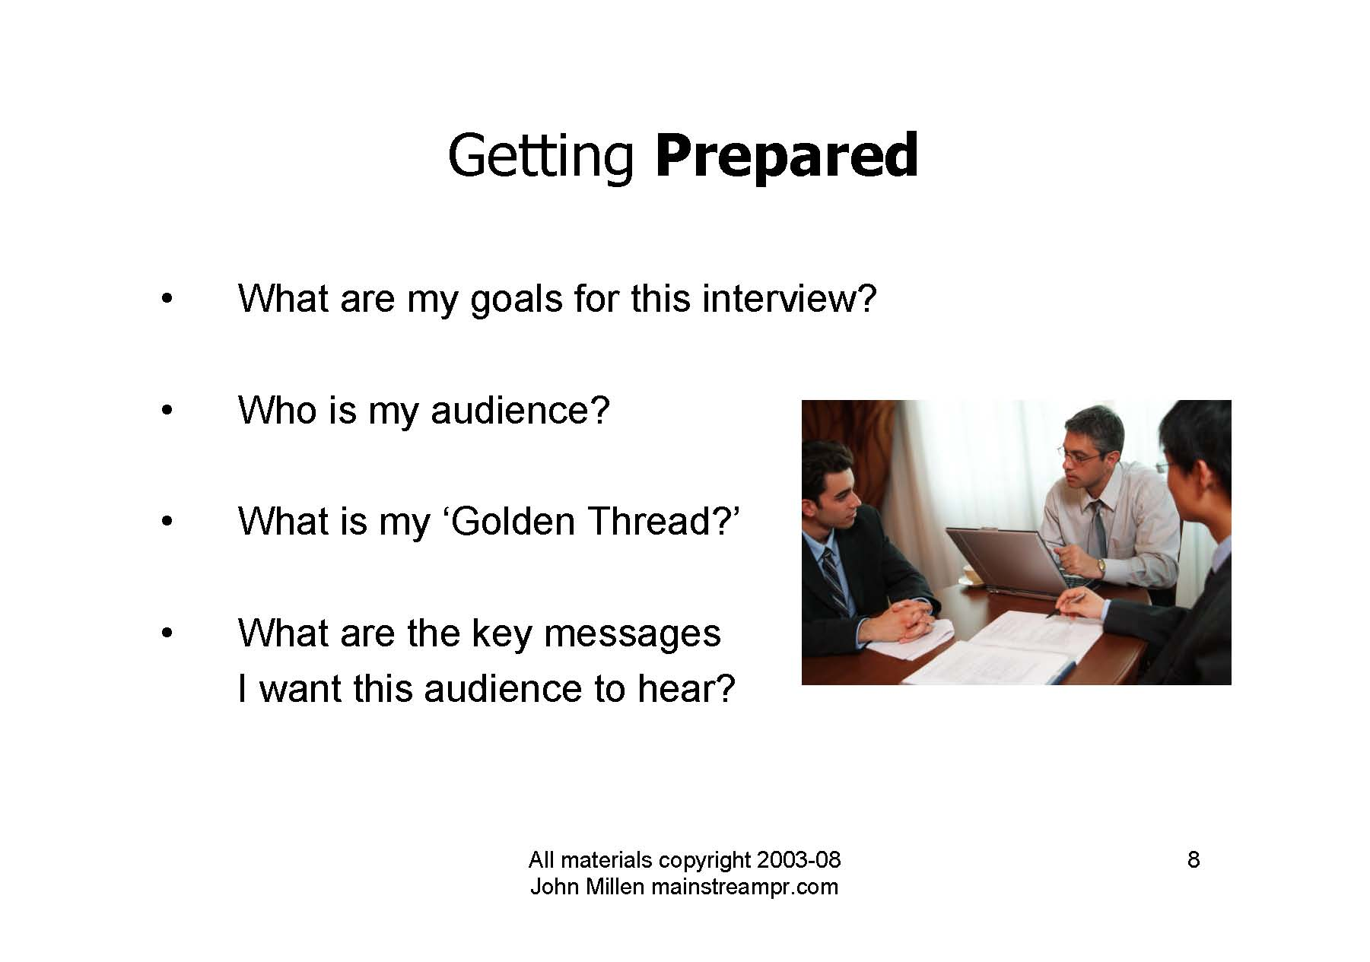



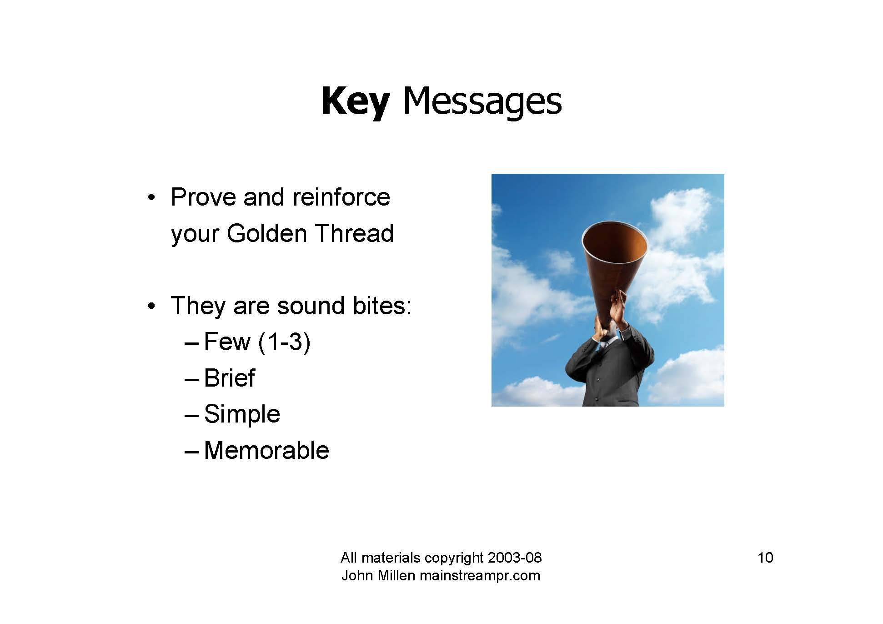

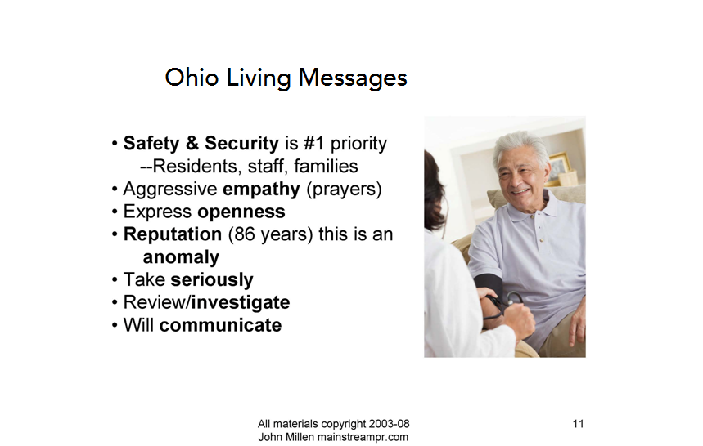

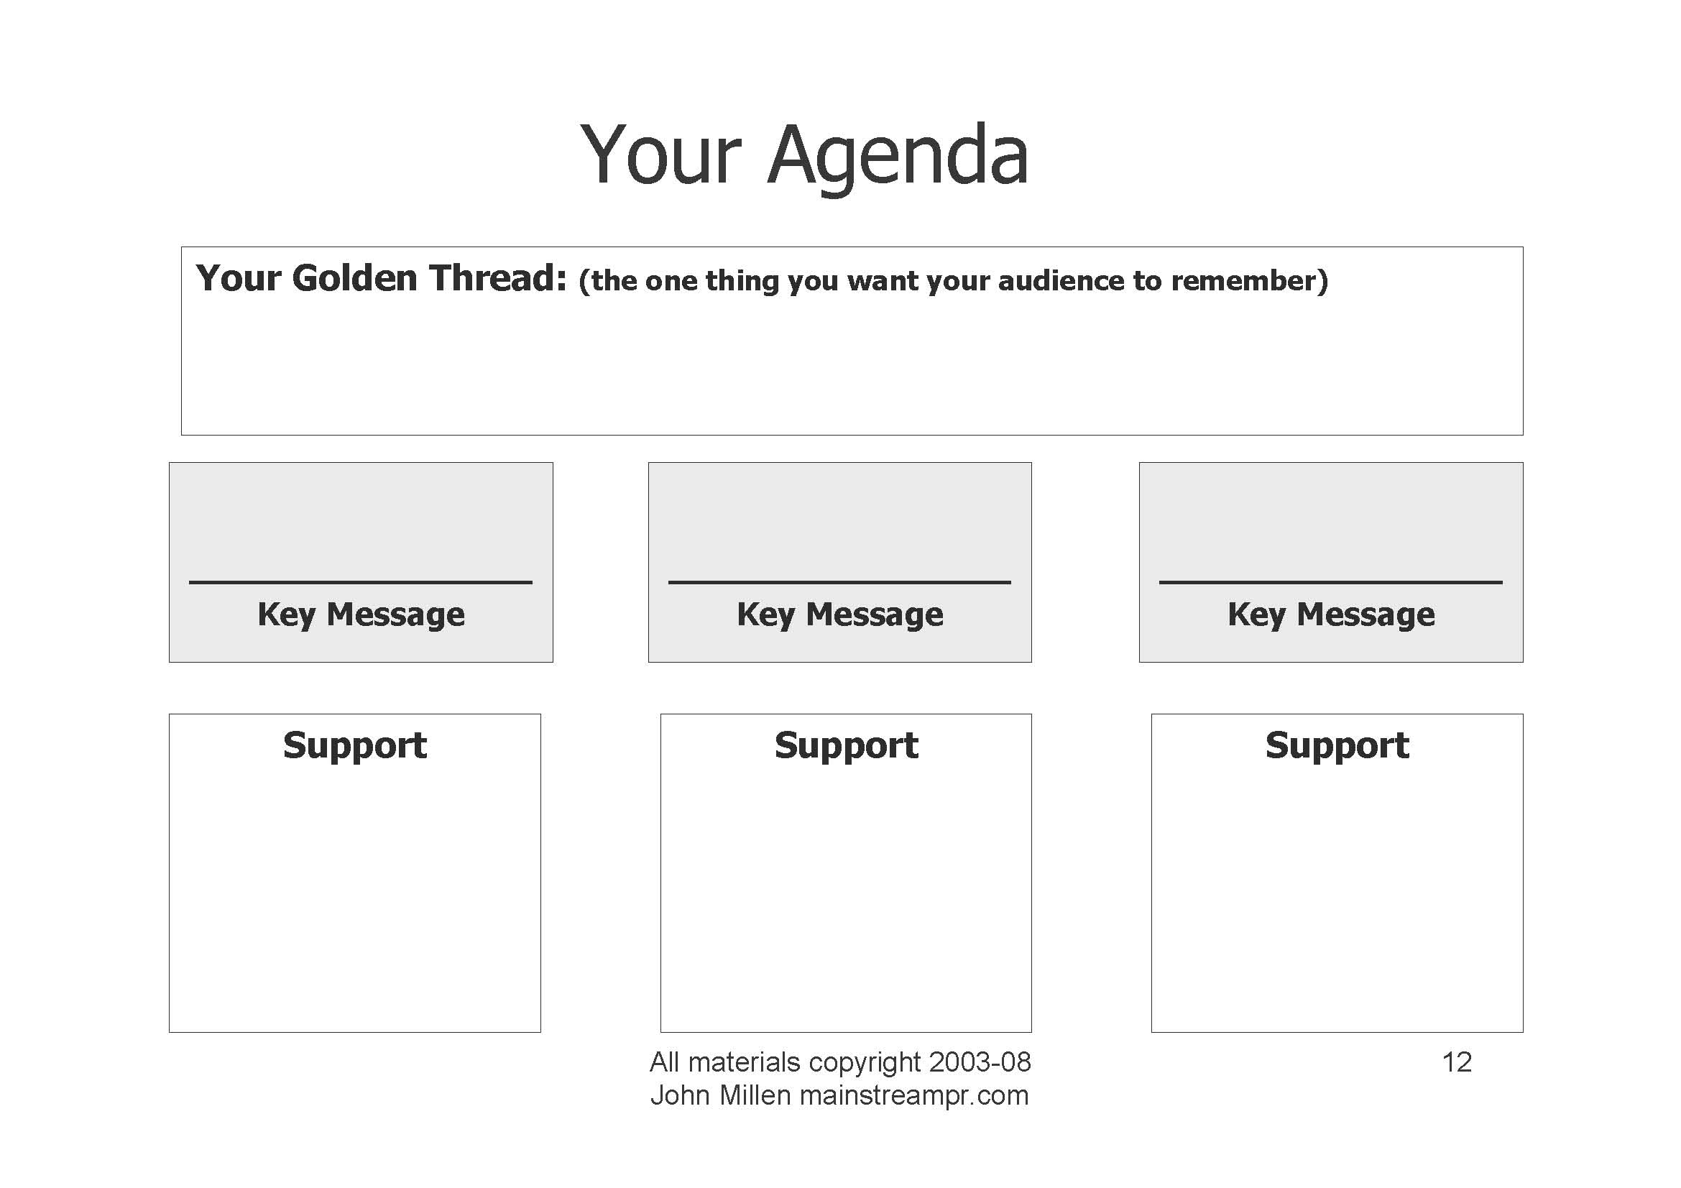



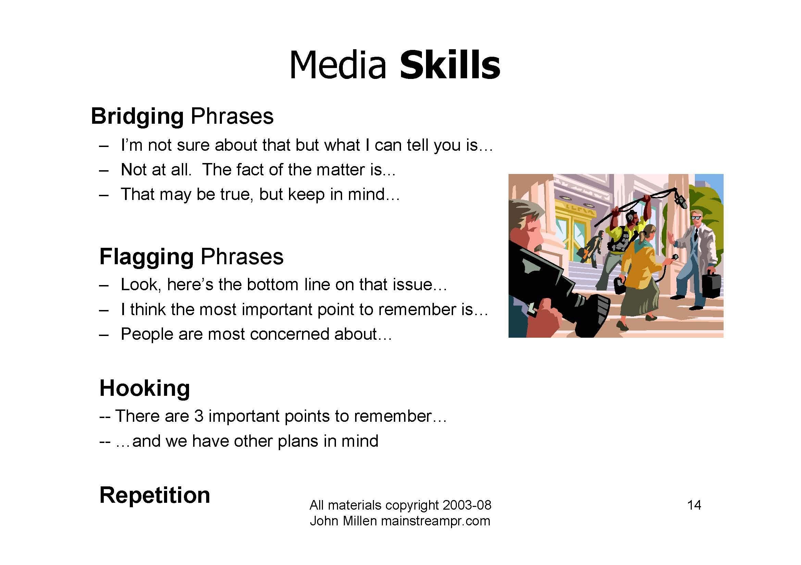

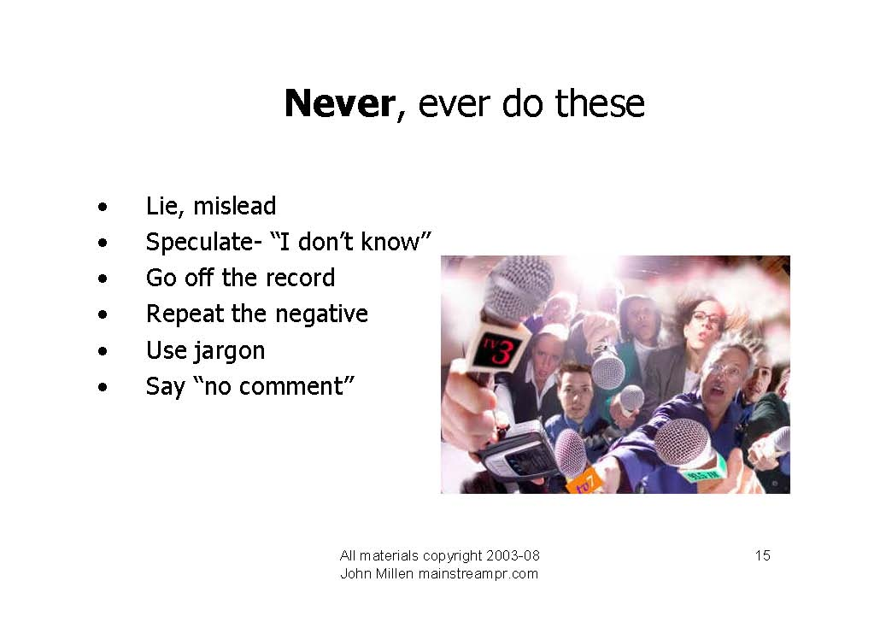

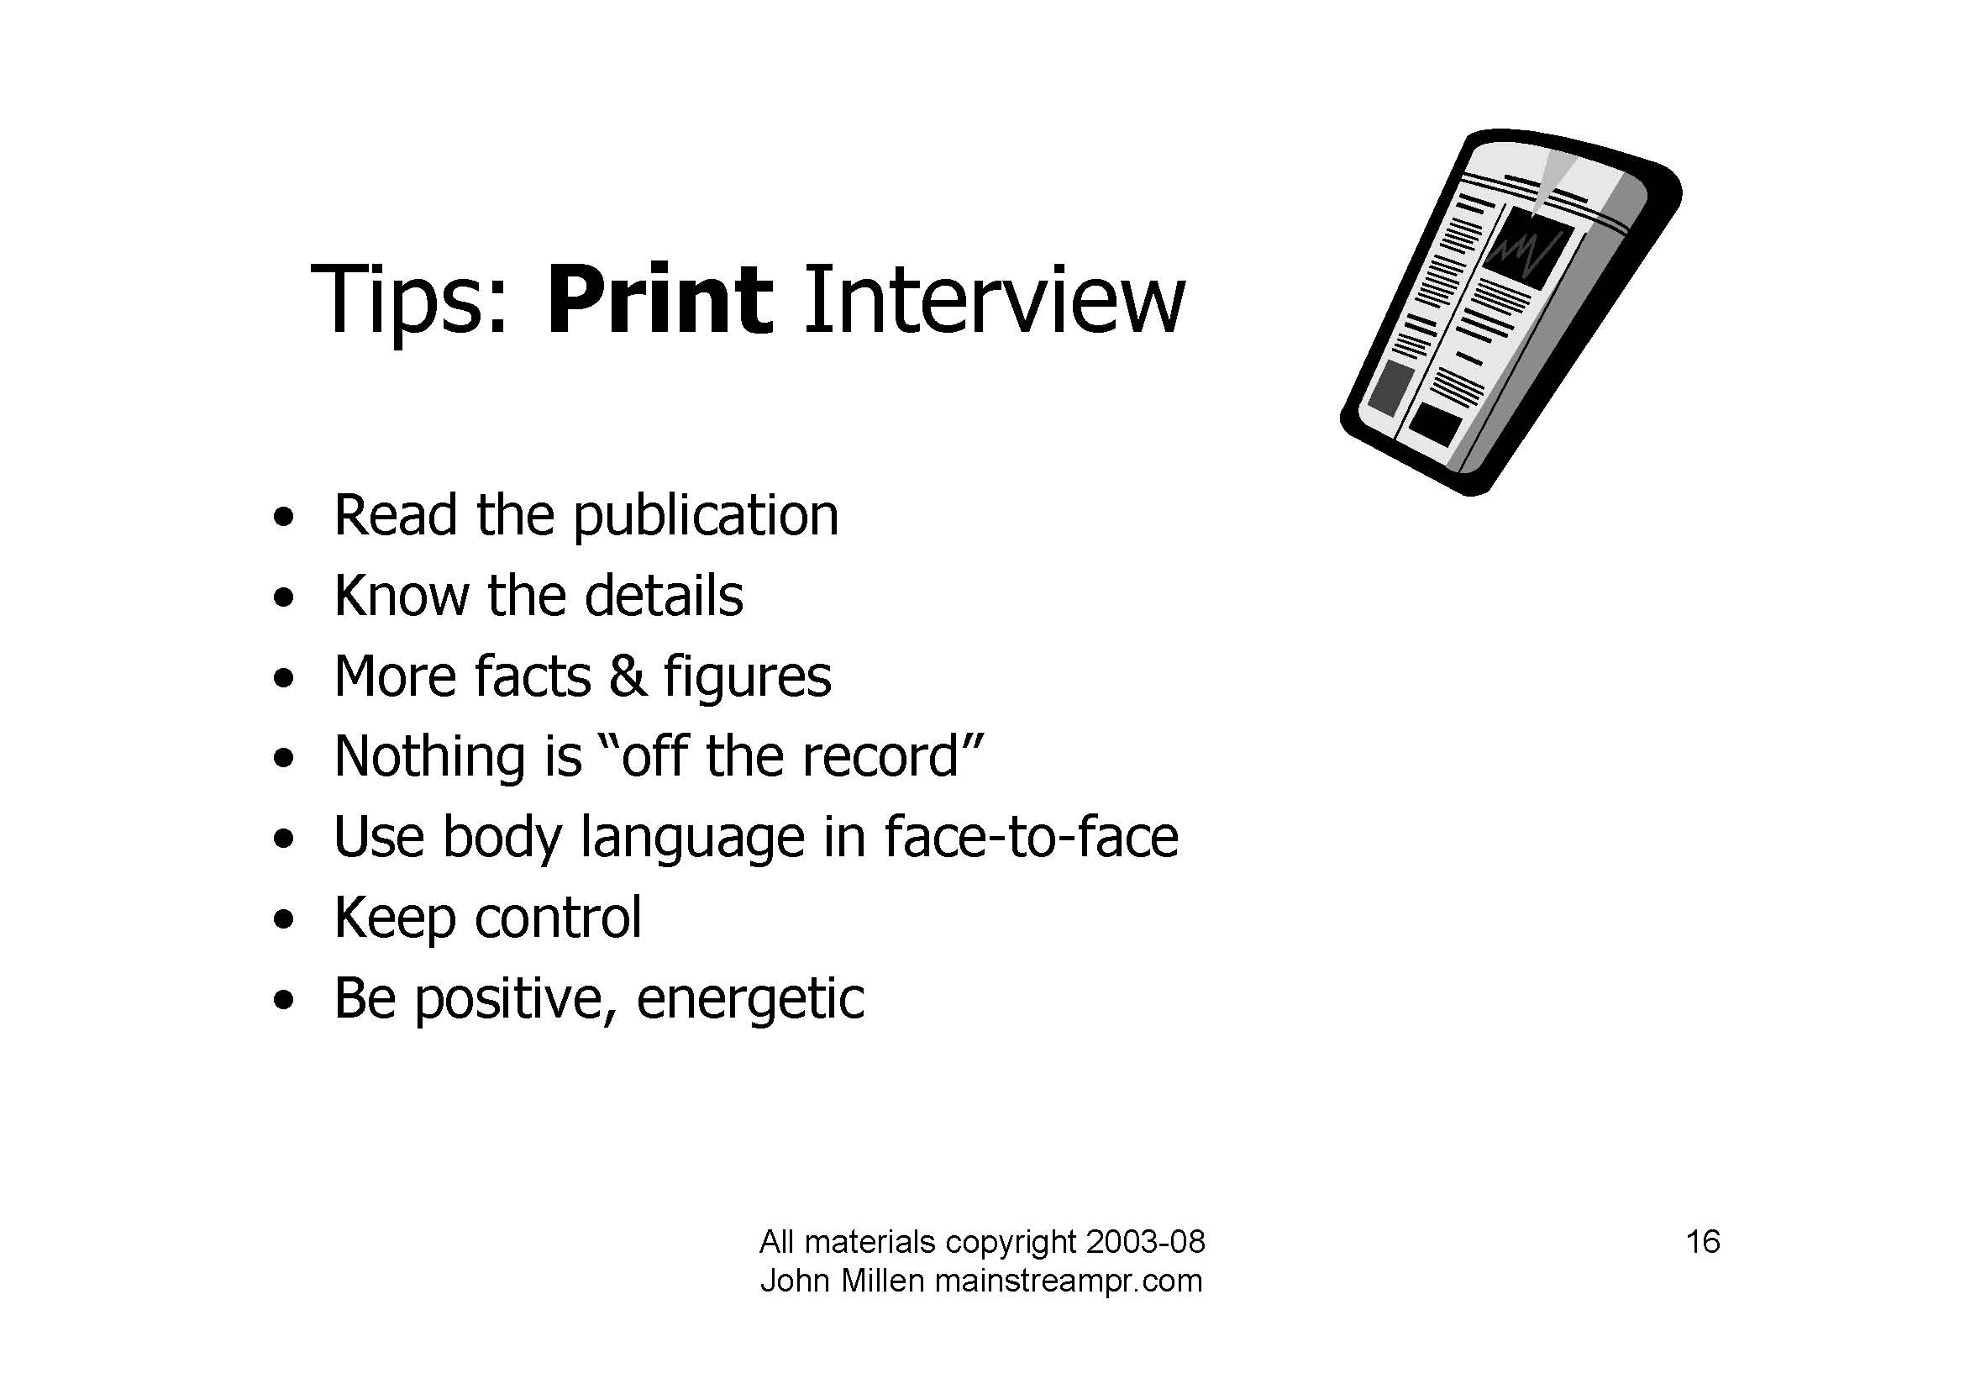

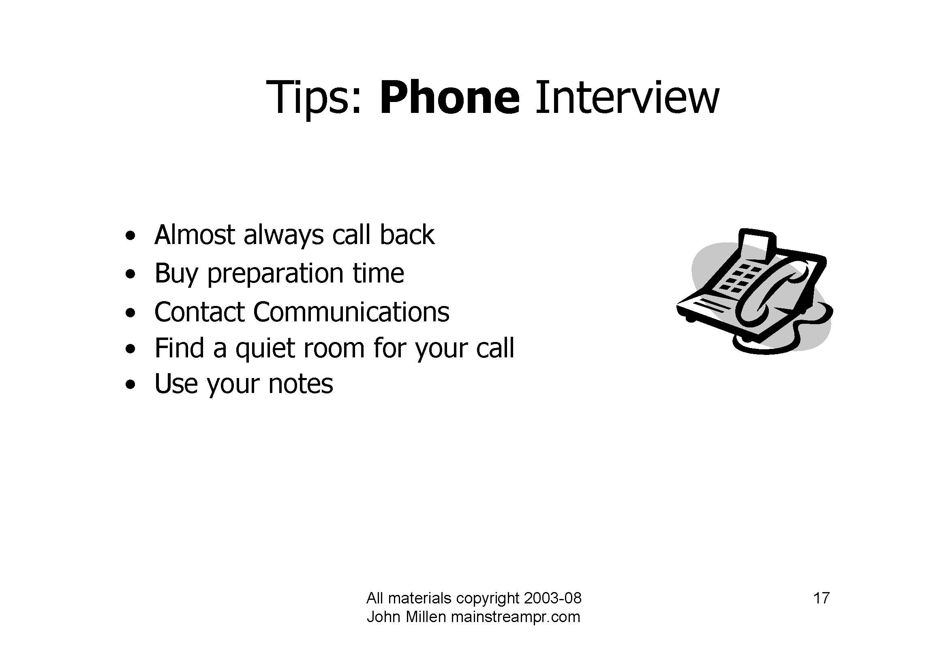



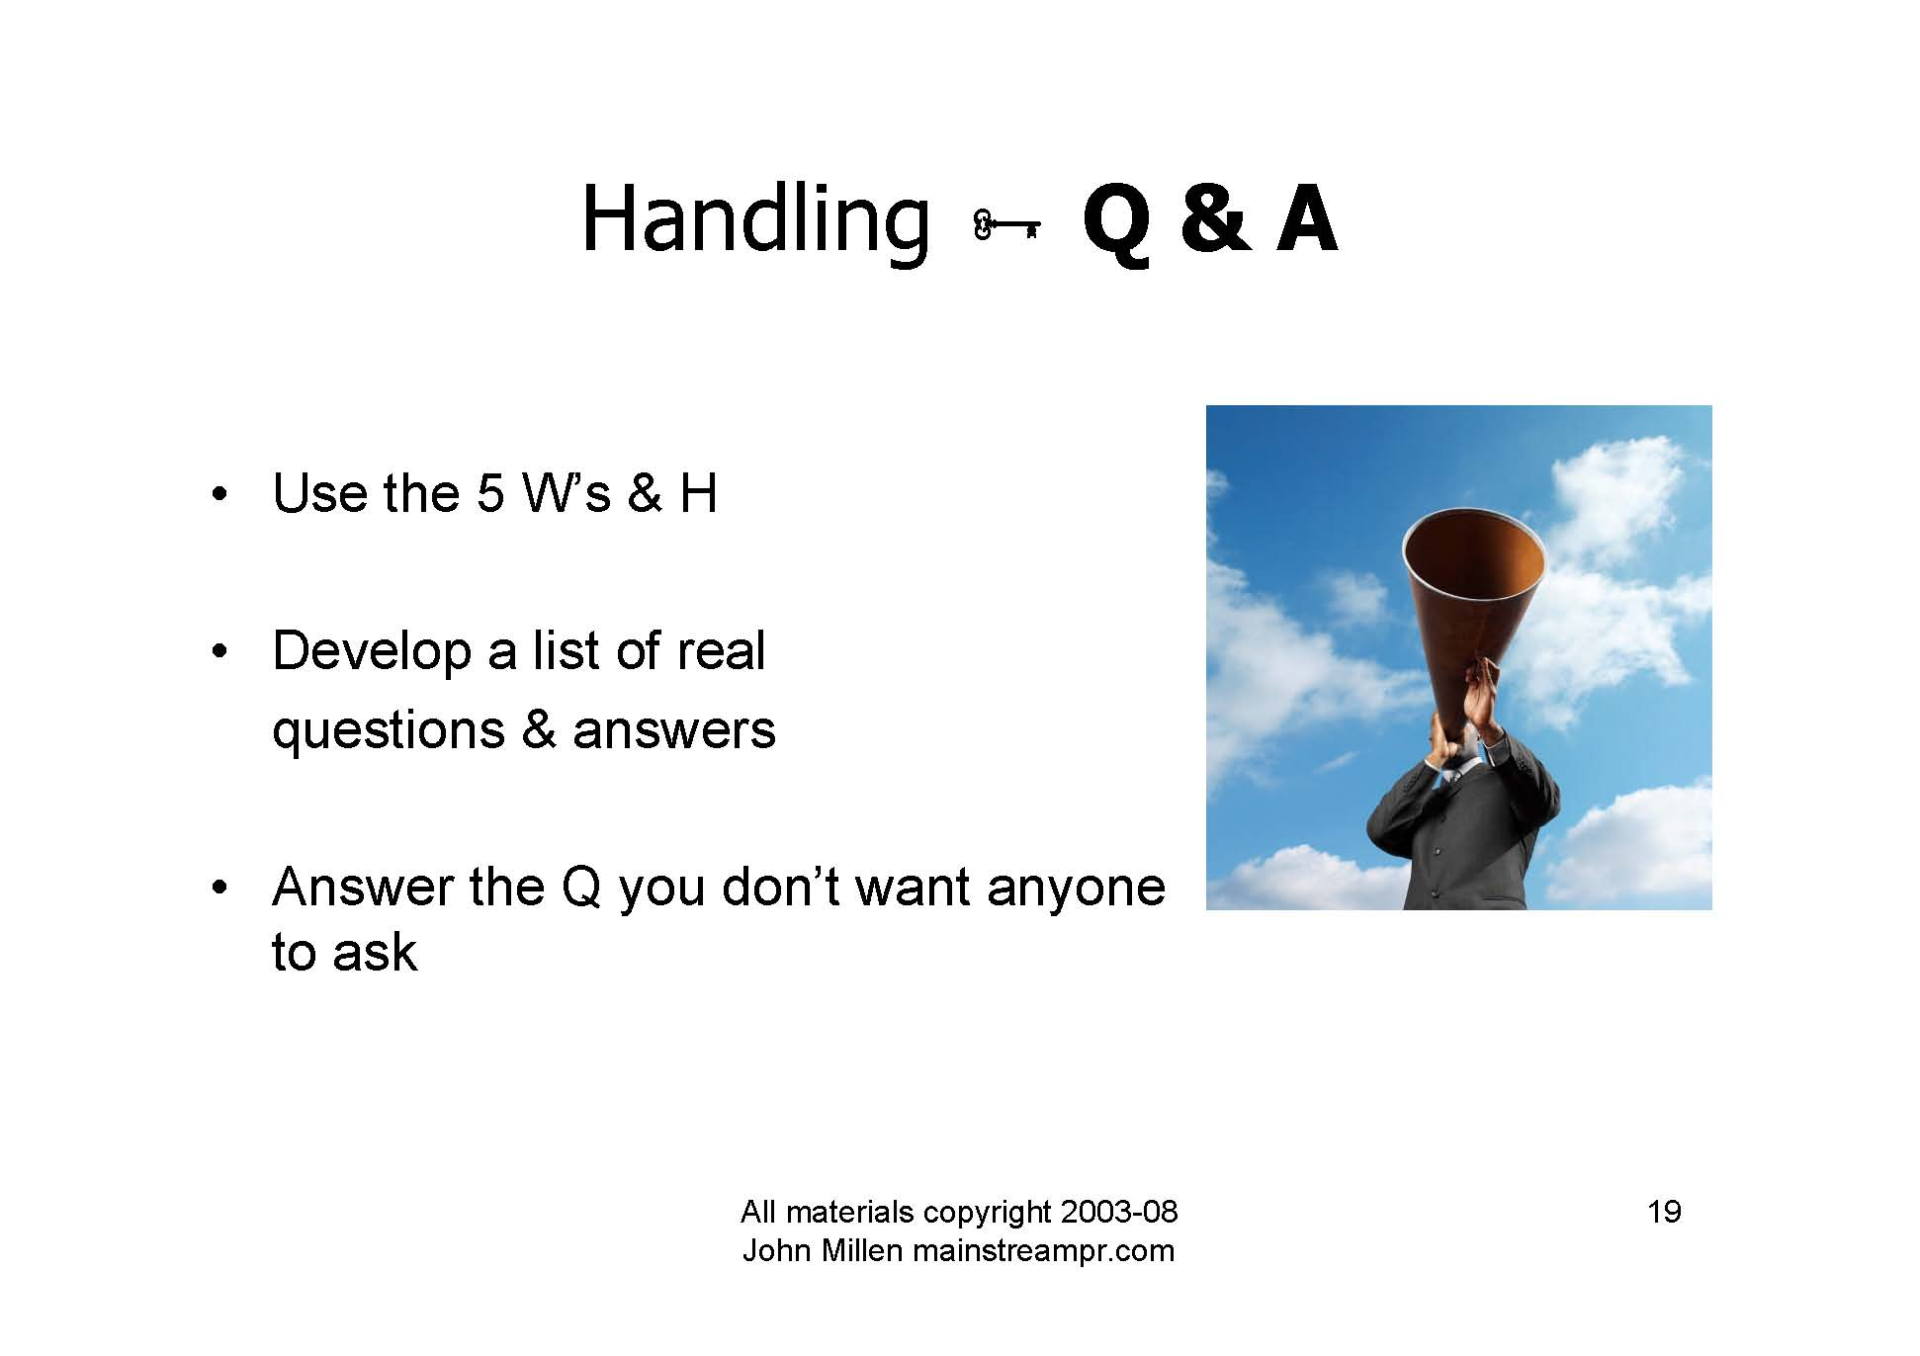

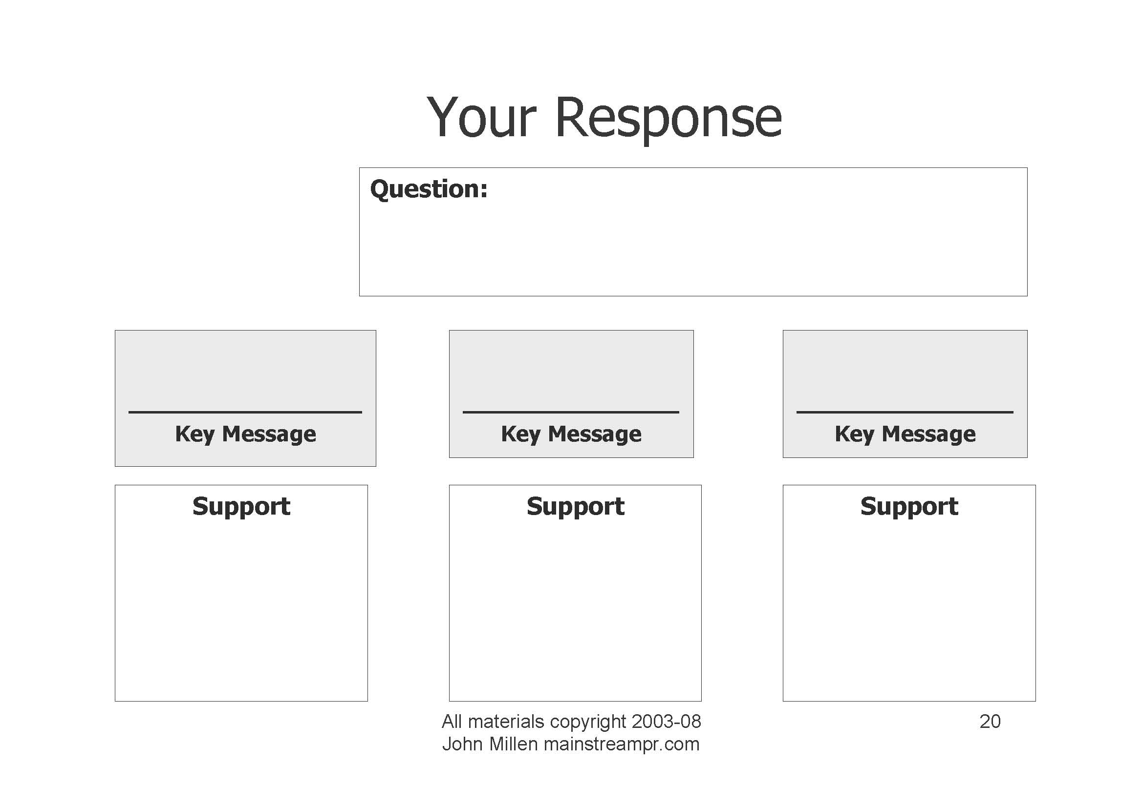

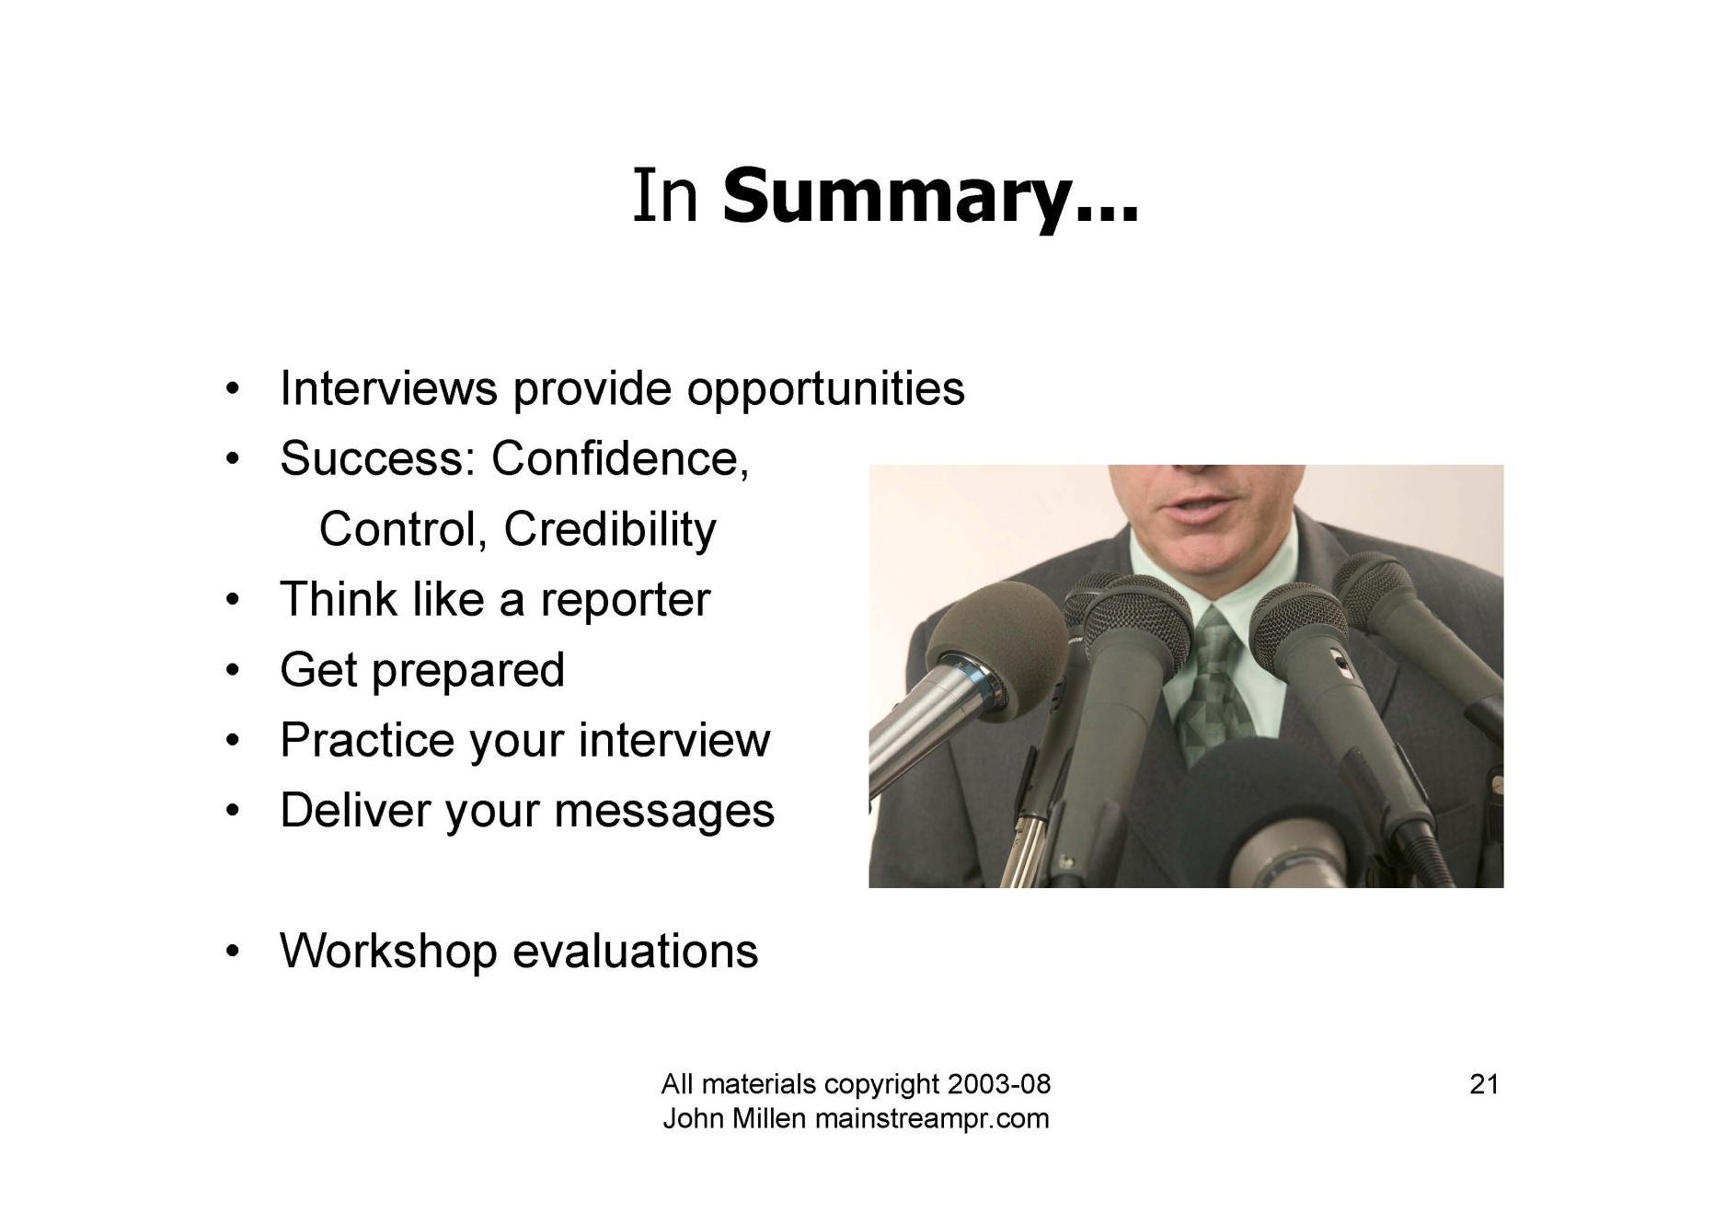

**Appendix iv**

**Environmental Emergency**

**Response**

**Environmental Emergencies**

See Emergency Procedures Plan, Policies and Procedures for the following:

* Fire Procedures
* Tornado/Severe Weather Procedures
* Evacuation Procedures
* Power Outages
* Water Disruption
* Chemical Spill
* Security Risks
* Homeland Security
* Medical Emergency

**Example Procedure for Fire Emergency**

**FIRE**

1. Follow Fire Policy and Procedure in Emergency Procedures Plan.
2. Rescue residents, clients or staff in immediate danger.
3. Follow Fire Department lead when they arrive.
4. If the fire is in the Health Care or Assisted Living areas secure medical records/charts for removal to a secured location.
5. Set up Communication Team - make calls to staff on the Emergency Call List.
6. Set up a security perimeter to prevent unauthorized persons on site during the emergency.
7. Coordinate communication to receptionist on how to handle incoming calls.
8. Establish media communication plan / statement.
9. First responders job assignments.
10. Staff assigned to resident/client comfort.
11. Relocation or staging area set up.
12. Securing emergency supplies needed .
13. Blankets, water, food, medications, cots, etc.
14. If necessary, follow resident/client evacuation plan in the Disaster Plan Manual.
15. Contact vendor support if building needs repair for temporary boarding up.
16. Establish clean up crew to address water issue and debris contact outside vendor as needed.
17. There are professional companies for fire cleanup.
18. Incident reporting completed.
19. State Fire Marshall report filled out and sent in.
20. Ohio Department of Health notification.
21. Post incident analysis.
22. Additional in-service training identified.
23. Action plan for training and drill improvements.

**Appendix v**

**Lessons Learned**

Swan Creek Retirement Village

Power Outage: 11/28/14-11/29/14

Lessons Learned

1. **Communication:** Keep families informed of what the current status is and make sure they are aware that a transfer is to happen. We should have started calling families earlier in the night. Could there be something on the website that could have been updated so families could check there? It would also be nice to have emails of families as this could have cut down on calls, although I think the families appreciated the personal calls. Could there be a number dedicated for a recorded message that families could call to get an update???? Residents did appreciate the calls-no matter what time we called them. We called families in the evening on Friday, in the morning on Saturday and on Saturday night.
2. **Call Tree for Staff:**  Make sure all managers are aware of the situation and ready to make decisions related to their departments. Make sure One-Call-Now lists are updated.
3. **Vendor Numbers:** See the attached power outage audit form. Every community should develop this form so that it can be readily available for emergent situations and this should be housed in the emergency management book at the facility. Cell numbers of key vendors should be listed so they can be reached at all hours.
4. **Transfer Agreements:** Make sure transfer agreements are up to date and useful. For instance, we had an agreement with the local school but this happened on a holiday weekend and we did not have the cell numbers for administration at the school. Make sure you have several transfer agreements.
5. **Generator Power:**  Use the audit form to make sure needed items are connected to the generator. Our POC s were not connected to the generator and this would have been helpful. Make sure refrigerators and freezers are on the generator.Have an agreement with a local company to provide extra generator capacity if needed.
6. **VPN:** Make sure staff knows how to use VPN so they can connect to the server system.
7. **Transportation:** Make sure you have a back-up transportation plan. We have a small nursing facility and one company handled the need but this would not have been sufficient if we had more residents to transfer.
8. **SI:** Call your local SI office for help with staffing issues. Tammy and Wendy were great to work with in this instance.
9. **Media:** Make sure staff answering the phones know that all media questions go to the executive director. Make sure security staff is watching for media entering the campus.
10. **Answering Phones:** Make sure there is someone is always at the front desk answering the phone-needed all through the night.
11. **Evacuation of residents:** Make sure you have bracelets on each resident leaving your facility-order some if you do not have any. Make sure when evacuating, you have someone tracking when residents leave the building and one person at the refuge taking “Roll-Call”.
12. **Medication carts and Downtime Binders:** You will have to transfer your med carts to the refuge site. Make sure your down-time binders are up-to date and you have several copies of the face sheet available. Our copier was not connected to the generator so we were printing face sheets on a small desk-top printer-not efficient. Give each resident a copy of their face sheet to hold during the transfer.
13. **Hospice Providers:** Work with local Hospice providers for placement in the local inpatient facilities if possible.
14. **Pharmacy:** Call pharmacy to let them know that you are transferring residents to a different facility. Deliveries need to be made to the right place.
15. **Ohio Department of Health:**  Make sure you call the local ODH regional office about the evacuation. I left a message and first thing Monday morning the regional director called to access the situation. The one question she asked was if the residents had hot meals. We had pizza delivered the first night and the next day we had a friend chicken dinner from Kroger.
16. **Red Cross and Local Emergency Management Agency:** Know who to contact at the local Red Cross and EMA. In this situation we could have asked for blankets to be delivered esp. since we could not use hot water.
17. **Emergency Supplies:**  After the water crisis in August, we put together an emergency supply room and this was helpful during this crisis as well.
18. **Ind Residents:**  Ind residents were given the option to go to local hostels. You need several people managing the independent side of the organization. In many ways, the independent residents seem to have more needs than the AL and skilled residents. We housed 36 residents on Friday night at local hotels. We brought them back on Saturday morning and fed them. Since the electricity was not on by 5PM, we sent them back to the hotels on Saturday night. It is very important to keep track of where everyone on the independent side is staying because families called to check on mom or dad.

|  |  |  |  |  |
| --- | --- | --- | --- | --- |
| Ohio Living Power Outage |  |  |  |  |
| Post Event Analysis |  |  |  |  |
| 12/10/2014 |  |  |  |  |
| **Power outage** |  |  |  |  |
| **Items** | **Audit** | **Audit Date** | **Acceptable** | **Action needed** |
|  |  |  |  |  |
| Call Tree: |  |  |  |  |
|  | Management Staff |  |  |  |
|  | Vendors |  |  | cell phones |
|  | Maint/ Security Staff |  |  |  |
|  |  |  |  |  |
| **Generator Provides Power to :** |  |  |  |  |
|  |  |  |  |  |
| **Skilled Building:** |  |  |  |  |
|  | Heating Boilers | 5-Dec | yes | correction!! the boilers are on EMP |
|  | Pumps for Heat loop | 5-Dec | yes | Pump #2 |
|  | Controls on HVAC | 5-Dec | no |  |
|  | Heat in Corridors | 5-Dec | no |  |
|  | Heat in Resident rooms | 5-Dec | no |  |
|  | Lights | 5-Dec | yes |  |
|  | Nurses call | 5-Dec | yes |  |
|  | Phones | 5-Dec | yes |  |
|  | Fire Alarm Panel | 5-Dec | yes |  |
|  | One outlet in each room | 5-Dec | yes |  |
|  | Corridor Outlets | 5-Dec | yes |  |
|  | POC outlets | 5-Dec | yes |  |
|  | Computers | 5-Dec | yes | both computers at nurse's station |
|  | Portable phones/ Chargers | 5-Dec | yes |  |
|  | Security / Maint Radio Chargers | 5-Dec | yes |  |
|  | Hot Water Boilers and Pumps | 5-Dec | no |  |
|  | Exit Lights | 5-Dec | yes |  |
|  | Exterior Lighting | 5-Dec | yes |  |
|  | Door Controls | 5-Dec | no |  |
|  | Kitchen equipment | 5-Dec | no |  |
|  | Refrigeration - Food | 5-Dec | yes | in kitchenettes |
|  | Med Refrigeration | 5-Dec | yes |  |
|  |  |  |  |  |
| **Assisted Living Building:** |  |  |  |  |
|  | Heating Boilers | 5-Dec | yes |  |
|  | Pumps for Heat loop | 5-Dec | yes | pump #2 |
|  | Controls on HVAC | 5-Dec | no |  |
|  | Heat in Corridors | 5-Dec | no |  |
|  | Heat in Resident rooms | 5-Dec | no |  |
|  | Lights | 5-Dec | yes |  |
|  | Nurses call | 5-Dec | yes |  |
|  | Phones | 5-Dec | yes |  |
|  | Fire Alarm Panel | 5-Dec | yes |  |
|  | One outlet in each room | 5-Dec | no | There are no EM outlets in the rooms |
|  | Corridor Outlets | 5-Dec | yes | 1500 watts/outlet |
|  | Computers | 5-Dec | yes | at nurse's station and recept. Desk |
|  | Portable phones/ Chargers | 5-Dec | yes |  |
|  | Security / Maint Radio Chargers | 5-Dec | yes |  |
|  | Hot Water Boilers and Pumps | 5-Dec | no |  |
|  | Exit Lights | 5-Dec | yes |  |
|  | Exterior Lighting | 5-Dec | yes |  |
|  | Door Controls | 5-Dec | no | M.E.C. and exit to Main St. |
|  | Kitchen equipment | 5-Dec | no |  |
|  | Refrigeration - Food | 5-Dec | no |  |
|  | Med Refrigeration | 5-Dec | yes |  |
|  |  |  |  |  |
| **Apartment Building:** |  |  |  |  |
|  | Roof top Units | 5-Dec | yes |  |
|  | Controls | 5-Dec | no |  |
|  | Heat in Corridors | 5-Dec | yes |  |
|  | Heat in Residents Apts. | 5-Dec | no |  |
|  | Lights | 5-Dec | yes |  |
|  | Emergency call | 5-Dec | yes | ???? |
|  | Phones | 5-Dec | yes |  |
|  | Fire Alarm Panel | 5-Dec | yes |  |
| emp. | Computers | 5-Dec | no | elect, data |
|  | Corridor Outlets | 5-Dec | no | There are no EM outlets in corridor. |
|  | Portable phones/ Chargers | 5-Dec | yes |  |
|  | Security / Maint Radio Chargers | 5-Dec | yes |  |
|  | Hot Water Boilers and Pumps | 5-Dec | no |  |
|  | Exit Lights | 5-Dec | yes |  |
|  | Exterior Lighting | 5-Dec | yes |  |
|  | Door Controls | 5-Dec | yes |  |
|  | Kitchen equipment | 5-Dec | no | Gas stove (yes), hood system, freezers, walk/reach in |
|  | Refrigeration - Food | 5-Dec |  | refrigerator ( no ). |
|  | Med Refrigeration | 5-Dec | n/a |  |
|  |  |  |  |  |
| **Safe Havens on Campus** | Location |  |  |  |
|  | Heat/ Lights/ Restrooms |  |  |  |
|  | How many will it hold? |  |  |  |
| HVAC Controls System: |  |  |  |  |
|  | Software local or Web based? | 5-Dec | no | network access only |
|  | Log In |  |  |  |
|  | Default modes |  |  |  |
|  | In Service |  |  |  |
|  | 24 / 7 service |  | yes | Kevin Lewis - 419-261-2625 |
|  |  |  |  |  |
|  |  |  |  |  |
|  |  |  |  |  |
| Server on Emergency power |  |  |  |  |
|  | What Computers will work |  |  |  |
|  | HR - Payroll |  | no |  |
|  | POCs |  |  |  |
|  | Main Desk |  | no |  |
|  | HVAC Control Systems |  | no |  |
|  |  |  |  |  |
| **Generator** |  |  |  |  |
| Emergency Panel Locations |  |  |  |  |
|  | Breakers Labeled | 5-Dec | yes |  |
|  |  |  |  |  |
| Hours per Gallon under load | Refill rate |  |  |  |
|  | Diesel Fuel Refill | 29-Nov | yes | 2 in/hr. - 1000 gal reserve tank |
|  | Fuel Contact Numbers - 24/7 | 2-Jul | yes | Tri county fuel - 419-343-1527 or 419-467-5748 |
|  | Diesel Fuel Refill Plan B | 29-Nov | yes | Brahier Fuel and Oil -419-531-2218 |
|  |  |  |  |  |
| Spare Power |  |  |  |  |
|  | Which Outlets can take electric heaters. |  |  |  |
|  |  |  |  |  |
| Other Contacts |  |  |  |  |
| Local Utility Contacts | Local Utility Contacts |  |  |  |
|  | Electric | 3-Dec |  | 1-800-447-3333- cs, Mark Everheart 419-392-8959 |
|  | Gas | 3-Dec |  | 1-800-344-4077 |
|  | Water | 3-Dec |  | 419-245-1800 |
|  | Propane |  |  |  |
|  |  |  |  |  |
|  |  |  |  |  |
| Local Emergency Management Agency | Local Emergency Management Agency | 5-Dec |  | Pat Momey, 419-213-6506- (8:30 - 4:30p) |
|  |  |  |  |  |
| Red Cross | Red Cross | 5-Dec |  | Jessica - 419-329-2900 #1 |
|  |  |  |  | Red Cross will contact EMA after hours and weekends |
| Transfer Agreement |  |  |  |  |
|  | Contacts and Plan B | 12/12/2014 |  | Lifestar-Dispatch Number:  419-245-6220 |
|  |  |  |  | St. Luke's Nursing Supervisor Number:  419-897-5438 (Transfer Agreement) |
| Transportation Plan |  |  |  | Maumee Valley Country Day School:  419-381-1313 (Transfer Agreement) |
|  | Buses |  |  | Flower Hospital:  419-824-1444 (Transfer Agreement) |
|  | Wheel Chair Buses/ Vans |  |  | UTMC:  419-383-4000 (Transfer Agreement) |
|  | Ambulance |  |  | Ohio Living Home Health and Hospice (Hospice and Help with staffing etc.) |
|  |  |  |  | America's Best:  1-800-383-5303  (Oxygen Company-May need to call to bring portable tanks) |
|  |  |  |  | NWO Hospice:  419-661-4001 (could help if they have patients in the building) |
|  |  |  |  | Promedica Hospice:   419-824-7400 (could help if they have patients in the building) |
| Additional Back up Generator |  |  |  |  |
|  | Rental | 5-Dec | yes | Transtar Electrical - Jerry 419-356-7801 |
|  | Local Utility |  |  | Nate 419-779-2252 |
|  | How to Hook up | 5-Dec | yes |  |
|  |  |  |  | Sunbelt rentals - 419-861-5155 |
| Emergency Heating Systems |  |  |  |  |
|  | Rentals | 9-Dec | yes | Sunbelt Rentals - 419-861-5155 |
| Emergency Cooling Systems |  |  |  |  |
|  | Rentals | 9-Dec | yes |  |
|  |  |  |  |  |
| **Post event** |  |  |  |  |
|  | Refill Generators and Fuel Storage tanks | 29-Nov | yes |  |
|  | Check Drained Batteries in Exit Lights | 8-Dec | yes |  |
|  | Flash Light Batteries re-stocked | 3-Dec | yes |  |
|  | Portable heaters remove and store | 29-Nov | yes |  |
|  |  |  |  |  |
|  | Dispose of Food in effected Refrigerators | 12/5/2014 | yes |  |
|  | Call for Dumpster pick up when done. | 12/3/2014 | yes |  |