Cleansing and Dressing Application
- With each dressing change: CLEANSE WOUND WITH NORMAL SALINE OR DERMAL WOUND CLEANSER
- Apply Skin-Prep to peri-wound skin, allow to dry before applying adhesive dressings Revised 11/10/21

Description | Skin Tear | Blister | Stage I | Stage II | Stage III |  | Stage IV | Slough and/or Eschar
 | 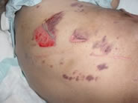 |  |  |  | 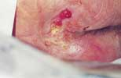 | 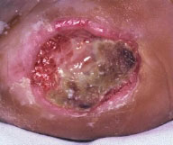 |  | 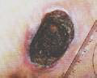
Rational | - Protect  - Manage exudate | - Protect  - Manage exudate | - Protect  - Remove cause | - Protect  - Manage exudate | - Protect  - Manage exudate  Fill dead space if necessary |  |  | - Protect  - Manage exudate  - Debride
Treatments and Dressing Change Intervals | With Flap  Approximate the edges, secure with Steri-Strips: Assess daily for infection and dressing placement  Without Flap  Adhesive foam drsg Change q 5d and PRN | - Skin Prep wipe to blister daily X3 days  - Alleviate and relieve pressure to area | Change position in bed or chair every 1-2 hours  Apply pressure reduction devices (heels, cushion, mattress, etc)  Maintain HOB 30 degrees or less  Use lift sheet for repositioning  Keep off of affected area  *See skin integrity/prevention protocol  Consider foam drsg for prevention Change q 7d & PRN | No to light exudate  Adhesive Foam drsg Change q5 days and PRN  Moderate to heavy exudate  Adhesive Foam drsg  (use the appropriate type: size and shape, sacral, heels, etc.) Change q5 days and PRN | None to light exudate  - Adhesive foam drsg  - Change q 5 days and PRN  - Hydo Gel, secure with Foam drsg  - Change daily and PRN  Moderate to heavy exudate-  - Alginate secure with Adhesive foam drsg  - Change q3 days and PRN  Stalled non-healing wound  - Collagen drsg & cover with Adhesive foam drsg  - Change q 5 days  Suspected Infection with multiple bacteria  - Antimicrobial drsg with Foam drsg  - Change 3 days  - Iodine gal pad secured with Adhesive foam drsg  Change q 3-5 days and PRN |  |  | If the wound appears to have purulent drainage, and/or necrotic tissue or eschar, notify nursing management. Consider  Enzymatic debriding agent Cleanse with NS and apply daily. Cover with Adhesive foam drsg  Suspected Biofilm  Iodine gel pad secured with Adhesive foam drsg. Change q3-5 days and PRN

