**Access eRiskHub’s Services and Resources**

Unlike insurance companies, your partnership with the Pool provides you with cyber liability coverage and related resources at no cost.

To access and take advantage of these services and resources follow these steps:

1. Visit our website [www.tmlirp.org](http://www.tmlirp.org) and click on LOGIN in the menu at the top of the homepage.

*If you do not yet have a password please contact: [mpsupport@tmlirp.org](mailto:mpsupport@tmlirp.org). If you have any other questions contact your member services manager.

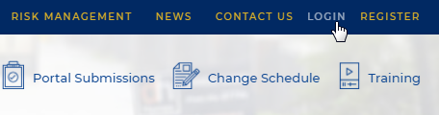

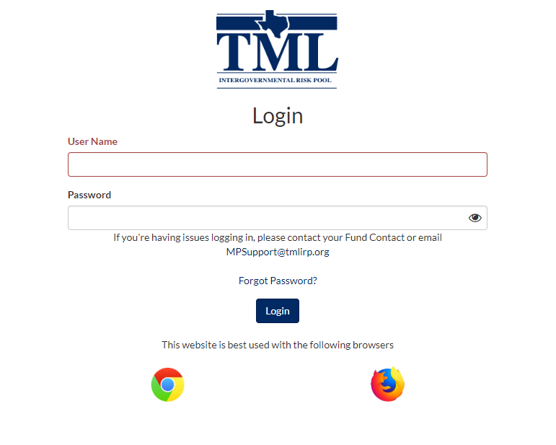

1. Click on the eRiskHub icon in the top right corner of the page.



1. On the eRiskHub home page members have access to these services and more:

**Pre-breach Services**

* Best Industry Practices
* Online Risk Assessment Tools
* Training
* White Papers

**Post-breach Services**

* Privacy Breach Response Services
* Notification of Affected Individuals
* Call Center Support
* Breach Resolution
* Legal Services
* Computer Expert Services
* Public Relations and Crisis Management Services

