EBCD MEDITECH Content Updates – 2022.2

NUR Module
This document is a high-level overview for end user education purposes about significant changes within the Nursing Module screens.
The enhancements are listed by intervention and provide a rationale behind the change and screenshot example(s).
Please read the MEDITECH selected prompts and follow the yellow information boxes onscreen as you become aware of changes in the documentation.

eMAR – Pain Management
In alignment with the Multi modal pain protocols and to ensure pain medication administration triggers a pain reassessment when administered, the Administering for pain field has been updated.
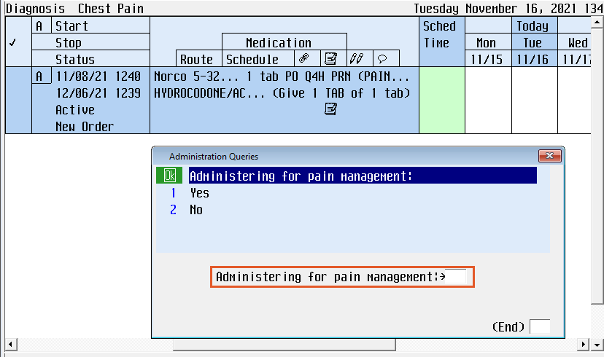 | Administering for pain has been changed to Administering for pain management in eMAR when documenting a pain medication.  Note: If this is ordered for pain management and or pain control, regardless if the patient is actively having pain, the clinician should select “Yes.”  If this is ordered for fever, such as Tylenol, it is appropriate for the clinician to select “No.”

eMAR – SUBQ Previous Injection Sites Info Box
Some medications, when administered via subcutaneous (SUBQ) route, should have the administration site rotated between doses. Currently the nurse has to manually go back and review the previous administration sites. An alert has been created to automate this process, providing the 4 most recent administration site(s) for the current medication order and displaying them to the documenting nurse along with the associated date(s) and time(s)
* Dalteparin (Fragmin) * Enoxaparin (Lovenox)
* Desirudin (Iprivask) * Fondaparinux (Arixtra)
* Unfractionated heparin

Screen Sample of the Past Administrations box  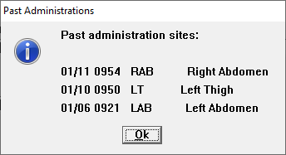 | Alert will only fire if documenting the order as “Given”.  Alert will NOT fire if documenting the order as “Not Given” or performing the action of “Undo” and there are no previous administrations on the current medication order.  After review of the informational alert, click “Ok” and proceed with documentation.  The alert will display one time. Either when the cursor lands in the Dose field or after the nurse selects a Site for the current administration. If this occurs, the nurse will need to review the information provided and determine if the Administration Site should be adjusted on the current documentation.

Dysphagia Screening
The Pass/fail dysphagia screening field has been updated in the following interventions:

Dysphagia Screening and Frequent Neuro Checks
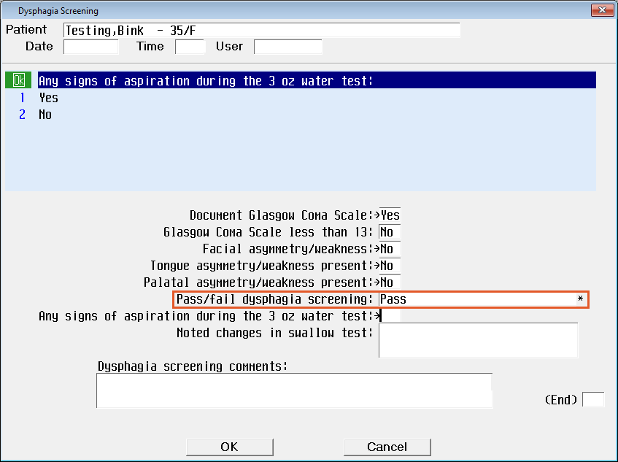  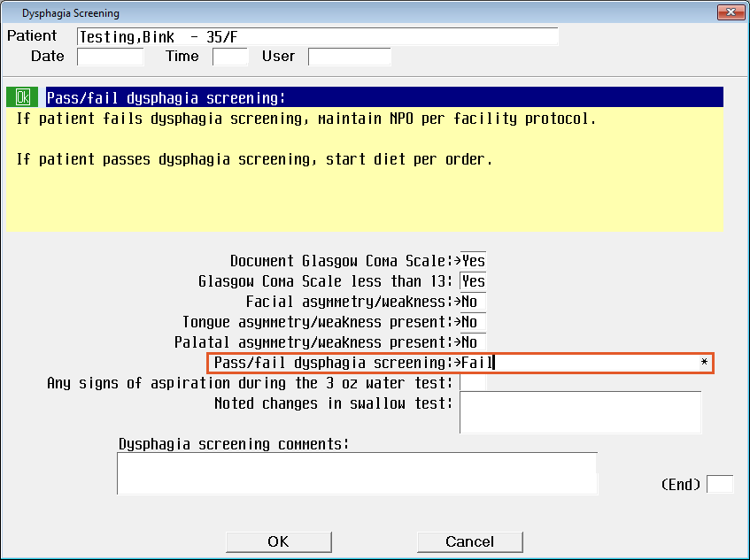 | If Pass/fail dysphagia screening is “pass,” the clinician will be able to document any observations during the 3oz. water test.  If Pass/fail dysphagia screening is “fail,” the clinician will skip over the 3oz. water test questions.  The Yellow Information Box has also been removed.  Note: If patient has a Glasgow Coma score greater than 13, the patient’s dysphagia will default to Fail.

Intake and Output
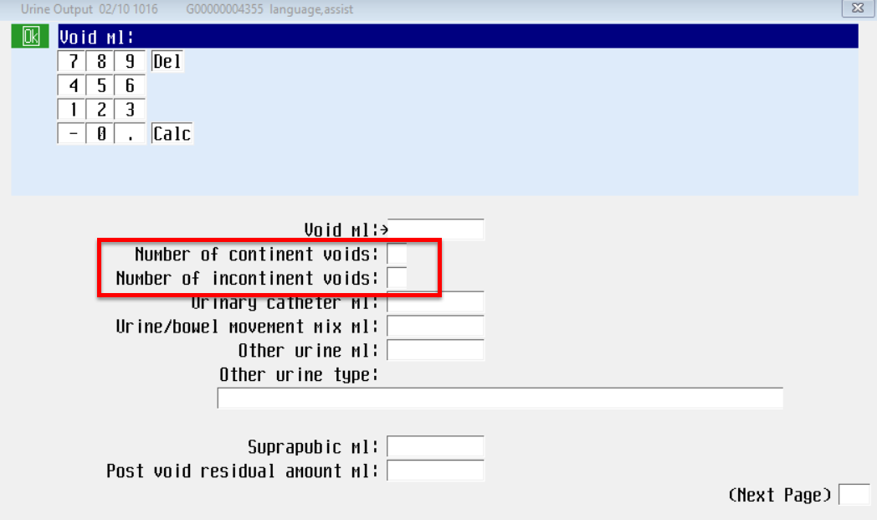 | Number of voids has changed to Number of continent voids.  Number of times incontinent urine has changed to Number of incontinent voids  Note: Yellow information guidance has been removed.

Safety/Risk/Regulatory
The Safety/Risk/Regulatory screen has been updated with the Morse Falls Scale and will be applicable to the adult population. Based on the responses, the system will auto populate the Morse Fall and risk level.

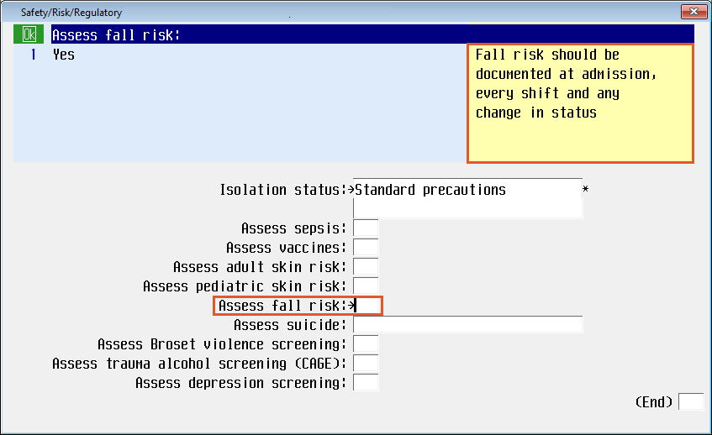 | Selecting “Yes” will open the appropriate Fall Risk Assessment based on patient location.  Note: For adult inpatient, ER, and Surgical Services areas, this will open the Morse Fall Scale. For Peds, Behavioral Health & Inpatient Rehab, this will open the existing Fall Risk Assessment.
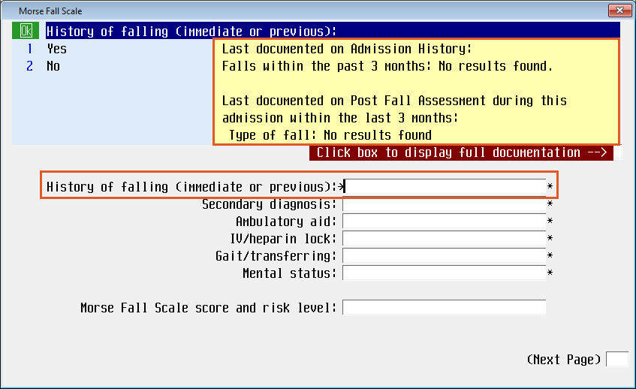 | History of falling (immediate or previous) is a new field with the following options:  - Yes  - No  Yellow information box  Last documented on Admission history:  Last documented on Post Fall Assessment during this admission within the last 3 months:
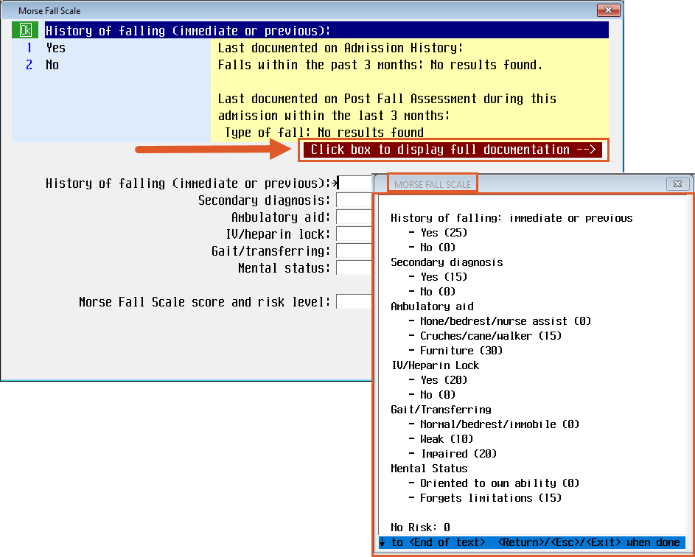 | To view the Morse Fall Scale in its entirety, click the Click the box to display the full documentation.
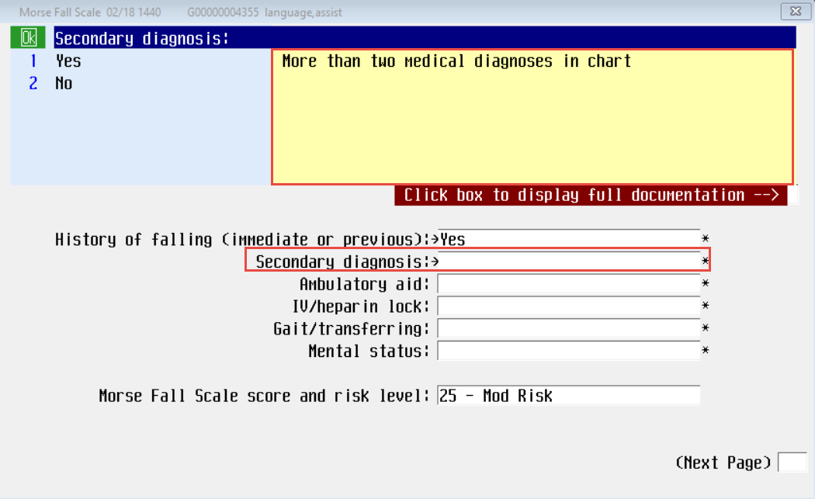 | Secondary diagnosis is a required field with the following options:  - Yes  - No  Yellow Information Box:  More than two medical diagnoses in chart
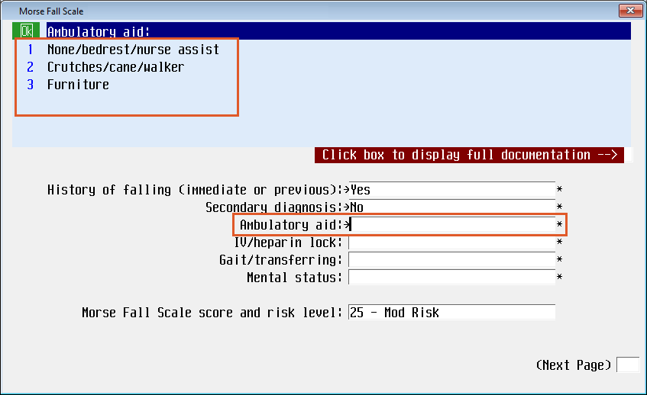 | Ambulatory aid is a required field with the following options:  - None/bedrest/nurse assist  - Crutches/cane/walker  - Furniture
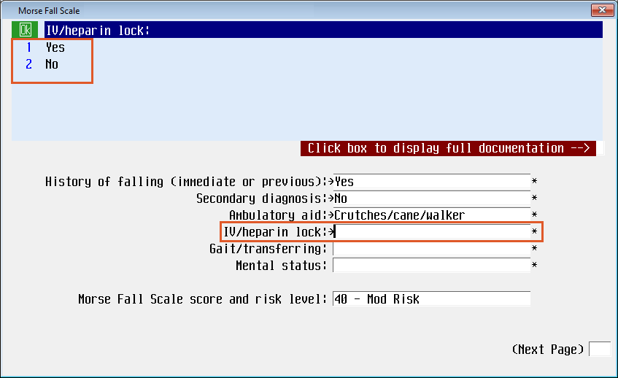 | IV/heparin lock is a required field with the following options:  - Yes  - No
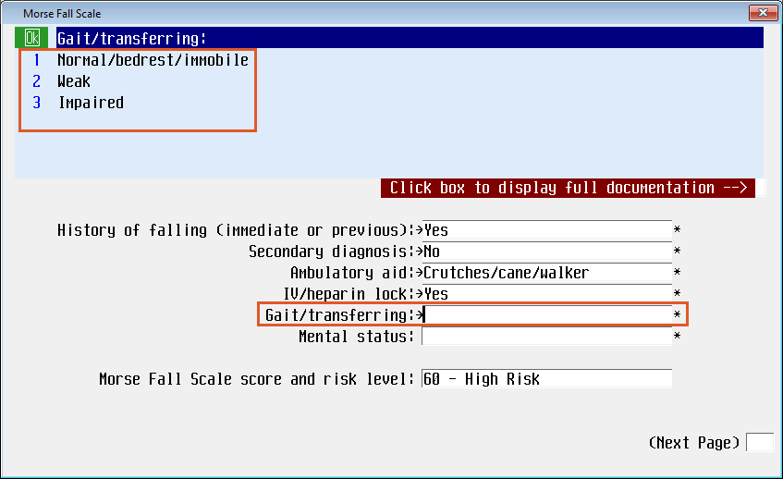 | Gait/transferring is a required field with the following options:  - None/bedrest/immobile  - Weak  - Impaired
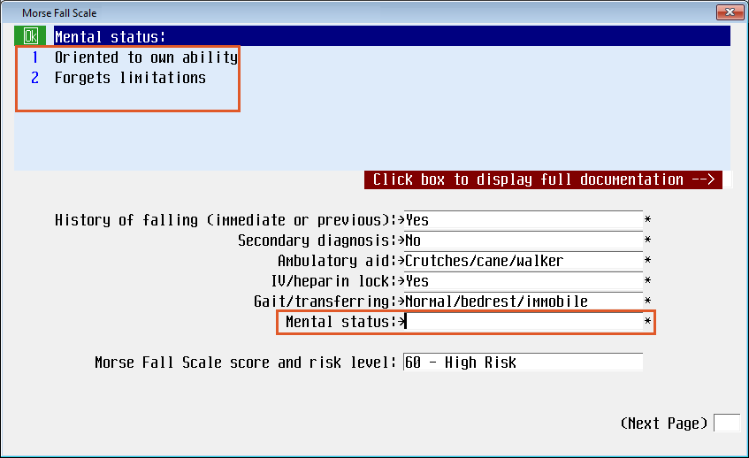 | Mental status is a required field with the following options:  - Oriented to own ability  - Forgets limitations
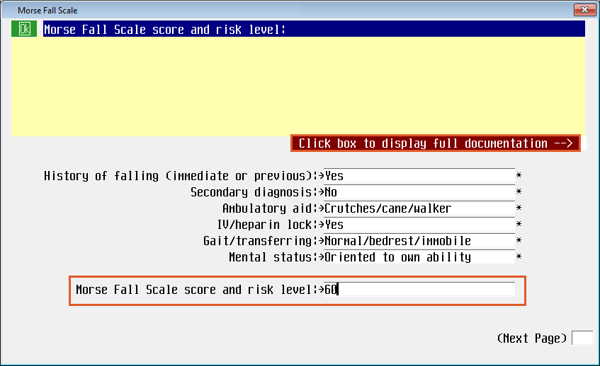 | The Morse Scale score and risk level will show the numeric value and associated risk level based on the Morse Falls algorithm.
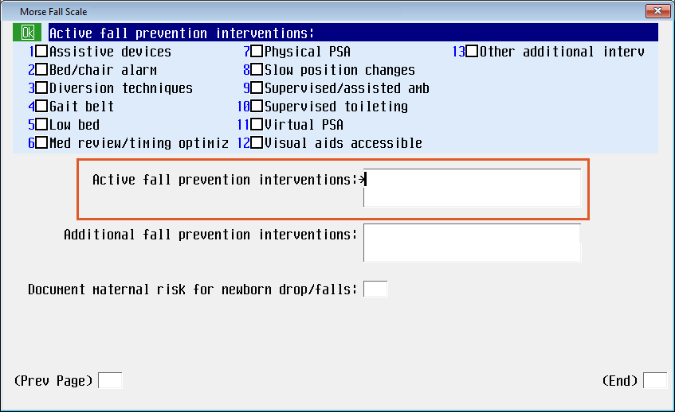 | Active fall precautions intervention is a multi-select field with the following options:  - Assistive devices  - Bed/chair alarm  - Diversion techniques  - Gait belt  - Low bed  - Med review/timing optimiz  - Physical PSA  - Slow position changes  - Supervised/assisted amb  - Supervised toileting  - Virtual PSA  - Visual aids accessible  - Other additional interv
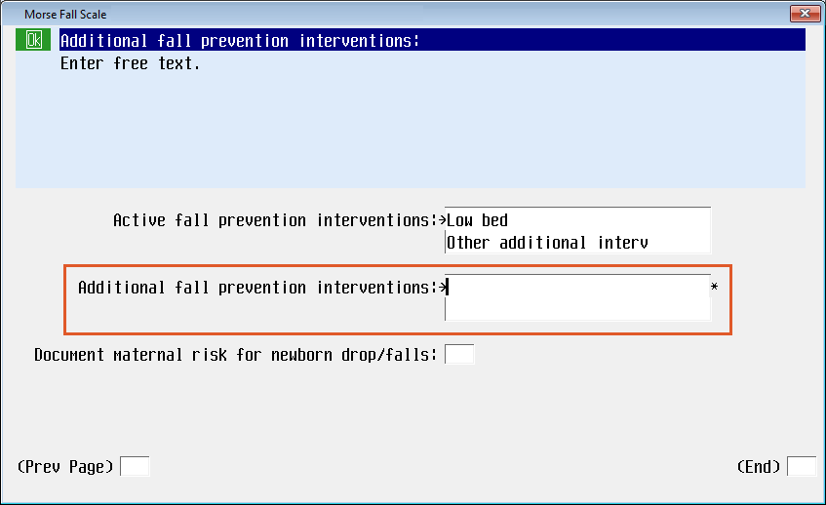 | Active fall precaution intervention is a required free text field when “Other additional interv” is selected in the previous field.

Suicide Risk Score
The Suicide Risk Score has been updated with new programing. The Calculated Suicide Risk level was updated to align with the Columbia Suicide Screening and can be addressed in the provider and nurse documentation.

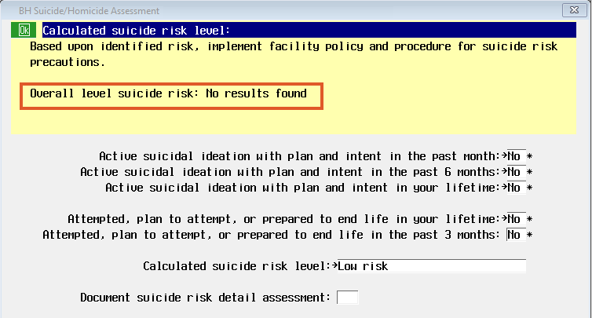  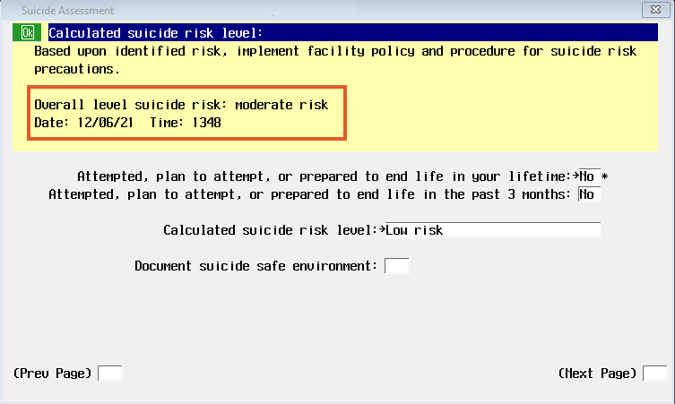  **************************************************  The Overall risk level may be different from the Calculated suicide risk level. Proceed with the highest risk level identified either from the Physician or nursing and communicate those differences with the Physician and follow facility processes. | Calculated suicide risk level has a new algorithm to calculate the score.  The Overall level suicide risk from the Provider’s documentation will populate in the yellow information box when available or will show No results found.  Yellow Information box  Based upon identification risk, implement facility policy and procedure for suicide risk precautions.  Overall level suicide risk:  Date: Time:  Note: The Calculated suicide risk level data is shared amongst nursing and provider documentation; the provider has the opportunity to import the nursing documentation if completed prior.

Modified Rankin score
A stand-alone intervention was developed for the Modified Rankin Score. This screen was formally called Stroke modified Rankin scale and was only accessible through the discharge instructions.
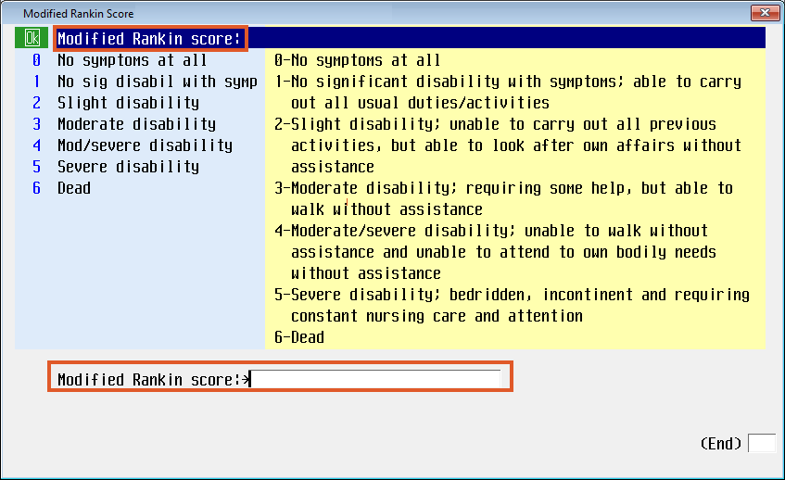 | Stroke Modified Rankin Scale is now the Modified Rankin Score and is available as a stand-alone intervention.  The Modified Rankin Score is completed for stroke patients upon discharge. Add the intervention to the Process Care items screen to complete as needed.

Health History Assessment
To align Equity of Care (EOC) across Health History screens, the following fields have been added to the Admission Health History
Note: These fields are shared with Admissions and EDM and will recall the previous responses filed. The clinician must confirm and update those fields as necessary.
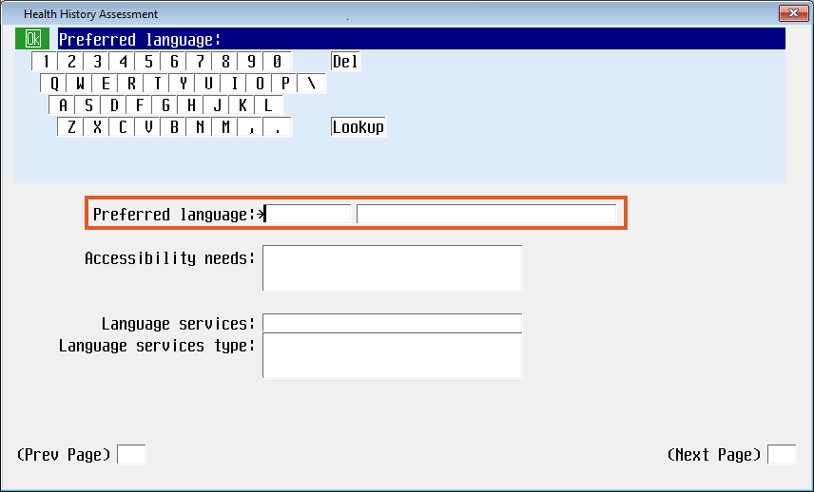 | Preferred language has been relocated to align with Equity of Care screens.
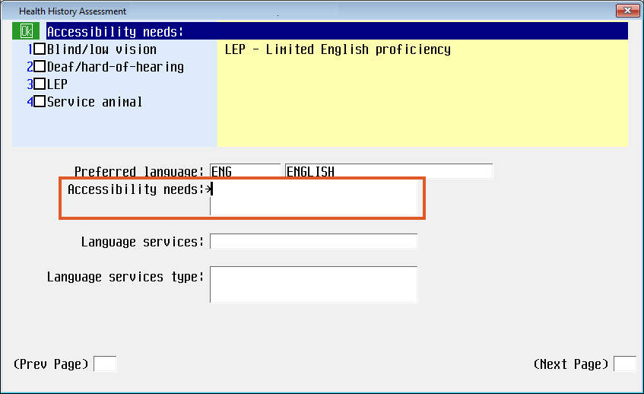 | Accessibility needs is a new, multi-select field with the following options:  - Blind/low vision  - Deaf/hard-of-hearing  - LEP (Limited English proficiency)  - Service animal  The new Yellow Information Box provides guidance to clinicians:  LEP – Limited English proficiency
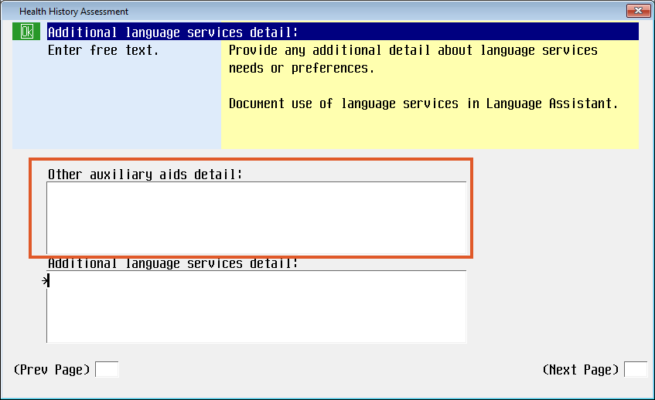  Examples of details may include:  For Blind/low vision patient:  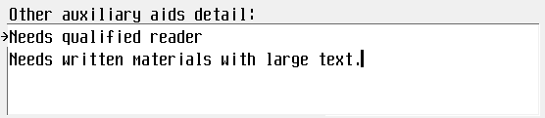  For Deaf/Hard-of-hearing patient:  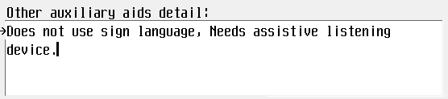 | Other auxiliary aid detail is a new free text field only accessible when “Other auxiliary aids” is selected in the Language services type field.  The new Yellow Information Box provides guidance to clinicians:  Describe preferred auxiliary aids needed and available.  Additional language services detail is a new free text field.  The new Yellow Information Box provides guidance to clinicians:  Provide any additional detail about language services needs or preferences.  Document use of language services in Language Assistant.

Hygiene Care and Routine Daily Care
Hygiene Care and Routine Daily Care have been updated to provide clarity on “How to document” in this field.

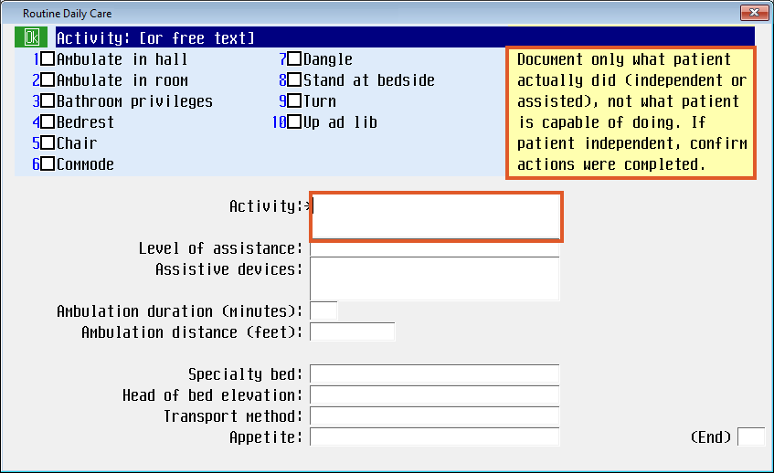  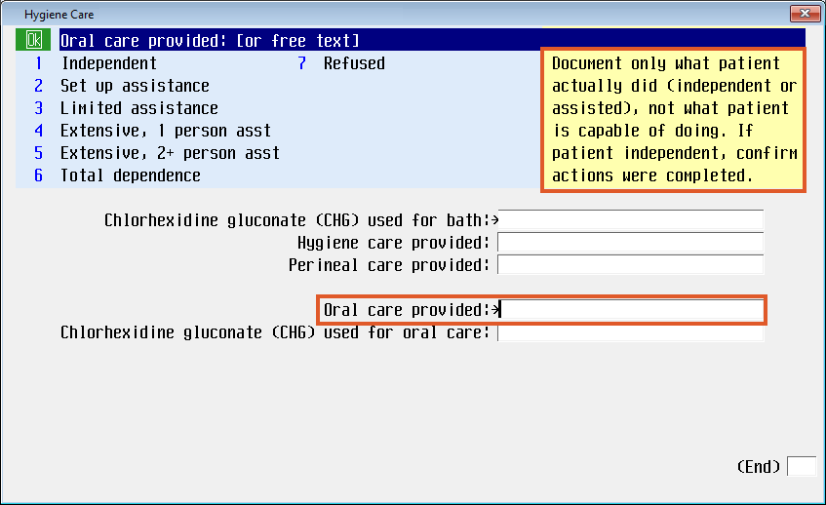 | Hygiene Care  For more direction in answering the question, a Yellow Information Box has been added to Oral care provided.  Date of last bowel movement has been removed.  Routine Daily Care  For more direction in answering the question, a Yellow Information Box has been added to Activity.  Document only what patient actually did (independent or assisted), not what patient is capable of doing. If patient independent, confirm actions were completed
ECMO  To align provider and nursing ECMO documentation and to increase patient safety, the ECMO intervention has been updated.  In the ECMO oxygenator details section, the following fields have been updated:  Old New  ECMO blender FiO2 1 ECMO blender FdO2 1  ECMO blender FiO2 2 ECMO blender FdO2 2  ECMO blender FiO2 3 ECMO blender FdO2 3 | In the ECMO oxygenator details section, the following fields have been updated:  Old New  ECMO blender FiO2 1 ECMO blender FdO2 1  ECMO blender FiO2 2 ECMO blender FdO2 2  ECMO blender FiO2 3 ECMO blender FdO2 3  In the ECMO safety checks section, the following field has been updated:  ECMO RPMs, FiO2, and SWEEP set per physician order has been changed to ECMO RPMs, FdO2, and SWEEP set per physician order.
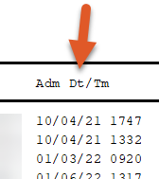  Patient Preferred Pharmacy Report  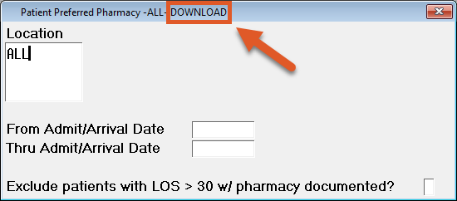  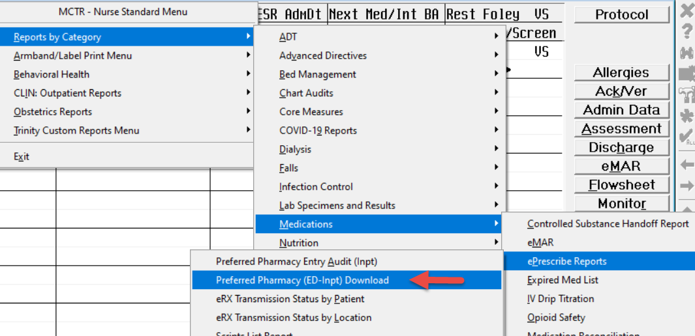  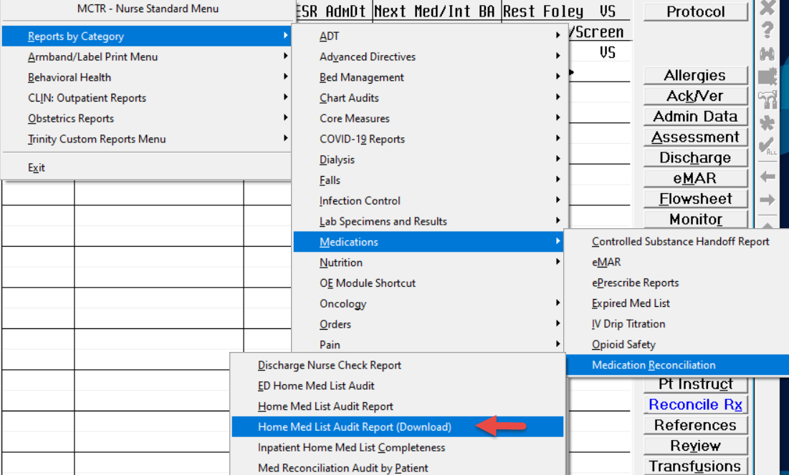 | Added Admit Date/Time field to output of Print Version (Inpatient only) report  Added ability to exclude admitted patients greater than 30 days with preferred pharmacy documented  Created a new Download Version (Inpatient and ED Patients) of the Preferred Pharmacy report  Added to print report button menu  Created a new Download Version of the Home Medication Audit report.  Added to print report button menu.

