**EBCD MEDITECH Content Updates – 2022.2**

NUR Module - PCTs – Go Live March 8th, 2022

To standardize the Intake and Output intervention, new verbiage and programming has been added.

## Intake and Output

|  |  |
| --- | --- |
|  | *Number of voids* has changed to *Number of continent voids.*  *Number of times incontinent urine* has changed to *Number of incontinent voids*  Note: Yellow information guidance has been removed. |

Note: These fields will be required for patients on Inpatient Rehab Units.

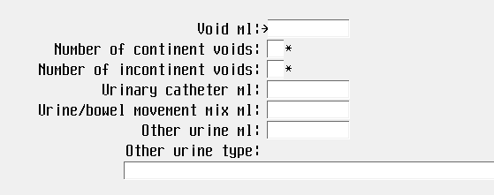

An * indicates required documentation.

Update 2022.2