EBCD MEDITECH Content Updates – 2022.2

Behavioral Health Go Live 3-8-22
This document is a high-level overview for end user education purposes about significant changes within the Nursing Module screens.
The enhancements are listed by intervention and provide a rationale behind the change and screenshot example(s).
Please read the MEDITECH selected prompts and follow the yellow information boxes onscreen as you become aware of changes in the documentation.
Equity of Care Updates
To align Equity of Care (EOC) across Health History screens, the following fields have been added to BH: Health History Assessment and BH: Psychosocial Assessment (PSA).

Note: These fields are shared with Admissions and EDM and will recall the previous responses filed. The clinician must confirm and update those fields as necessary.

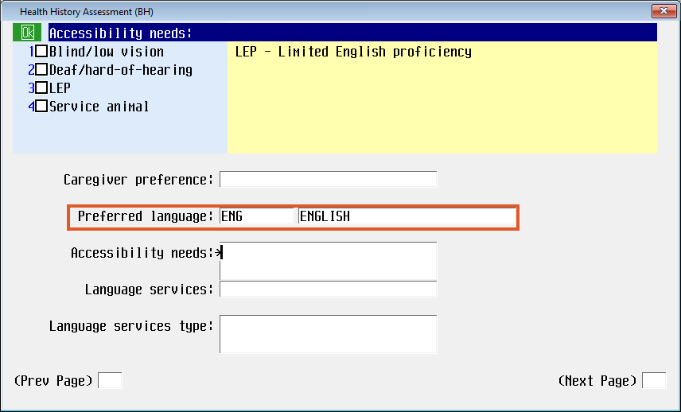 | Preferred language field allows for early identification and documentation of the patient’s preferred/primary language for healthcare communications and will assist clinicians interacting with the patient.
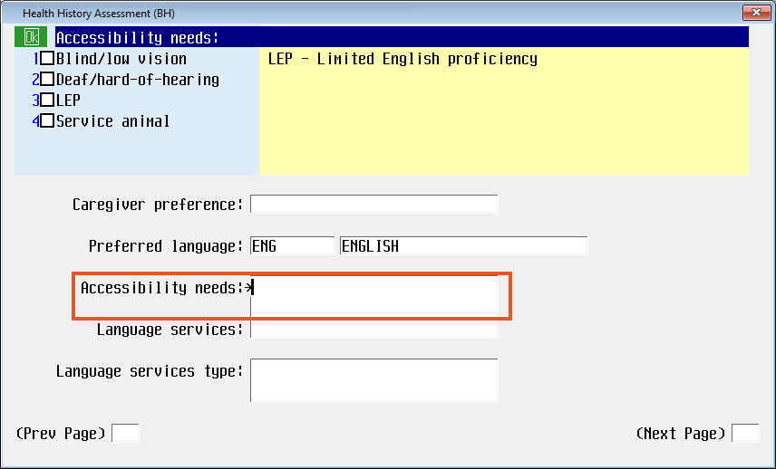 | Accessibility needs is a new, multi-select field with the following options:  - Blind/low vision  - Deaf/hard-of-hearing  - LEP (Limited English proficiency)  - Service animal  The new Yellow Information Box provides guidance to clinicians:  LEP – Limited English proficiency
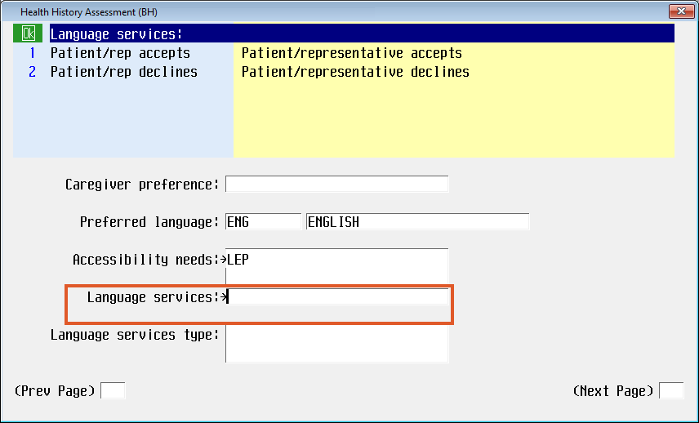 | Language services is a new field and has the following responses:  - Patient/rep accepts  - Patient/rep declines  This field is automatically skipped if “Service animal” is the only selection chosen in the Accessibility needs field. Otherwise, this field remains available if multiple responses are selected.  The new Yellow Information Box provides guidance to clinicians:  Patient/representative accepts  Patient/representative declines
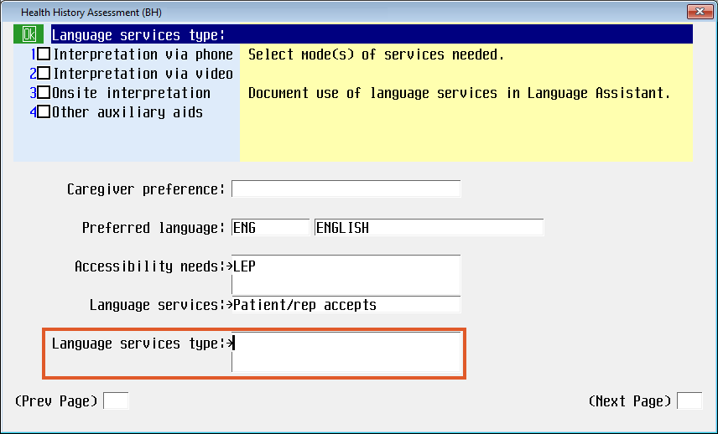  When providing language services, clinicians should provide services in the patient’s preferred mode of communication. | Language services type is a new, multi-select field with the following responses:  - Interpretation via phone  - Interpretation via video  - Onsite interpretation  - Other auxiliary aids  This field is automatically skipped if “Patient/rep declines” is selected in the Language services field.  The new Yellow Information Box provides guidance to clinicians:  Select mode(s) of services needed.  Document use of language services in Language Assistant.
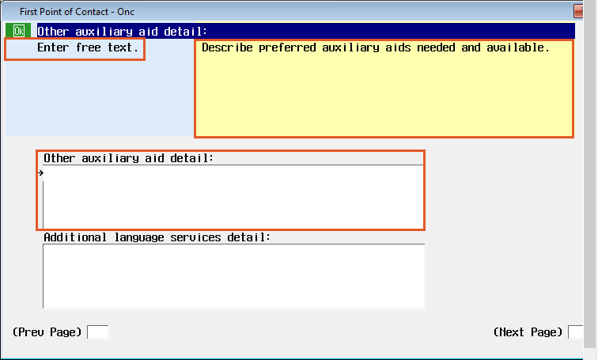 | Other auxiliary aid detail is a new free text field only accessible when “Other auxiliary aids” is selected in the Language services type field.  The new Yellow Information Box provides guidance to clinicians:  Describe preferred auxiliary aids needed and available.
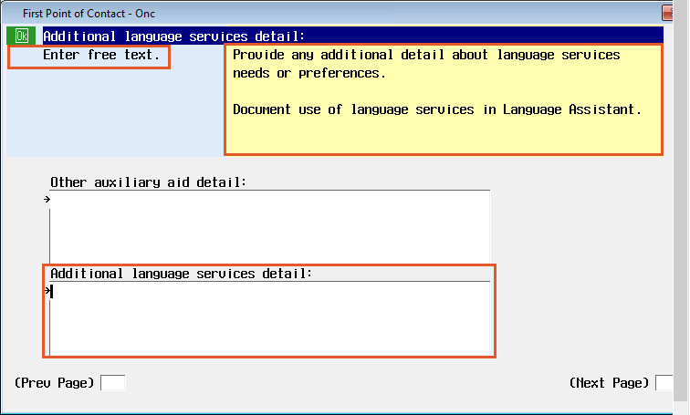 | Additional language services detail is a new free text field.  The new Yellow Information Box provides guidance to clinicians:  Provide any additional detail about language services needs or preferences.  Document use of language services in Language Assistant

Suicide Risk Score
The Suicide Risk Score has been updated with new programing. The Calculated Suicide Risk level was updated to align with the Columbia Suicide Screening and can be addressed in provider and nurse documentation.
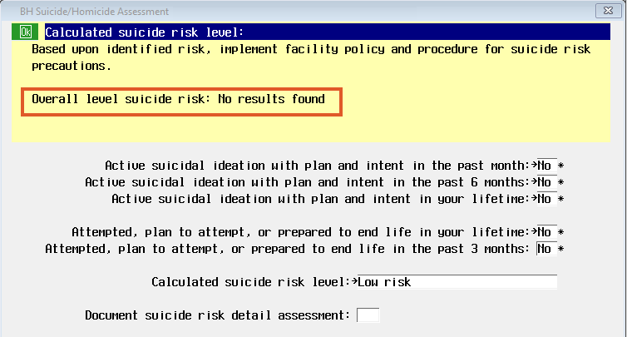  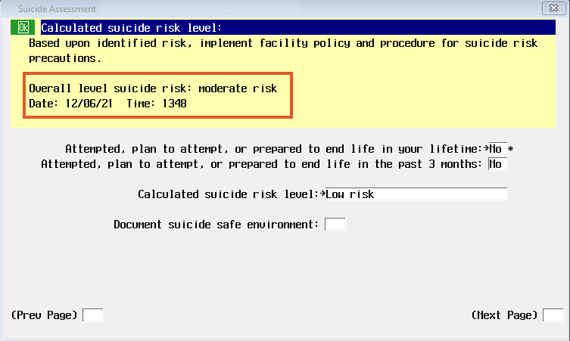  The Overall risk level may be different from the Calculated suicide risk level. Proceed with the highest risk level identified either from the Physician or nursing and communicate those differences with the Physician and follow facility processes. | Calculated suicide risk level has a new algorithm to calculate the score.  The Overall level suicide risk from the Provider’s documentation will populate in the yellow information box when available or will show No results found.  Yellow Information box  Based upon identification risk, implement facility policy and procedure for suicide risk precautions.  Overall level suicide risk:  Date: Time:  Note: The Calculated suicide risk level data is shared amongst nursing and provider documentation; the provider has the opportunity to import the nursing documentation if completed prior.
These updates affect the following NUR Assessments:
- Safety/Risk/Regulatory
- BH: Behavior Health Assessment
- BH: Initial Nurse Assessment
- BH: Psychosocial Assessment
- BH: RN Reassessment
- BH Suicide/Homicide Screen
- BH: Outpatient Initial Nurse Assessment

Emar – Pain Management
In alignment with the Multi modal pain protocols and to ensure pain medication administration triggers a pain reassessment when administered, the Administering for pain field has been updated.
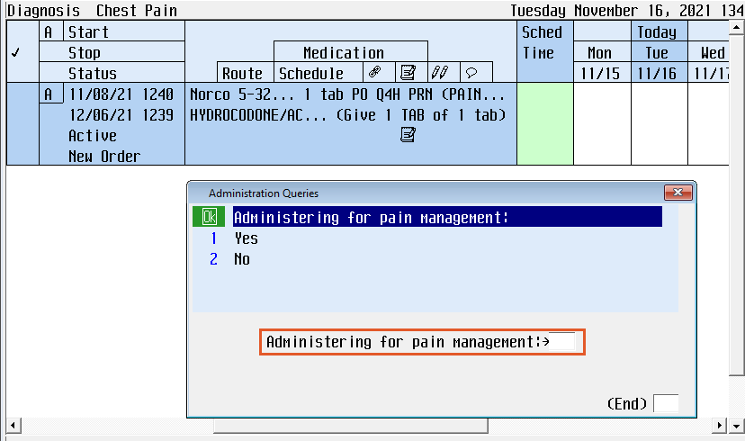 | Administering for pain has been changed to Administering for pain management in eMAR when documenting a pain medication.  Note: If this is ordered for pain management and or pain control, regardless if the patient is actively having pain, the clinician should select “Yes.”  If this is ordered for fever, such as Tylenol, it is appropriate for the clinician to select “No.”

eMAR – SUBQ Previous Injection Sites Info Box
Some medications, when administered via subcutaneous (SUBQ) route, should have the administration site rotated between doses. Currently the nurse has to manually go back and review the previous administration sites. An alert has been created to automate this process, providing the 4 most recent administration site(s) for the current medication order and displaying them to the documenting nurse along with the associated date(s) and time(s)
* Dalteparin (Fragmin) * Enoxaparin (Lovenox)
* Desirudin (Iprivask) * Fondaparinux (Arixtra)
* Unfractionated heparin

Screen Sample of the Past Administrations box  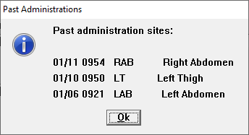 | Alert will only fire if documenting the order as “Given”.  Alert will NOT fire if documenting the order as “Not Given” or performing the action of “Undo” and there are no previous administrations on the current medication order.  After review of the informational alert, click “Ok” and proceed with documentation.  The alert will display one time. Either when the cursor lands in the Dose field or after the nurse selects a Site for the current administration. If this occurs, the nurse will need to review the information provided and determine if the Administration Site should be adjusted on the current documentation.

Intake and Output
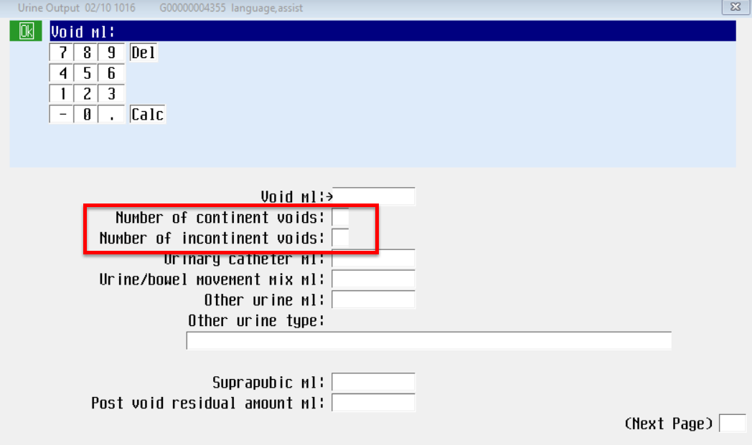 | Number of voids has changed to Number of continent voids.  Number of times incontinent urine has changed to Number of incontinent voids  Note: Yellow information guidance has been removed.

Hygiene Care and Routine Daily Care
Hygiene Care and Routine Daily Care have been updated to provide clarity on “How to document” in this field.
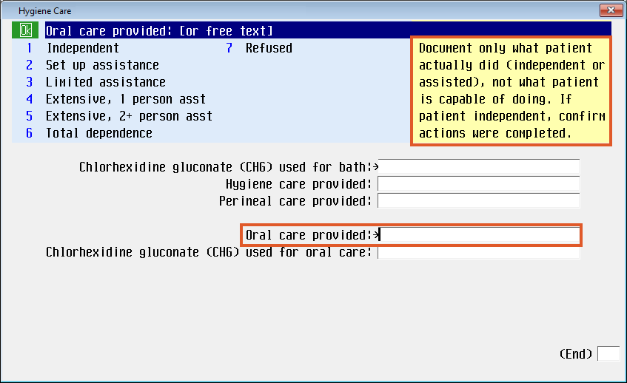  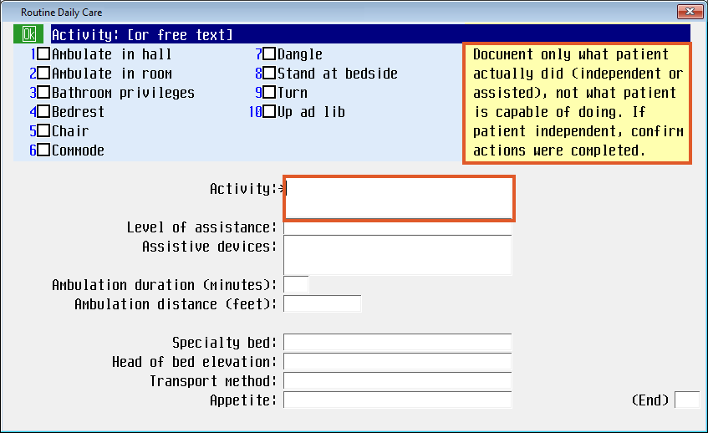 | Hygiene Care  For more direction in answering the question, a Yellow Information Box has been added to Oral care provided.  Document only what patient actually did (independent or assisted), not what patient is capable of doing. If patient independent, confirm actions were completed.  Date of last bowel movement has been removed.  Routine Daily Care  For more direction in answering the question, a Yellow Information Box has been added to Activity.  Document only what patient actually did (independent or assisted), not what patient is capable of doing. If patient independent, confirm actions were completed.

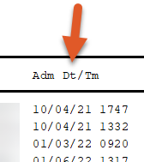  Patient Preferred Pharmacy Report  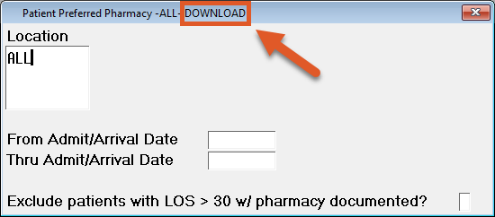  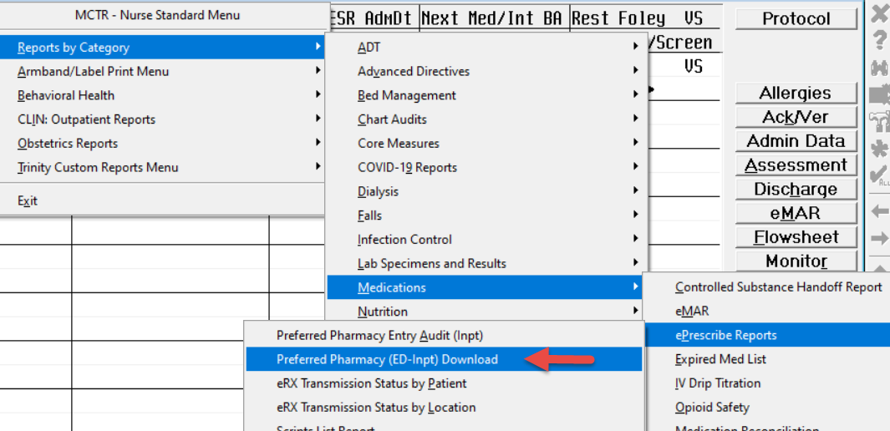  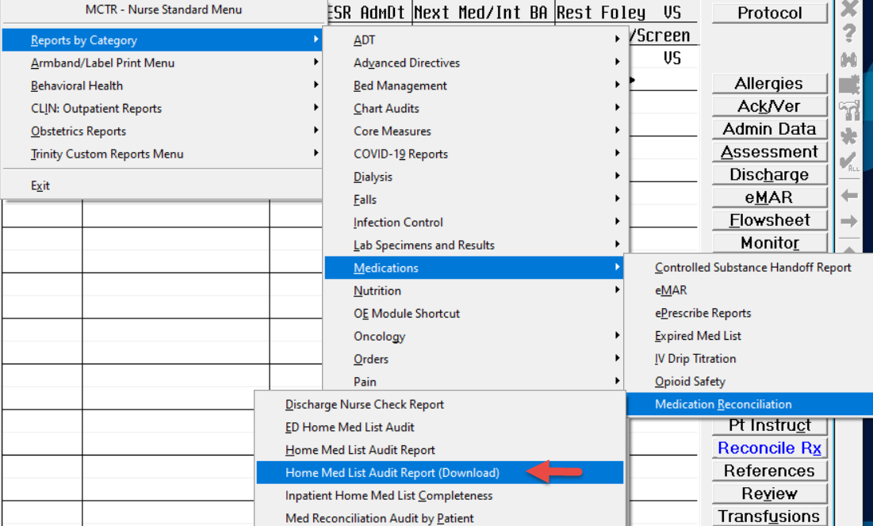 | Added Admit Date/Time field to output of Print Version (Inpatient only) report  Added ability to exclude admitted patients greater than 30 days with preferred pharmacy documented  Created a new Download Version (Inpatient and ED Patients) of the Preferred Pharmacy report  Added to print report button menu  Created a new Download Version of the Home Medication Audit report.  Added to print report button menu.

