# **Process for Charging Hemodialysis & Peritoneal Dialysis**

The process for charging will be a reflex to Meditech Order Entry to enter charges from Nursing documentation for each Dialysis type. When the documentation intervention is filed, you will be taken automatically to the order entry routine.

** All charging will be in OE, with the ordering provider name and a Z order source. **

1. **Hemodialysis: documentation to reflex charge order in Order Entry (OE) – Dialysis Stop Time**
   1. In the Hemodialysis Treatment documentation screen, once the Post-Treatment **Dialysis Stop Time** is documented and the screen is completed, when FILED, the system reflexes into Order Entry for you to enter the charge.

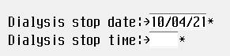

* 1. **Enter Ordering Provider** and the **order source Z – Department process**, Click OK

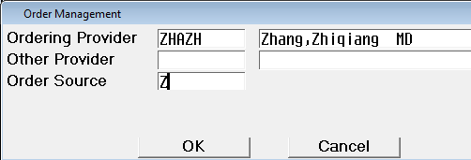

* 1. Hemodialysis charge will reflex into the ordering session. Click Submit; then OK.



1. **PD documentation to reflex charge order in Order Entry (OE)**
   1. In the PD procedure documentation screen when the **PD Drain Stop time**

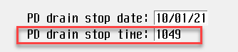

is entered and the screens are completed, when FILED the system reflexes

in the charging process to Order Entry.

* 1. **Enter Ordering Provider** and the **order source Z – department process**

**Click REQ** – to choose appropriate TYPE details



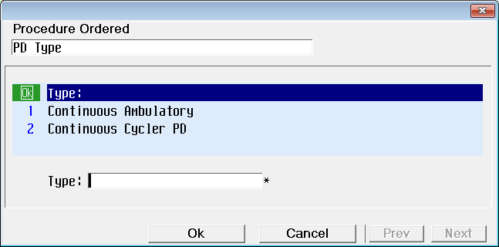

* 1. The choice will **reflex the appropriate charge and department** then Click Done, Submit.

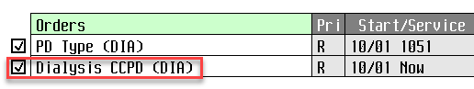

**Daily Charge Reconciliation**

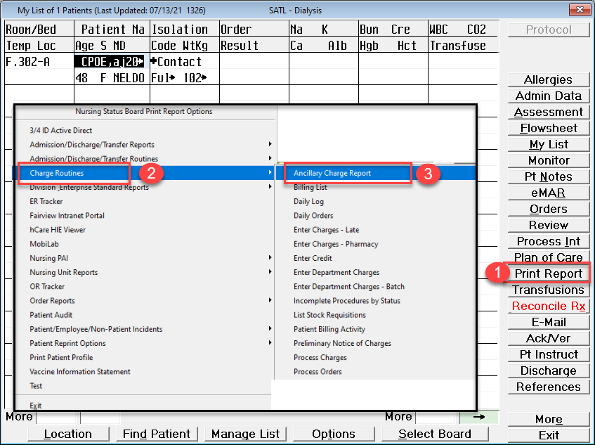

Select the date you are reconciling. Each date must be run separately.

Charging/Ordering Depts: 749



Enter your printer name

Compare charge list with patient list from same date