**New Dialysis Status Board**

**Fairview Park Hospital**

**October 24, 2021**



**New Dialysis Status Board**

A new status board has been created to help the dialysis nurse keep track of their daily or ongoing patient list. This new status board contains information on the patient’s isolation, lab values, Hepatitis B status, vital signs, and other relevant information.

**Accessing the Dialysis Status Board**

To make the Dialysis status board your default status board:

1. Select the Options button at the bottom of the screen.
2. Click in the Status Board Format box and select “.SDDIAL” from the list that appears.
3. To save this view, enter YES in the Save Status Board Format for Next Time box.

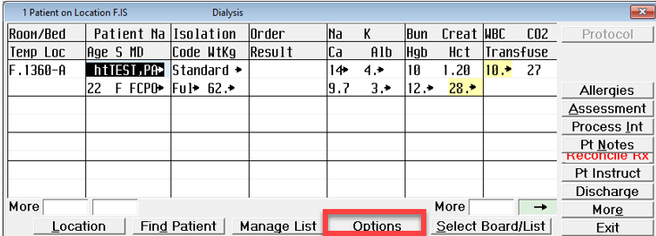

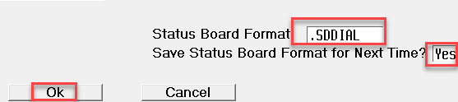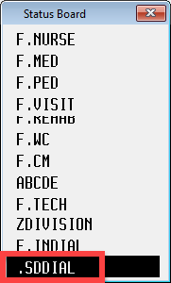

For quick access to the Dialysis status board without changing your default option:

1. Navigate to your default status board and click the Select Board option at the bottom of the screen. This will show a list of all status boards you have access to view.
2. Select the .SDDial option. This will remain as your status board until either you switch to a different one or you exit the status board. When you return, your normal defaulted status board will be visible.

**Dialysis Status Board Display**

This status board displays lab results and other helpful information needed to provide appropriate care to the dialysis patient.

Navigation and Functions:

* To view all of the status board, click the right and left arrows at the bottom of the screen.
* Each item is clickable and will open more information for that single item.
* The small arrows indicate more than one result or entry can be viewed and gives a direct link to clinical review if needed.
* Items that show as “Pend” indicate the item has been ordered and collected but not yet processed.
* A plus sign in front of the item indicates multiple entries are available.
* There are also options to view new orders, results, or blood products.

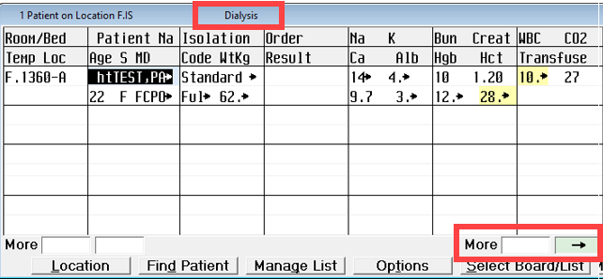

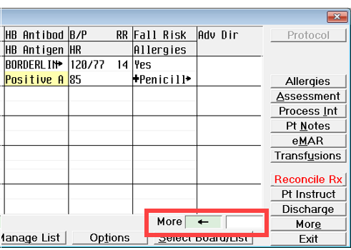

Displayed Items include:

* Isolation status
* Code Status
* Patient’s weight in Kg
* New Orders Flag
* New Results Flag
* Sodium
* Potassium
* Calcium
* Albumin
* BUN and Creatinine
* Hemoglobin
* Hematocrit
* WBCs
* CO2
* Blood product status
* Hepatitis B Antibody results
* Hepatitis B Antigen results
* Vital Signs
* Fall Risk Status
* Allergies
* Advanced Directives