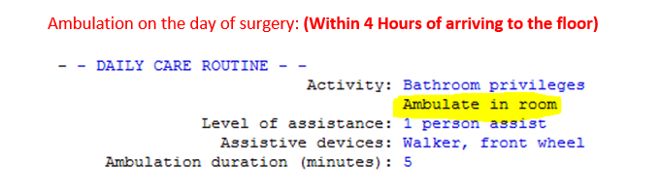

Neurovascular Assessments must be documented as ordered by physician. This is done by adding the Neurovascular Checks intervention.

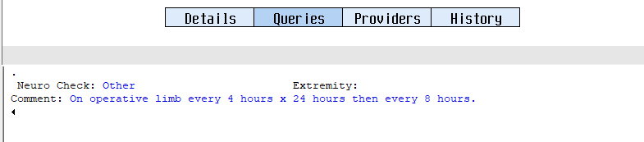

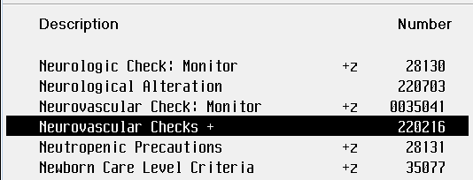

Peripheral Pulses must be documented as ordered by physician. This is done adding the Pulse and Site Assessment intervention.

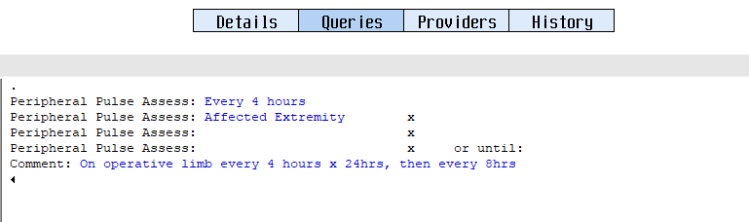

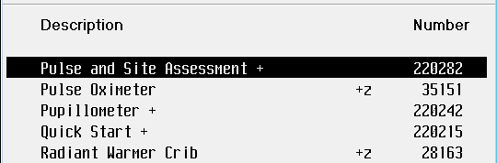

Warming/Cooling methods should be documented Q shift. This is done by selecting the Warming/Cooling intervention.

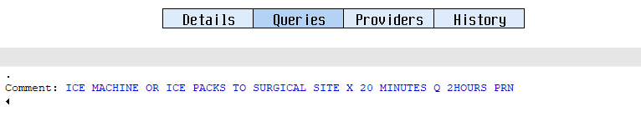

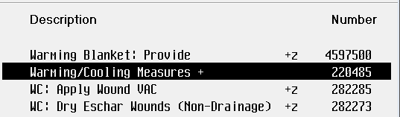

Incentive Spirometer Usage should be documented Q shift. This can be done by selecting the Incentive Spirometry intervention.

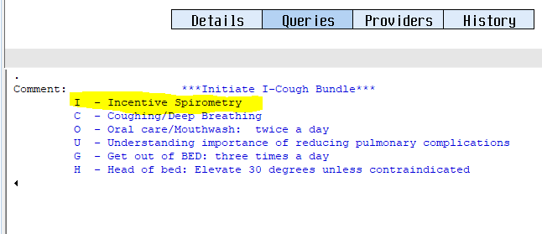

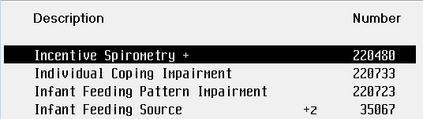

A Pain Assessment should be documented Q shift.

Performance Measures

* Ambulation within 4 hours of arriving to MST Unit
* Ambulate 250ft Post-OP Day 1
* ERS Components
* Pre-Op Hgb 9 and above