# Documenting Stool Output

When documenting stool output in the EBCD Intake and Output process intervention, you will first be asked, “Has patient had any liquid stools?” Answering Yes will launch a *C.Diff assessment* and answering No will take you to the main I&O documentation screens.

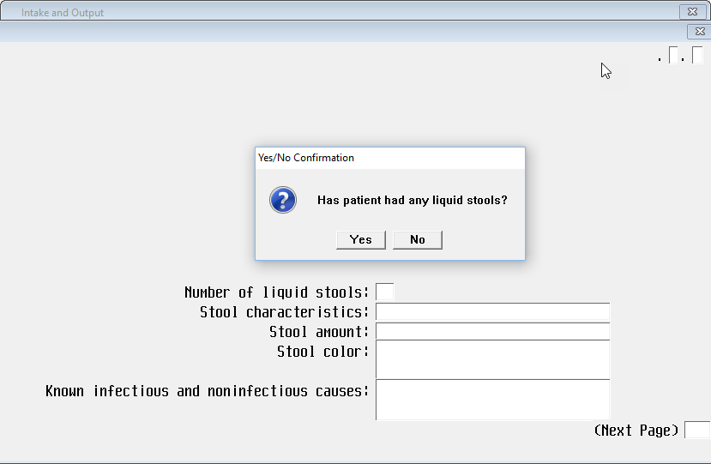

Clicking **Yes** to the question, “Has patient had any liquid stools?” will launch questions which will assess the patient’s need for a C.diff screening and **DOES NOT COUNT TOWARD I&O DOCUMENTATION.** Any liquid stools documented on this screen are for assessment purposes only and will also need to be documented on the main I&O screen following.

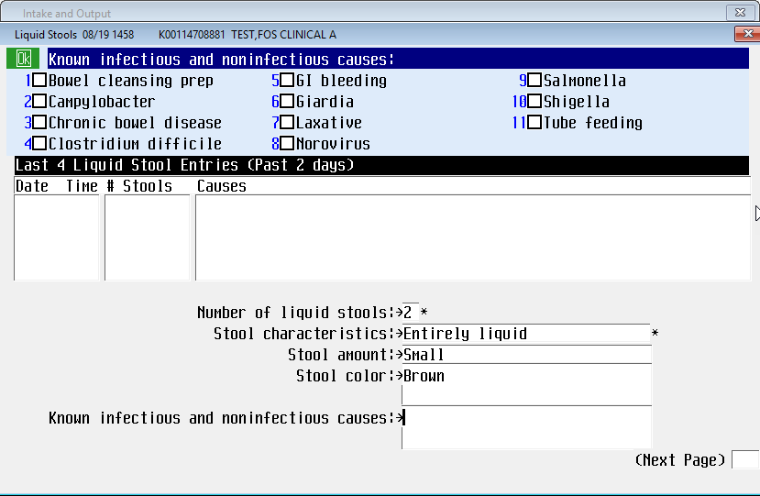

You must document liquid stools (from first screen) within the continent stool count or number of times incontinent stool in order for I&Os to be counted.

