Documentation Dashboard

From the circulator menu click on #200 Link to Documentation Dashboard (Am I Finished)

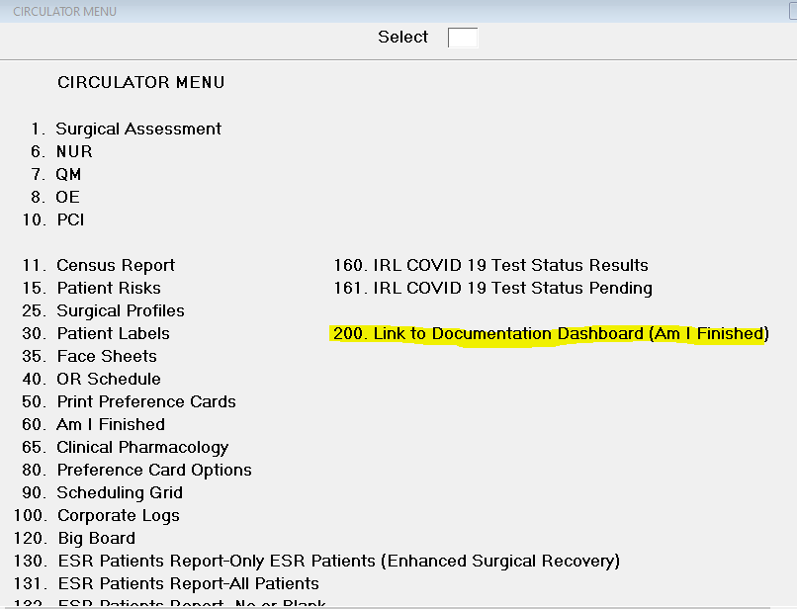

The documentation dashboard website will open. Fill out the Begin OR Date, End OR Date, which Facility, your Mnemonic (in capitals); i.e. 3WSS3811, and then click View Report. There is an option to only see any missing documentation by changing the Display Missing Info Only to “Yes”.

Missing documentation will show in **RED**.

