Stroke Documentation Refresher

**\*Neurovascular checks is ONLY used for joint patients**

Neuro Assessment and Vital Signs:

MST Q 4 hours; PCU Q 2 hours; ICU Q 1 hour

How to document neuro assessment: (you may choose 1)

Admission/Shift Assessment; Frequent Neuro Checks; NIH stroke scale (Adult/Peds)

Document a **full** NIHSS:

Admission, Discharge, any change in neuro status

**Dysphagia screen:**

Must be completed on **all** patients who exhibit stroke-like symptoms. **Make sure the patient passes the dysphagia screening before giving anything orally.**

Stroke Education:

Provide patient with stroke education book before discharge.

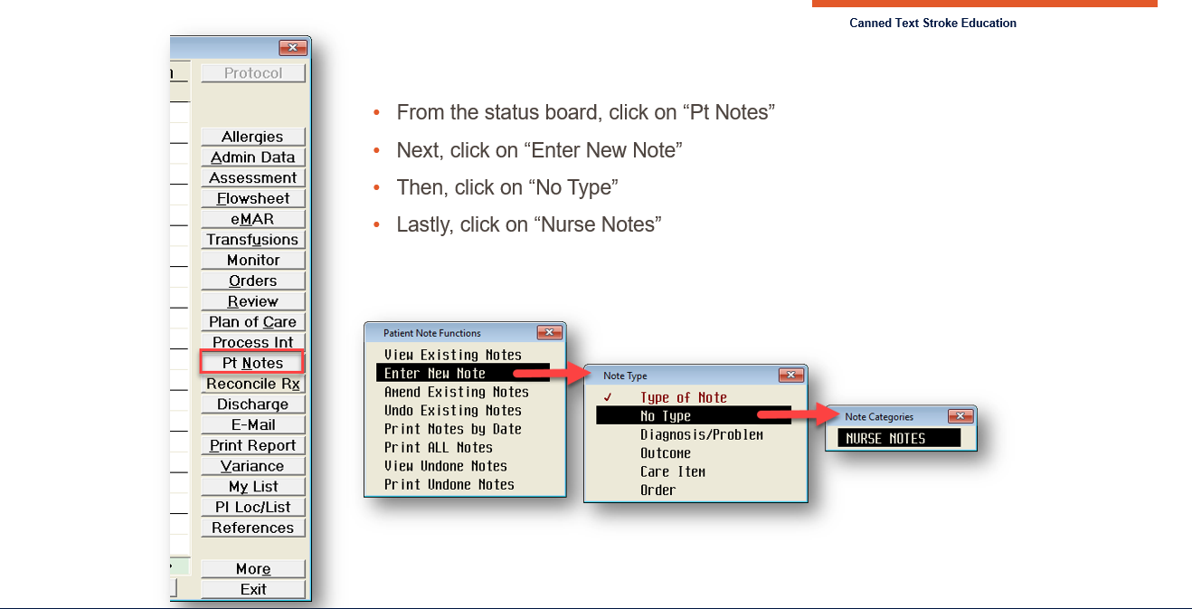

Q Shift **(See screenshots below)**

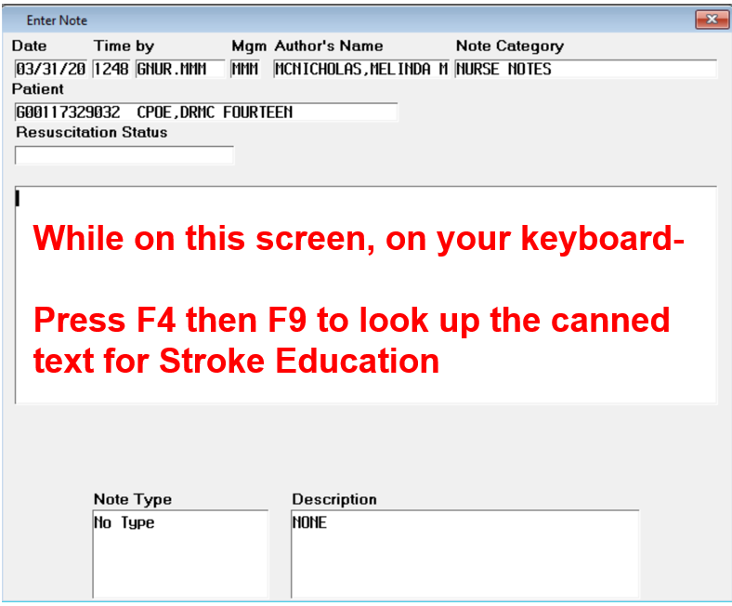

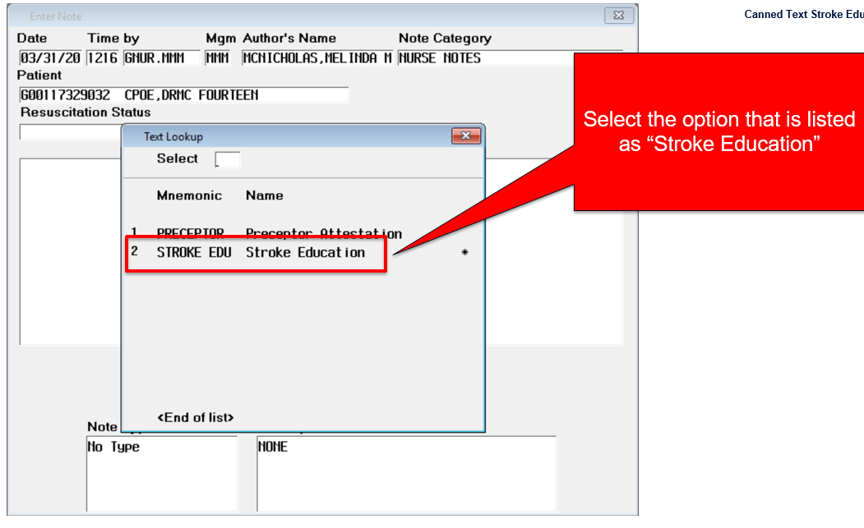

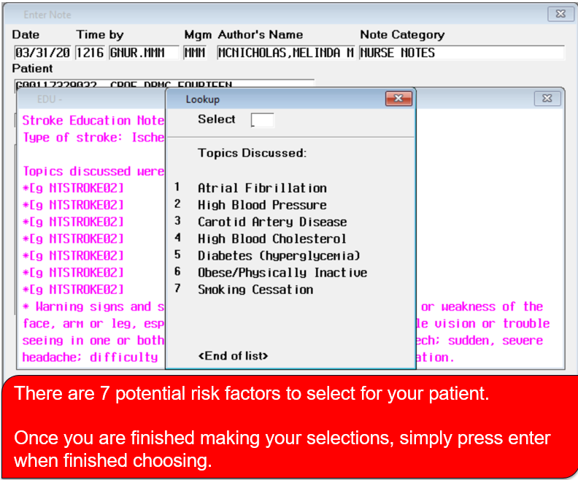

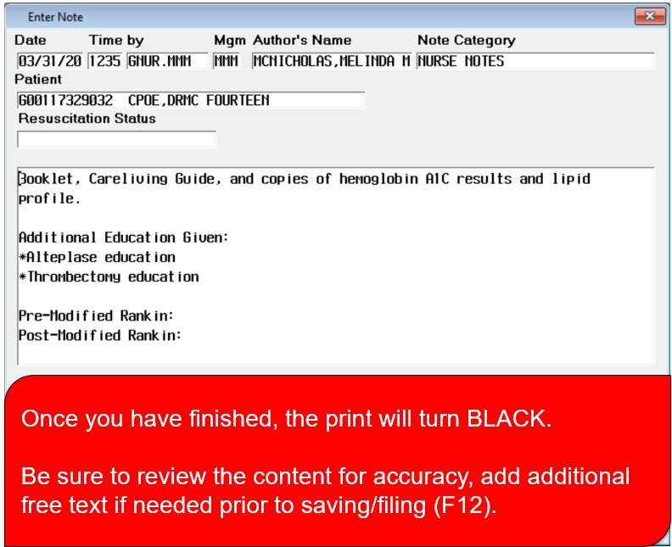

Stroke Core Measures:

VTE Prophylaxis by day 2

Antithrombotic Administered by day 2 (**If NPO request rectal ASA)**

Discharged on Anticoagulation for A-fib/A-Flutter patients

Stroke Education

Assessed for Rehabilitation

Discharged on an antithrombotic

Discharged on a STATIN medication

Smoking Cessation

What to do for Code Stroke on the floor:

Call RRT and Code Stroke *95555

Primary’s Nurse’s Role

* Do not leave the patient
* Determine last known well
* Complete a full NIHSS
* Ensure Labs are drawn (CBC, BMP, PT/PTT, Troponin) (In CT room)
* Transport patient to CT
* EKG (After CT)
* Dysphagia Screening

Charge Nurse’s Role

* Respond to Code Stroke
* Communicate with patient’s family
* Re-arrange staffing assignment for primary nurse
* Contact attending physician-obtain STAT- CT, EKG, Chest X-Ray, PT/PTT, CBC, BMP, Troponin

Unit Clerk’s Role

* Inform CT Code Stroke is in route

PCT’s Role

* Hand delivers labs
* POC Glucose
* Obtain Blood Pressure