Heru re:Vive

Instructions for Use
PDPROJ-1_IFU
PDPROJ-1_DHF

Contents
1. Introduction 4
2. Device Description 4
3. Intended Use 4
4. Symbols and Labels 5
5. General and Installation Safety Precautions 5
5.1. General Precautions 5
5.2. Installation Safety Precautions 5
6. Pre-Use Requirements and Dependencies 5
7. Heru Portal Registration 6
8. Software Installation, Upgrade, and Configuration 7
9. Cleaning the Device 7
10. Light-Shield and Lens Holder Installation 7
11. Step-By-Step Instructions 9
11.1. Logging into the Heru Portal 9
11.2. Getting Started 10
11.3. Adding a New Patient and creating an appointment (testing session) 12
11.4. Taking a Test 14
11.5. Reviewing the Results 19
11.6. Printing Test Results 20
12. Troubleshooting 21
13. Technical Specifications 22
14. Regulatory Information 23
15. Contact Us 24

INSTRUCTIONS FOR USE

Introduction
The Heru re:Vive application measures a patient’s field of vision by testing their central and peripheral sight capability. The Heru system provides speed, flexibility, and precision not available with legacy perimeters. The Heru re:Vive is a software solution that works with commercially available Head Mounted Display devices (HMDs).

Device Description
The complete system is comprised of the following items:
- re:Vive Visual Field Application
- Bluetooth patient response controller
- Light shield and lens holder
You will need to access the Heru Portal via a web browser in order to start, store, and review patient’s clinical test results. Stable internet connection is required.
The Heru re:Vive application performs static visual field testing to identify and quantify central vision defects. Stimuli are presented over the patient’s field of view, and according to the response of the patient, a map of the visual field is created to indicate the presence and locations of field defects. One stimulus will be displayed at a time. Eye tracking is employed to ensure that the patient is gazing at the fixation target.
The Heru re:Vive application works with no pupil dilation (non-mydriatic).
Please read this instruction manual thoroughly before using Heru re:Vive. Please keep these instructions for future reference.

Intended Use
The Heru re:Vive is an perimeter intended to measure the field of view of the eye for the purpose of mapping the visual field utilizing commercially available head mounted display devices (“HMDs”).
Heru re:Vive is intended for use on adults eighteen or over in need of a perimetry mapping.
Note: These perimetry results are an aid to interpretation, not a diagnosis.

Symbols and Labels
Manufacturer
See Instructions for Use
This software is a medical device

General and Installation Safety Precautions

General Precautions
- Periodically change your password to the Heru Portal and do not share it with anyone.
- Always log out after your session is over.
- Heru re:Vive measures the visual field and does not provide a diagnosis of an eye pathology. Products and Services made available through Heru visual field do not make clinical, medical, or other professional decisions.
- Heru re:Vive is not intended for use by people under 18 years of age.
- DO NOT take a test when not seated.
- The clinician is solely responsible for obtaining necessary consents for use and disclosure of patient information.
- Please read the general safety precautions for the HMDs prior to use.

Installation Safety Precautions
- A Heru representative will schedule a virtual training appointment upon receipt of your Heru equipment. During this training appointment, you and your staff will be guided through the basic operations of configuring, using, and maintaining your Heru equipment.
- Use only those parts provided by Heru to achieve optimum performance and safety.
- Make sure that your computer meets the technical specifications in section 13.
- For Technical Support or Customer Care: Please see section 15.

Pre-Use Requirements and Dependencies
The Heru re:Vive application is intended to be for use in healthcare provider offices and clinical environments. The users are healthcare providers with professional training or experience in the use of ophthalmic equipment. Specific assumptions regarding the profiles of individuals performing instrument operation or data interpretation are given below.
The operator should be an adult, trained in at least one of the following professions: Ophthalmologist, Optometrist, Nurse, Medical Technician, or Ophthalmic Technician/Photographer.
The operator must have training and the ability to carry out the system operation.

Heru Portal Registration
An authorized Heru administrator will create your account and assign a username during initial setup. At this time, the email address associated with the account will be sent a link to set a password.
Once you have successfully logged onto the Portal, go to the “My Account” tab located on the far left of the screen. When you first turn on your HMD, you will be prompted to enter the device activation code using the PIN pad on the screen. This code is located on the upper right side of the page on the portal. Note, the Device Activation Code resets every 60 seconds.
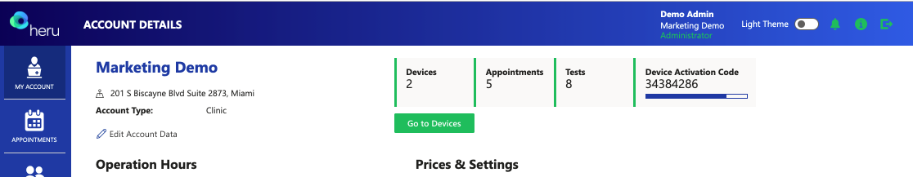
Once you have successfully paired the HMD to your account, go to the “Devices” tab and update your device’s label code. Next, select the desired HMD and click the edit button (). Update the Label Code to match the colored label located on the underside of the HMD battery pack and click “Save Device”. Note, the same-colored label should be visible on the controller as well. Labeled controller should always be used with the same labeled HMD.
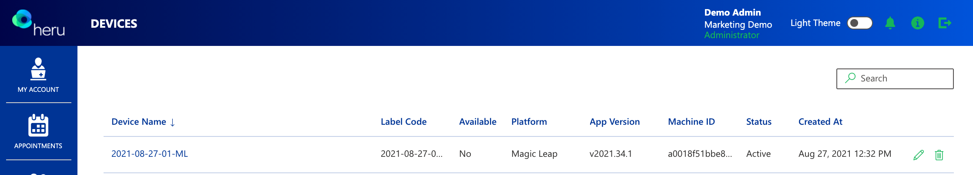
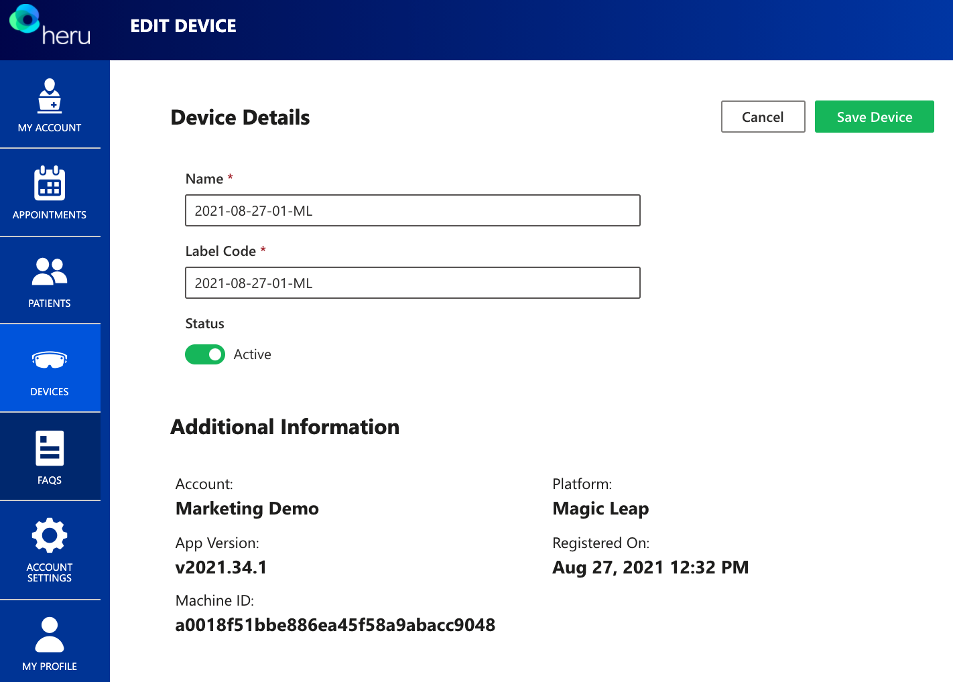

Software Installation, Upgrade, and Configuration
An authorized Heru representative will install and configure the re:Vive Test prior to shipment. To ensure optimal customer experience, Heru will remotely push software updates to both the HMD and the Heru Portal.

Cleaning the Device
To minimize cross-contamination, it is recommended to clean the device before each use, taking care to clean the areas that come in contact with the patient, such as the HMD, light shield, lens holder, and controller.
Component | Clean with
HMD screen | Lens cloth
Trial lenses | Lens cloth
HMD | 70% isopropyl alcohol
Controller | 70% isopropyl alcohol
Light shield | 70% isopropyl alcohol
Lens holder | 70% isopropyl alcohol

Light-Shield and Lens Holder Installation
The purpose of the HMD light-shield is to obscure the patient’s view and to prevent light leakage during the operation of the test.
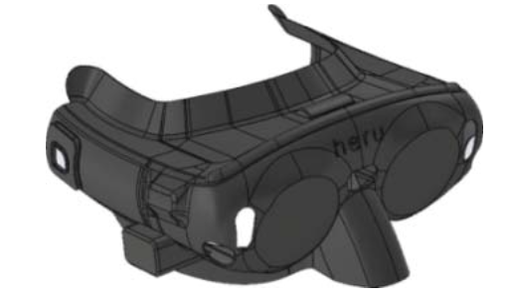
Figure 1 1 - Light-Shield Magic Leap 1 HMD

Start by unpacking your HMD, light shield, and lens holder and follow the steps below:
1. Slide the light shield over the front of the HMD and carefully align the nosepiece, sides, and forehead. Ensure the sensors on the front of the HMD are not occluded.
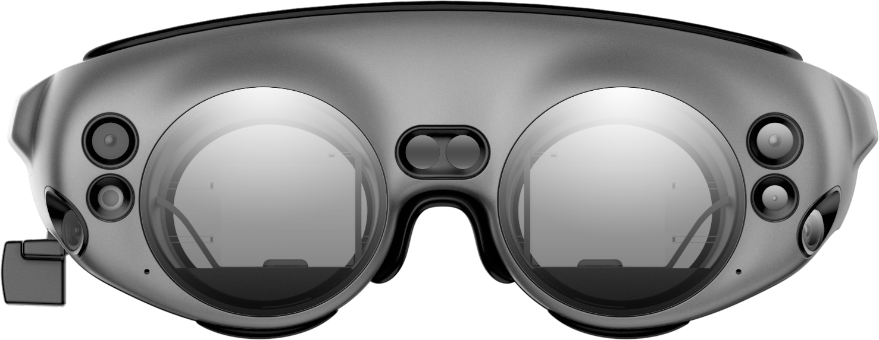
Sensors
Sensors

Figure 2 2– Sensors on HMD

The purpose of the lens holder is to position off-the-shelf trial lenses to correct the patient’s distance vision as necessary for the tests. The Lens Holder replaces the forehead pad in the HMD device. To install the lens holder, remove the standard insert that comes with the HMD and the forehead pad by pulling them straight out. Install the Lens Holder by inserting the back poles to the device. To insert the trial lenses, open the lens holder and slide the lenses in by their handle as shown below:
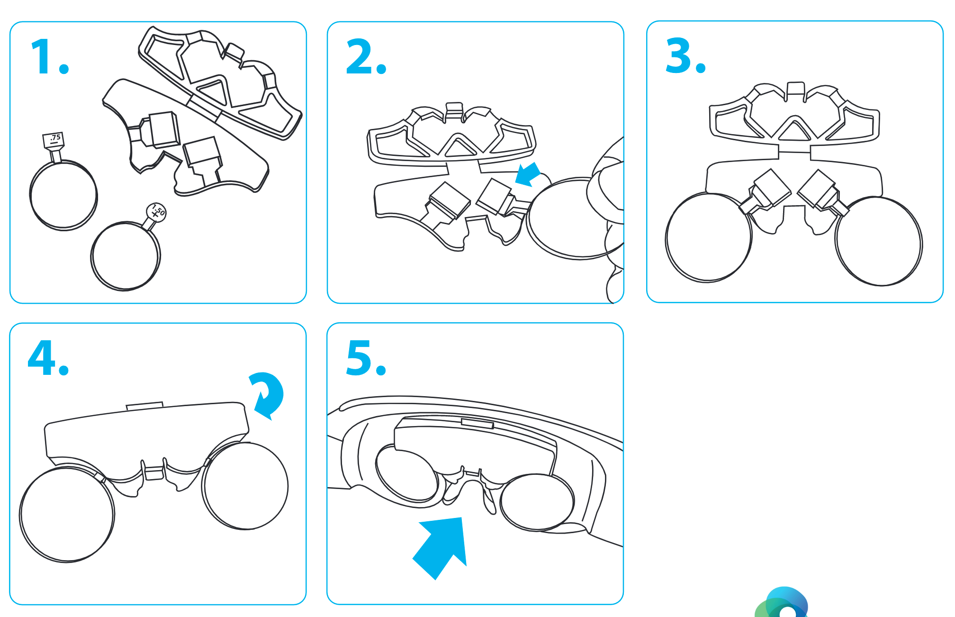
Figure 3 3– Lens Holder Instructions

Note: It is recommended to minimize reflections by carefully cleaning each lens with a lens cloth before placement and by placing the flattest portion of the lens towards the HMD screens.

Step-By-Step Instructions
Before beginning the exam, confirm that you have successfully completed the Heru portal registration and HMD shield/lens holder installation (if refractive correction is required).
Note: Screenshots are for illustrative purposes.

Logging into the Heru Portal
- Using your web browser, access the Heru Portal at https://portal.seeheru.com
- Log in with your credentials.
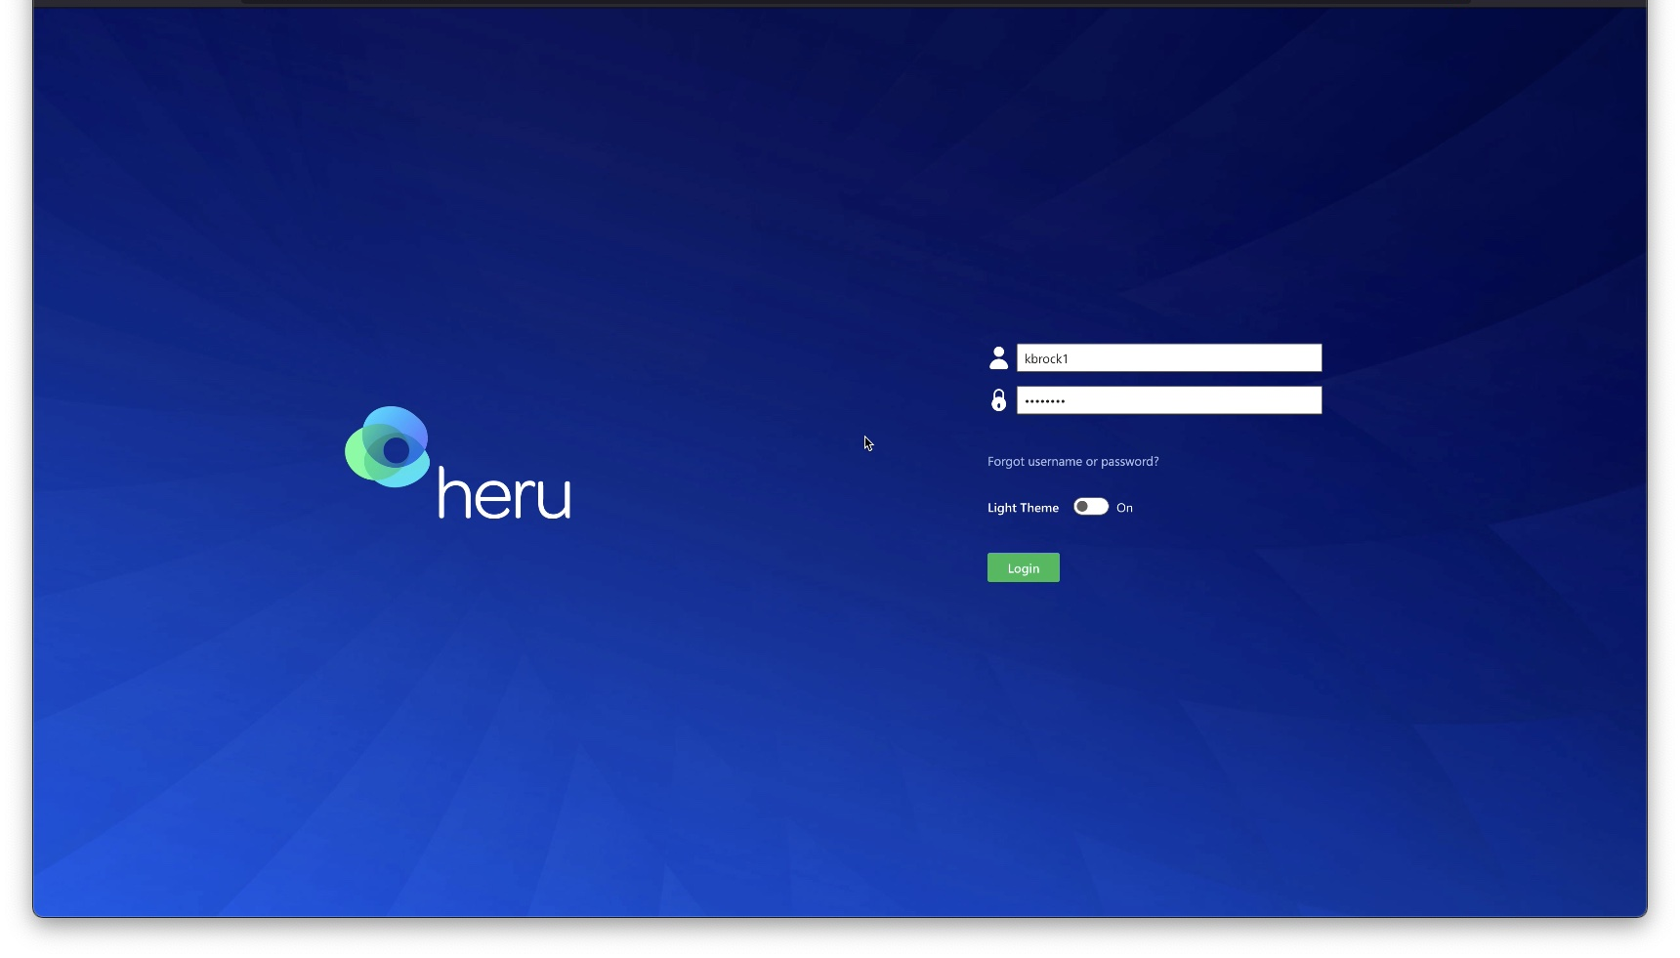
- If you forget your username or password, select “Forgot username or password” and use a registered email address to retrieve or reset your login credentials.
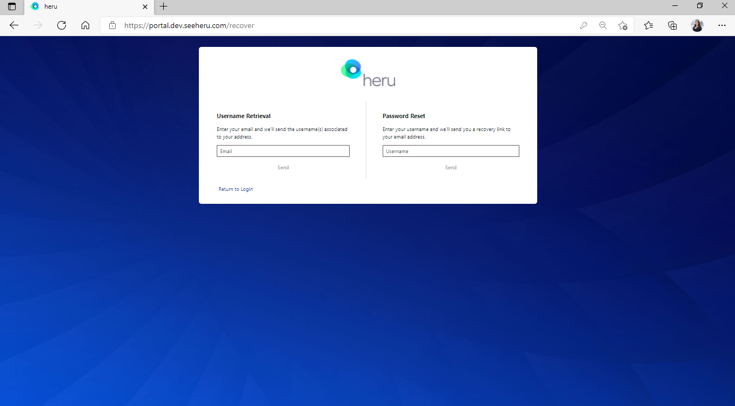

Getting Started

Title bar icons
Light Theme toggle – Change theme from light to dark for comfortable viewing in a dark room.
Alert – Notifications such as but not limited to pending errors or warnings from ongoing tests.
Information – Display information useful when contacting Heru, Inc. Customer Service.
The following information is displayed when you press the button:
• Heru, Inc. About Us Information
• Software and Web Portal Version
• Contact Information
• Support Contact Information
Logout – Log out or sign in under a different user.

Operating icons
Accounts: Account management and enables multiple users to customize their preferred settings.
Appointments: View previous and scheduled appointments database and test data.
Patients: Create new patients, create new appointments for existing patients, and view or edit existing patient data.
Devices: Confirm list of devices associated with the clinic, check status of devices, and modify details such as name of devices.
FAQ: Frequently Asked Questions.
Account Settings: Available for account administrators to configure Heru portal account settings and defaults such as password strength and expiration.
My Profile: Configure Heru portal contact details such as modifying username or password.

Adding a New Patient and creating an appointment (testing session)
- Click on “Patients” on the left side bar.
- Click on “Create Patient”.
- Patient Details page will open. Enter your patients details and click “Save Patient”.
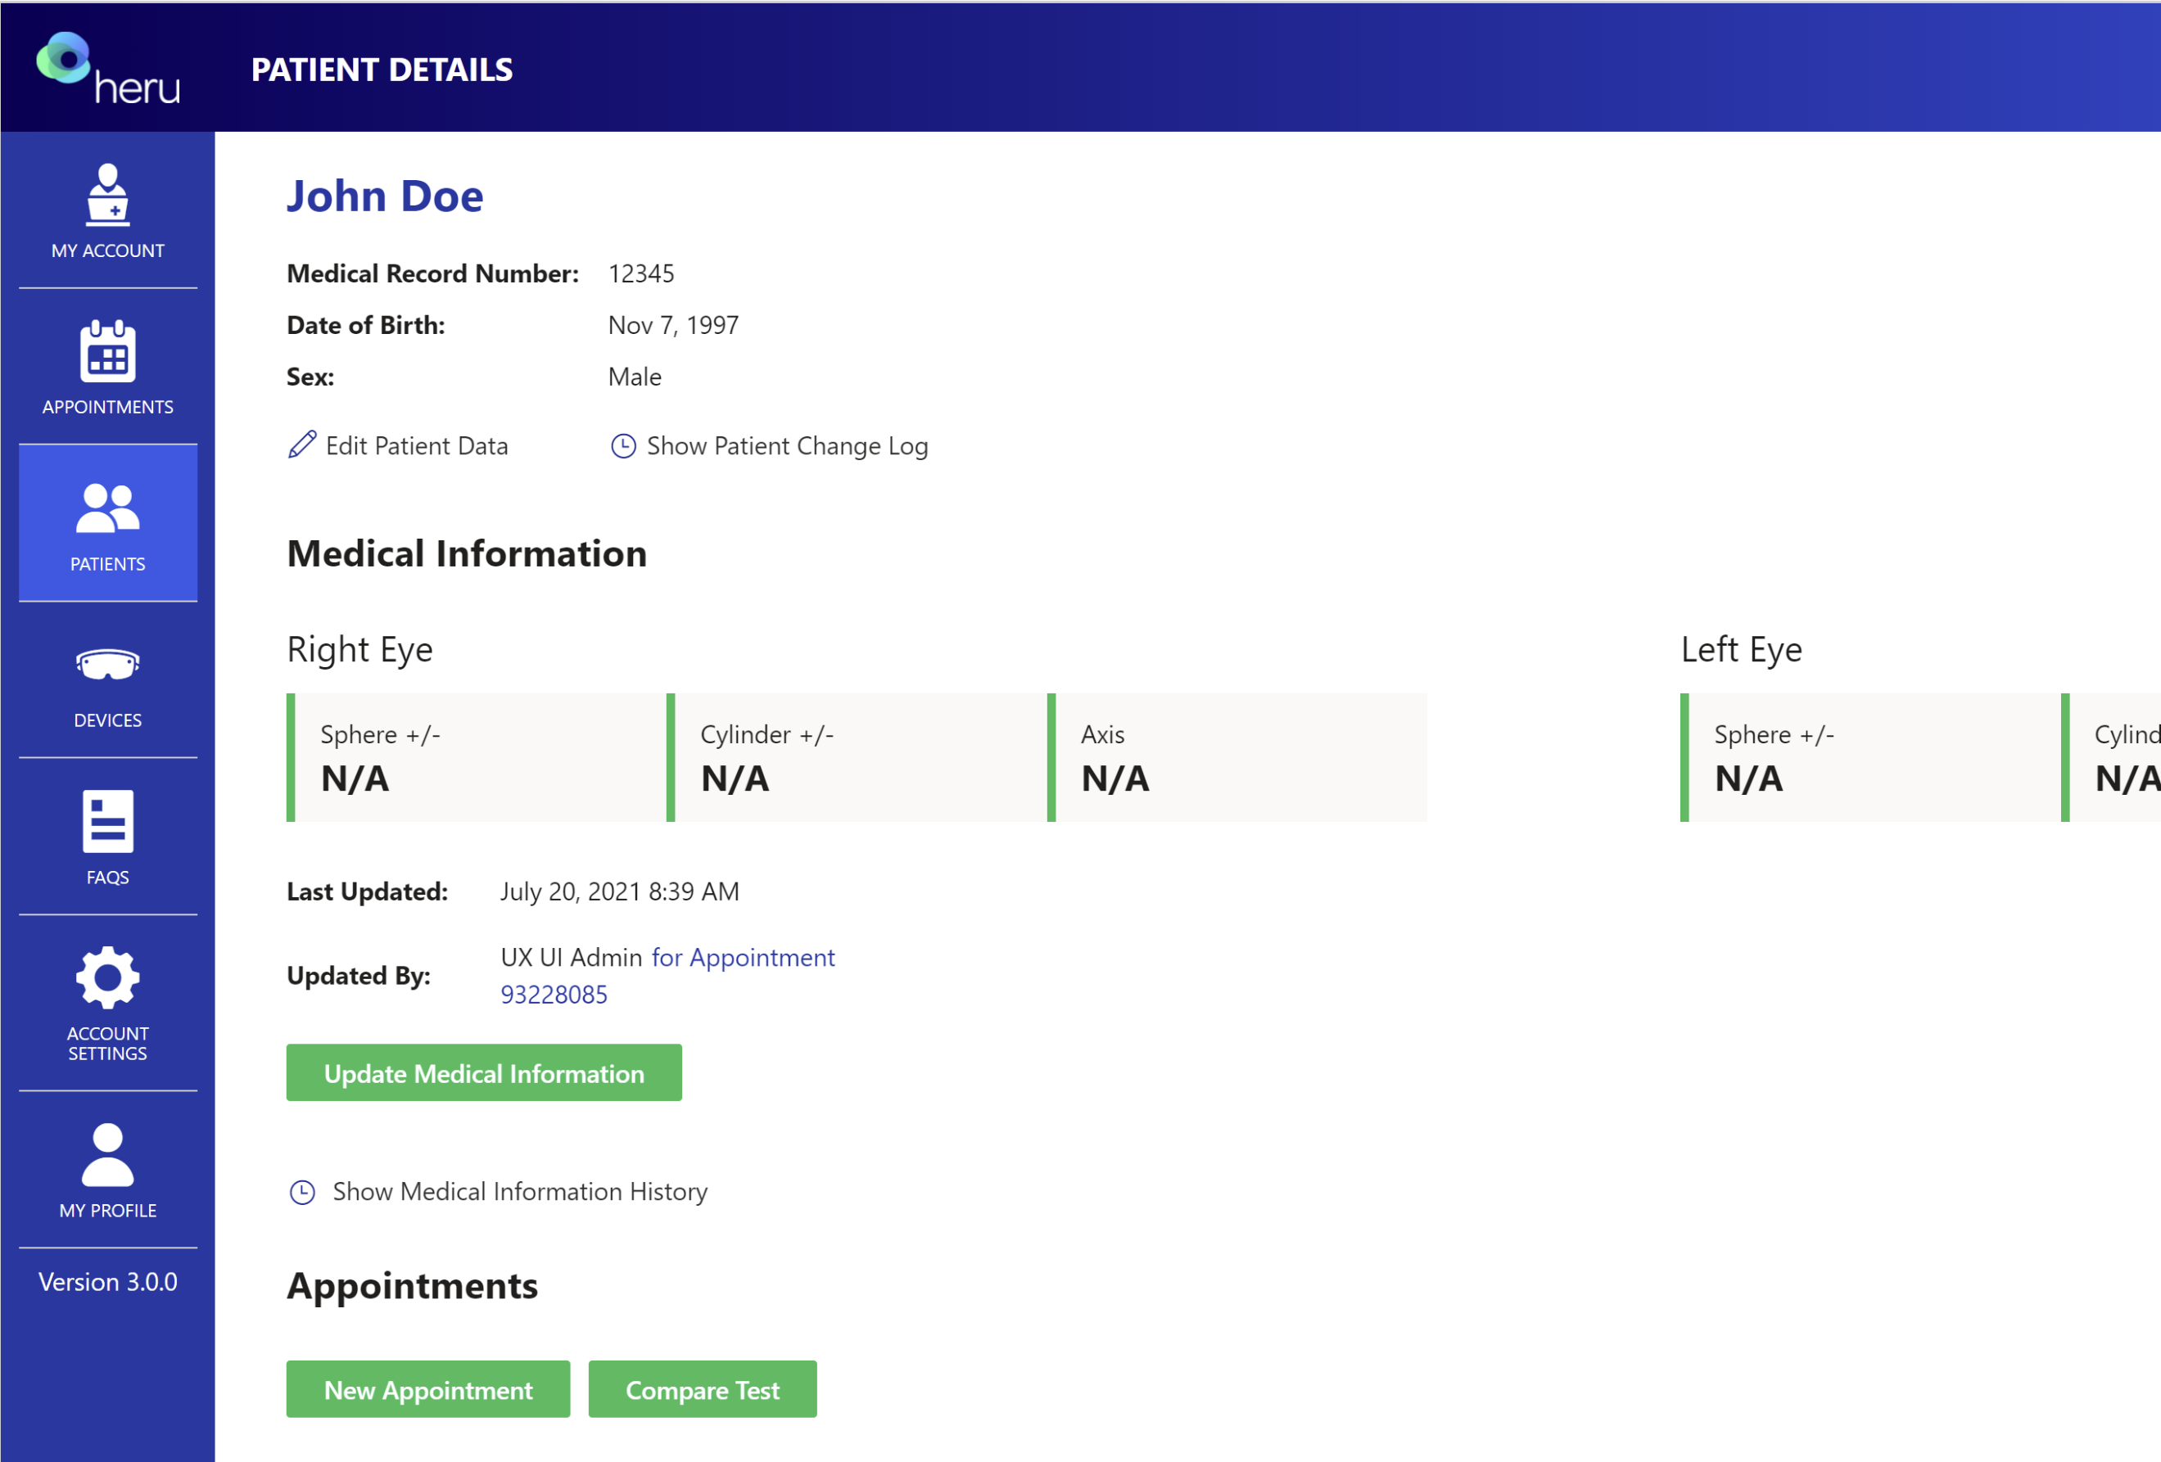
- Select to create an appointment by clicking on “New Appointment”.
- Complete the “Patient information” section and confirm accuracy.
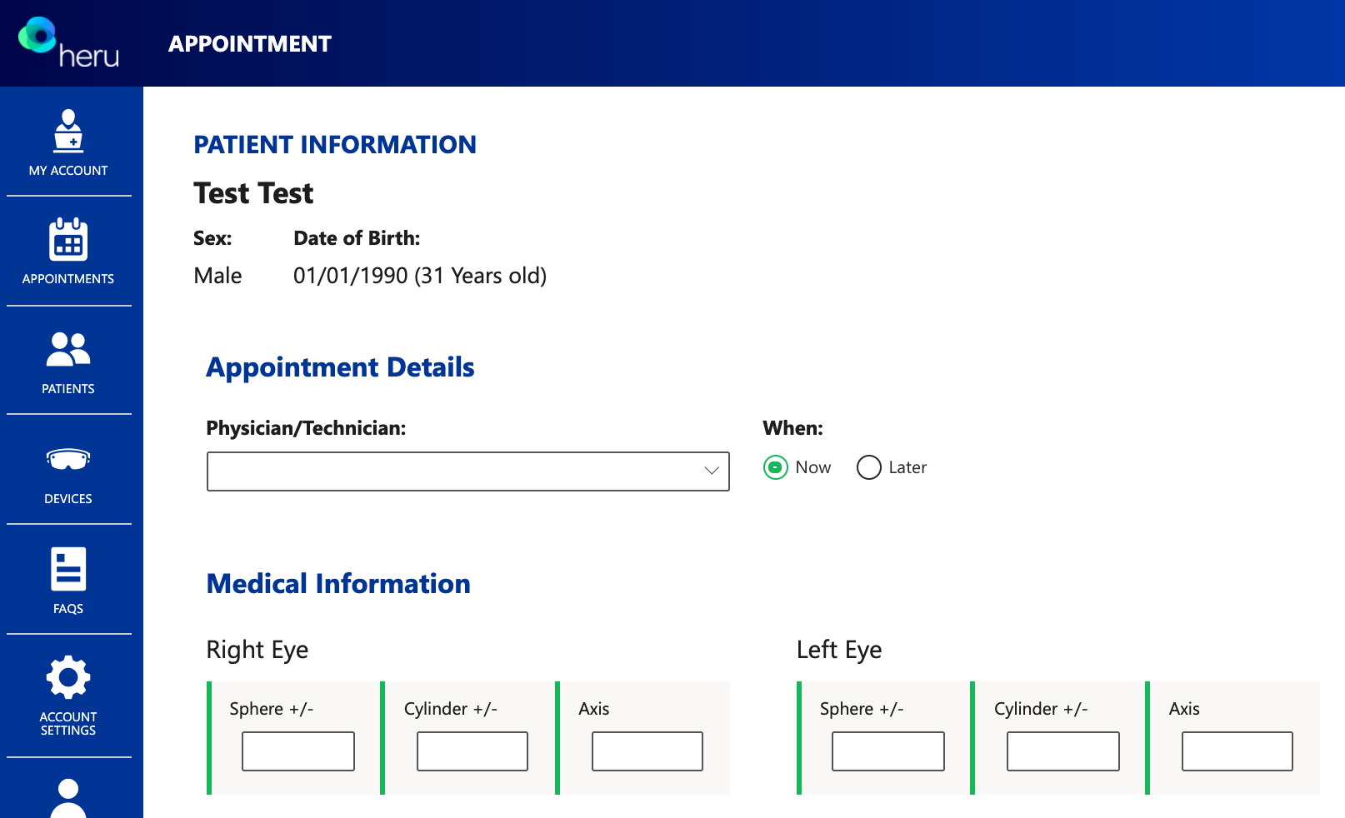
- Select test option under “Visual Field Tests To Apply”

- Autoworkflow
By selecting AutoWorkflow, this will enable a suprathreshold test to seamlessly proceed directly into an RE: I Threshold if a certain number of stimuli are missed without having to create another appointment. This option can be selected when creating an appointment under “Subjective/Suprathreshold”.
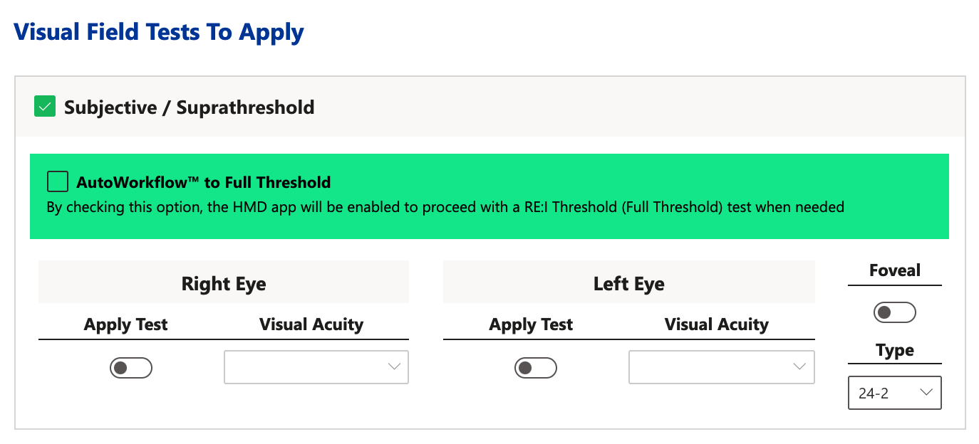

- Select available device from dropdown menu or type device label code into search field on the right upper side of the screen.
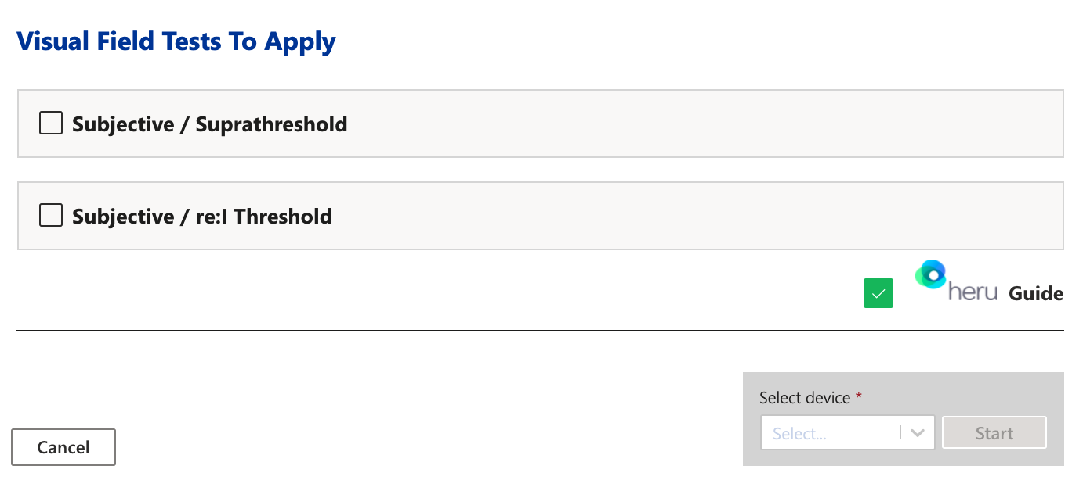

Taking a Test
Before beginning the exam, confirm that you have successfully completed the Heru Portal registration and HMD Light-Shield/Lens Holder installation (see sections 7 and 10).

Magic Leap 1 HMD
Note: If you are using a HoloLens 2 HMD, refer to section 11.4.2.
- Ensure that the battery of the HMD is charged to at least 50%. Refer to HMD manual for charging instructions.
- You will need to use the trial lens holder if the patient has a distance prescription. Use spherical equivalent for each eye being tested. You do not need to occlude either eye for the Heru Visual Field Test.
Turn on the HMD as well as the controller at the beginning of the day. The operator will need to initiate testing by clicking “LETS GET STARTED” on the HMD from the dashboard page.
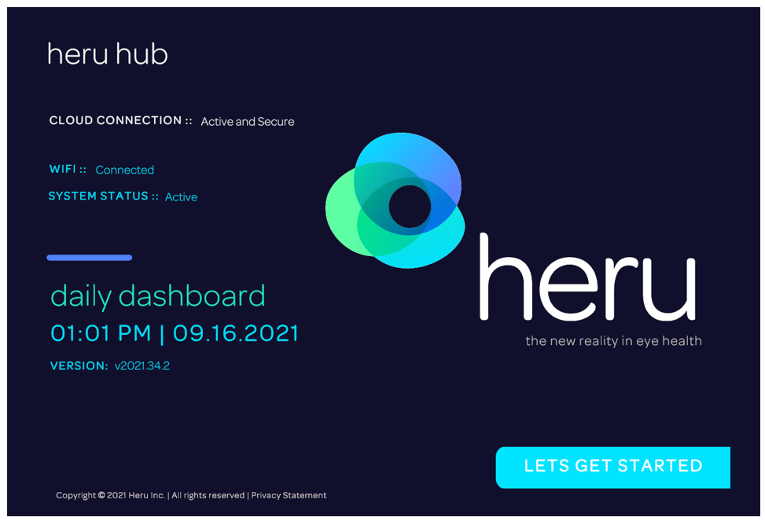

- Orient the patient to the controller, showing them the bumper that they will press during the test. This should be the only button they press to confirm when they see stimuli during the re:Vive application.

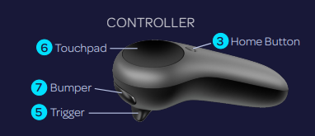
Figure 4 Magic Leap 1 Controller (clicker)

- Show the patient how the HMD expands to fit most heads and instruct them to keep the back padding high on the back of their head. Allow the patient to place the HMD on their head. Make sure it is comfortably positioned with the back of the HMD resting high on the back of the patient’s head.

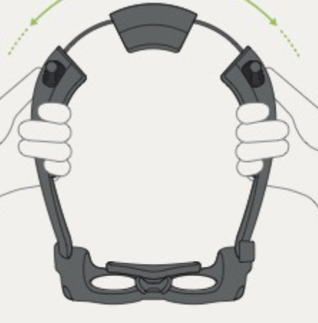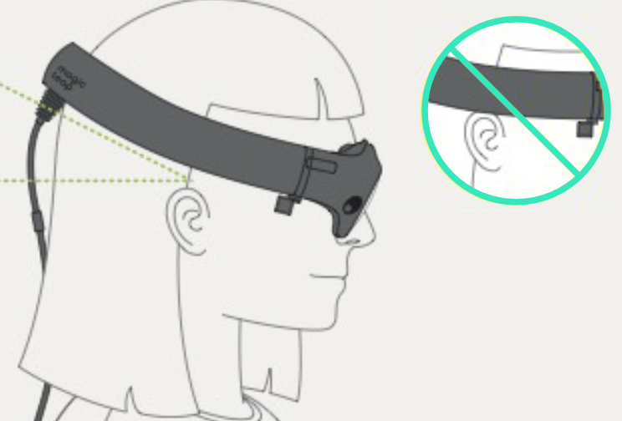

- Hand the patient the controller and make sure they have their finger resting gently over the bumper and are not pressing any other buttons.
- Once the patient is comfortable, let them know they can follow the prompts on the screen. The Heru Guide will walk them through the test initialization and the operator can follow along from the Exam View in the Heru Portal.
- Alignment step:
- First, the patient will be shown a screen reminding them how to fit the HMD on their head.
- Next, the Heru Guide will ask the patient to confirm they can see all four corners of the screen. This will ensure that the patient’s view is unobstructed during testing.
- If the patient cannot see the four corners, have them adjust the device on the head until all four corner markers are visible.
- Heru Guide:
  - If the Heru Guide is turned on, the patient will be given an interactive overview of the testing process.
- Ask the patient to hit the bumper to start the actual visual field test.
- A bright white dot will appear in the middle of the screen and the test will progress automatically. No interaction with operator is required.
- During the test, the health care provider will be able to see the progress of the test on the Exam View including what points on the test pattern have been tested, have not been tested, need to be retested, were not seen, and seen. There is also a progress bar in the Exam View.
- All tests will start using ActiveTrack™ real-time eye tracking during the exam. While testing, if a patient loses track of the fixation point in any area of the screen:
- Stimuli will stop showing and the Heru Guide will return to encourage the patient to fixate while the fixation target wiggles to get their attention.
- Once the patient looks back at the target the test will resume after a few seconds.
- If the HMD continues to detect poor fixation, the Heru Guide will run a short eye tracking calibration.
- If the HMD continues to detect poor fixation, it will track the patient’s fixation using Optic Nerve Fixation Monitoring, keeping track of fixation losses as they are detected.
- If the patient’s two eyes are being tested: after the first eye is done, the device will go to a resting step and ask the patient to start by pressing the bumper when they are ready (see step 10).
- Once testing is complete, the Heru Guide will congratulate the patient and instruct them to return the HMD and controller to the operator.
- Screen will read, “Click to start a test”

HoloLens 2 HMD
Note: If you are using a Magic Leap 1 HMD, refer to section 11.4.1 for instructions.
Before beginning the exam, confirm that you have successfully completed the Heru portal registration and HMD Light-Shield/Lens/Liner installation (see sections 7 and 10).
- Ensure that the battery of the HMDs is charged to at least 50%. Refer to HMD instructions for use for charging instructions.
- Select the trial lens to go onto the trial frame, using spherical equivalent for each eye.
- Turn on the device as well as the patient clicker.
- Place the device on the patient’s head. Make sure it is comfortably positioned. Ensure device is secured onto the patient’s head, to prevent it from sliding down.
- Explain to the patient that during the exam that he/she needs to keep their head straight without moving it.
- A voice prompt will say: “Welcome to Heru” and the same message will appear on the screen of the HMD.
- Ask the patient to look in the direction of the monitor. The operator will use the access code to start the test. Press the upper button and read the code.
  - The HMD will read the code again and ask for confirmation.
    - If the code is correct, press the middle button of the clicker for HoloLens 2. Alternatively, press the upper button and say “Yes” then press the upper button again.
    - If code is incorrect, press the lower button of the clicker. Alternatively, press the upper button and say “No” then press the upper button again. In that case the device will go back to step 4.
- Calibration steps: This calibration step only happens if the patient has not used the device before. If the patient has used the device before with successful calibration, the HMD will skip this process and go directly to step 7.
- The patient will see a gray with white corners screen on the HMD.
- Ask the patient if her/she can see all four corners.
- If the patient can see the four corners, then the device is positioned correctly. The patient needs to press on the middle button on the clicker.
  - If the patient cannot see the four corners, have them adjust the device on the head until all four corners are visible. Then the patient can click on the middle button on the clicker.
  - A voice prompt will say “Hold your head still and follow the gems with your eyes”. Ask the patient to follow the gems that appears on the HMD with their eyes.
  - If the calibration is successful: A voice prompt will say “Your HoloLens 2 is calibrated. You can always make changes in settings if something doesn’t look right”.
  - If the calibration is not successful, a voice prompt will say “It is not working, let’s keep going and you can adjust this later in settings”.
  - The health care provider or the patient needs to say “Done”. Alternatively, the patient can reach out with their finger to press the button saying “Done”.
- The HMD will present a screen to the patient with the name and date of birth of the patient and ask for confirmation:
    - If the name and date of birth of the patient is correct, press the middle button of the clicker of the HoloLens 2. Alternatively, press the upper button and say “Yes” then press the upper button again.
    - If the name or date of birth of the patient is incorrect, press the lower button of the clicker. Alternatively, press the upper button and say “No” then press the upper button again. In that case the device will go back to step 5.
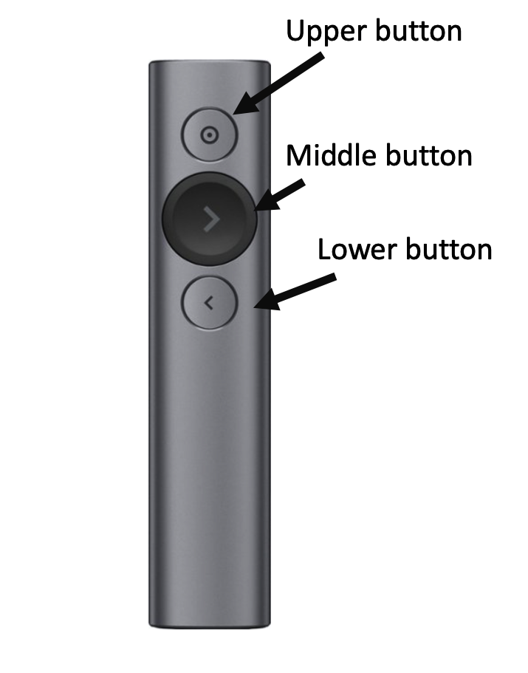
Figure 5 - HoloLens2 Clicker
- A voice prompt will say: “Starting the test in 3 - 2 - 1” and the same message will appear on the screen of the HMD.
- A white rectangle will appear on the screen. Ask the patient if they can see all four corners of this rectangle.
    - If the patient can see the four corners of the white rectangle, then the device is positioned correctly. Remind patient to keep their head position straight.
    - If the patient cannot see the four corners of the white rectangle, have them adjust the device on the head until all four corners of the white screen are visible.
- While the patient is on the screen with the white rectangle, give them the following instructions:
    - Fixate your eyes on the bright white dot that will appear in the center and follow this white fixation target wherever it moves.
    - There will be flashes of light in your peripheral vision. Do not move your eyes to look at the flashes.
    - Click the middle button whenever you see a flash. The brightness of the flashes will vary during the test.
- To start the actual visual field test:
    - The patient needs to hit the middle button.
    - Note: if the calibration was not successful in step 5, the patient will need to press once to get to a black screen. Press another time to go to step 14.
- A bright white dot will appear in the middle of the screen and the test will progress.
- During the test, you will be able to see the progress of the test on a progress bar on the web portal screen. If an error occurs during the test, an error message will appear.
- When the test is completed, a voice prompt saying “test completed” will be heard and the same message will appear on the screen of the HMD.
- If the patients’ two eyes are being tested: after the first eye is done, the device will go to step 8 above.

Reviewing the Results
After the patient takes the test, the results will appear in the Heru Portal under the results tab.
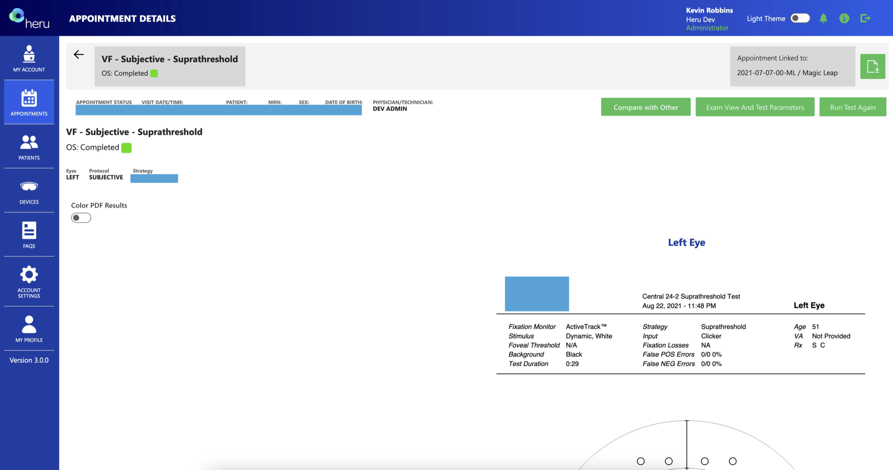
The office has option to compare test side-by-side, by selecting Compare with Other.

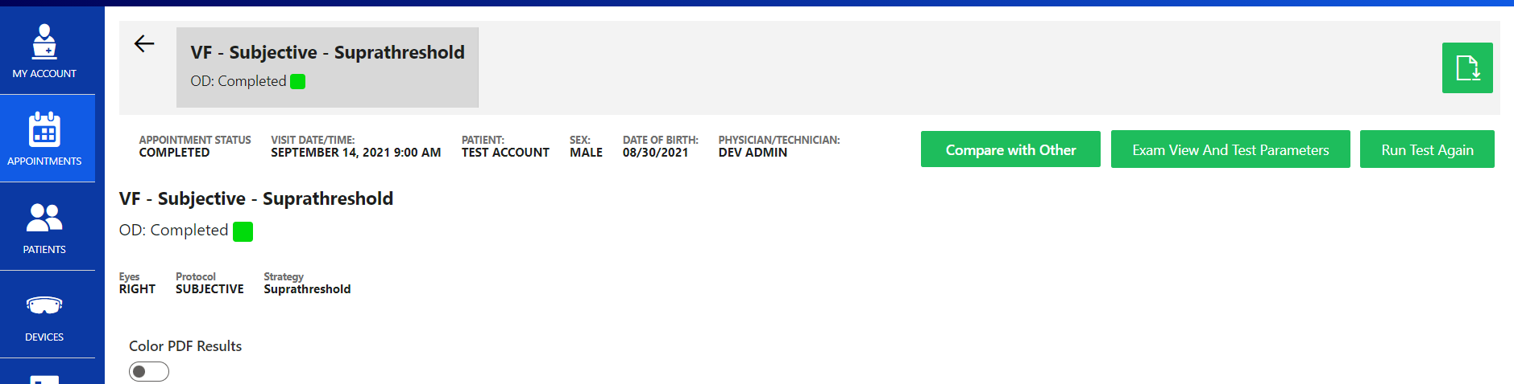

- Select Test Completed On (options: Any Time, Last Year or Last Month)
- Include in Comparison (options: Both Eyes, Right Eye Only or Left Eye Only)
- Visual Field Types (options: Subjective Supratheshold or Subjective re:I Threshold)
- On dropdown select the dates you are wanting to view
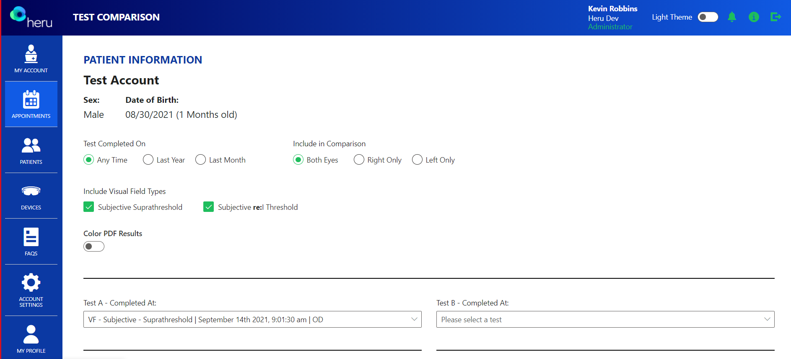

Printing Test Results

From the Results display screen, the download icon can be found in the upper right-hand corner to save or print your results.

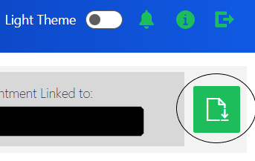

Troubleshooting
Issue | Resolution
Difficulty logging into the Heru Portal | - Make sure you are connected to the Internet.  - Make sure you are using an approved web browser (see section 13.  - Reset your password. Select “Forgot username or password” from the login screen and use a registered email address to retrieve or reset your login credentials.
Not able to create the appointment for the patient | - Make sure that all the required fields on “Create appointment” section are completed.  - Make sure that the appointment is not created for a past date/time.
Ambient light leaking into patient field of view | - Readjust the light shield. If the light shield is readjusted while the patient is taking the test, the test will need to be repeated.
Test interrupted | - Make sure that the HMD’s battery is more than 50% charged. If not, then connect the HMD to power with the charger that is provided with it. The test can be performed while the HMD is connected to power.
The patient is not seeing the four corner markers during alignment displayed on the HMD screen. | - Ask the patient to adjust the position of the wearable device until he/she sees the four corners.
Test keeps on restarting while the patient is taking the test | - Check your Internet connection.
Results are not appearing in the results section of the web portal | - Make sure you are connected to the Internet.  - Make sure that you are using a supported browser. See section 13 for a list of supported browsers.

Technical Specifications
Component | Attribute | Value
Light Shield for HoloLens 2 HMD | Weight | 114g (0.25g)
 | Dimensions | 11.7cm x 9.7cm x 19cm
Light Shield for Magic Leap 1 HMD | Weight | 45g
 | Dimensions | 13.78" x 19.69" x 13.78"
 | Supported Browsers | Windows: Microsoft Edge (minimum version 81)  Windows or macOS: Google Chrome (minimum version 80)
 | Supported Screen Resolution | Minimum: 1280x800  Recommended: 1920x1080
 | Visual Field Test Patterns | 24-2  10-2
 | Visual Field Testing Strategy | re:ImagineTM  Suprathreshold
 | Stimulus Duration | 200 msec
 | Wavelength | Broadband visual light
 | Maximum Visual Field Range Tested | 24 degrees temporally  30 degrees nasally
 | Number of Stimuli tested | 54 points (24-2)  68 points (10-2)
 | Spacing Between Stimuli | 6 angular degrees (24-2)  1 angular degree (10-2)
 | Fixation Monitor | ActiveTrackTM (Gaze) or Blind spot (Fixation Losses)
Network requirements | Internet | Outbound, port 443

Regulatory Information
re:Vive is classified as a Class I medical device.
Agency | Type of Document | Reference
United States
Quality Systems
FDA | Federal Regulation | 21 CFR 803 Medical Device Reporting
FDA | Federal Regulation | 21 CFR 806 Medical Devices – Reports of Corrections and Removals
FDA | Federal Regulation | 21 CFR Part 807 Registration and Listing
FDA | Federal Regulation | 21 CFR 820 Quality System Regulation
EC | Standard | EN ISO 14971:2019 Medical devices - Application of risk management to medical devices
IEC | Standard | IEC 62304:2006 Medical Device Software – Software Life Cycle Processes
Biocompatibility
ISO | Standard | ISO 10993-1:2009 Biological evaluation of medical devices Part 1: Evaluation and testing in the risk  management process
Labeling
FDA | Federal Regulation | 21 CFR 801 Labeling
Cybersecurity
Congress | Federal Law | HIPAA Health Insurance Portability and Accountability Act
PCI | Standard | PCI Data Security Standard Version 3.2

Contact Us

Headquarters  Heru, Inc.  201 S. Biscayne Blvd  Suite 2873  Miami, FL 33131 | For General Inquiries contact us at:  help@seeheru.com  For Service & Support contact Heru Customer Care:  support@seeheru.com  Regular hours of operation  M-F, 8:00 a.m. – 6:00 p.m. EST  Phone: +1 (844) SEE‑HERU

