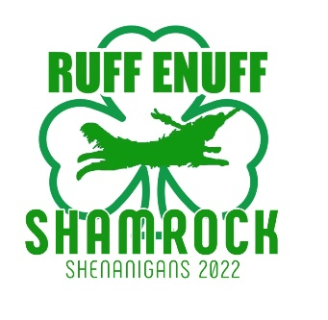
Local Restaurant List

Tavern in the Square Littleton
$$$ · American
810 Constitution Avenue, Littleton · In The Point
Phone: (978) 339-5372

Il Forno Restaurant
$$$ · Italian
529 King Street, Littleton
Phone: (978) 540-2880

Great Road Kitchen
$$$ · Oyster/American Bar/Grille
613 Constitution Avenue, Littleton · In The Point
Phone: (978) 952-7333

Taka Asian Cuisine
$$$· Asian (Chinese/Japanese/Thai)
602 Constitution Ave, Littleton · In The Point
Phone: (978) 339-5498

Anthony's Coal Fired Pizza
$$ · Pizza
201 Constitution Avenue, Littleton · In The Point
Phone: (978) 486-4124

Chili’s Bar & Grill
$$ · American
137 Littleton Road, Westford
Phone: (978) 692-8498

Ixtapa Cantina
$$ · Mexican
765 Boston Road, Groton
Phone: (978) 272-1465

Not Your Average Joe’s
$$ · American
305 Main Street, Acton
Phone: (978) 635-0101

Moe's Southwest Grill
$ · Mexican
607 Constitution Avenue, Littleton · In The Point
Phone: (978) 506-5154
Asian Plus Noodles and Rice
$ · Asian
313 Littleton Road, Westford
Phone: (978) 577-6425

Lazy Mary’s
$ · Pizza/Sandwiches
30 Littleton Road, Ayer
Phone: (978) 772-7600

Chip Shots Pub
$ · Pizza/Burgers/Sandwiches
245 Ayer Road, Littleton
Phone: (978) 772-0072

Subway
$ · Sandwiches
287 Great Road, Littleton
Phone: (978) 486-9782

